**Loan Credit Assessment System using Explainable AI**

BENJAMIN ZI FENG KHOR

23001158

UXCFXK-30-3

Digital Systems Project



# Abstract

Your Abstract

# Acknowledgements

I would like to express my sincere gratitude to my lecturer, Dr. Benedict Gaster, for his valuable guidance and support throughout my studies.

I am especially indebted to my project supervisor, Prof. Jun Hong, whose expertise, patience, and continuous support have been instrumental in every stage of this project. His constructive feedback, thoughtful suggestions, and unwavering encouragement have not only helped me overcome challenges but have also inspired me to strive for excellence.

My sincere appreciation also goes to my family and friends, whose unwavering support and motivation have been a constant source of strength throughout this journey. Their understanding, patience, and belief in my abilities have encouraged me to persevere, even in times of difficulty. Without their encouragement, this achievement would not have been possible.

Additionally, I would like to acknowledge my fellow classmates and colleagues for creating a stimulating and collaborative learning environment. Their camaraderie, shared experiences, and willingness to help have enriched my academic experience and made this journey truly memorable.

Lastly, I am grateful to everyone who, directly or indirectly, contributed to my academic and personal development. Each act of kindness, support, and encouragement has played a vital role in helping me complete this project successfully.

# Table of Contents

Abstract 1

Acknowledgements 2

Table of Contents 3

Table of Figures 6

1.0 Introduction 7

1.1 Problem Background 7

1.2 Significance 7

1.3 Aims and Objectives 7

1.4 Report Outline 8

2.0 Literature Review 9

2.1 Overview 9

2.2 Credit Risk Assessment 9

2.2.1 Background 9

2.2.2 The Rise of AI and its application in Credit Risk Assessment 10

2.2.3 AI/ML Algorithms in Credit Risk Assessment 10

2.2.4 Challenges in existing AI credit assessment system 11

2.3 Explainable Artificial Intelligence (XAI) 12

2.3.1 What is XAI 12

2.3.2 Historical Development 13

2.3.3 XAI Concepts 13

2.3.4 Importance of XAI and Explainability 15

2.3.5 XAI Techniques 16

2.3.6 Evaluation Metrics of XAI 18

2.3.7 XAI Applications in Loan Credit Assessment 19

2.3.8 Limitations of XAI 21

3.0 Requirements 22

3.1 User Stories 22

3.2 Requirement Engineering 23

3.2.1 MOSCOW 23

3.2.2 Functional Requirements 23

3.2.3 Non-Functional Requirements 25

3.3 UML Diagrams 26

3.3.1 Use Case Diagram 26

3.3.2 Activity Diagram 27

4.0 Methodology 30

4.0 Agile Software Development 30

4.0.1 Concept 30

4.0.2 SCRUM 30

4.1 Justification 31

4.2 Sprint Planning 32

4.3 Project Timeline and Planning 33

5.0 Design 34

5.1 High-Level Design 34

5.1.1 System Architecture 34

5.1.2 User Interface Design 35

5.1.3 Database Design 36

5.2 Low-Level Design 37

5.2.1 Class Diagram 37

5.2.2 Sequence Diagram 38

5.2.3 State Diagram 42

5.3 Tools and Framework 44

5.4 SHAP Classification Explanation 45

5.5 Test Design 45

6.0 Implementation 46

6.1 SPRINT 1 – ML and XAI Development 46

6.1.1 Machine Learning 46

6.1.2 ML Service Deployment 50

6.1.3 XAI Service Deployment 55

6.2 SPRINT 2 – Django Setup and Admin Functionalities 62

6.2.1 Django Backend Framework 62

6.2.2 Authentication and Role-based Control 65

6.2.3 Initial Interface Setup 66

6.2.4 Admin Functionalities Development 70

6.3 SPRINT 3 – Borrowers and Loan Officers Functionalities 73

6.3.1 ML Service Integration Challenges 73

6.3.2 Borrower Functionalities Development 75

6.3.3 Loan Officers Functionalities Development 84

6.4 SPRINT 4 – AI Engineer Functionalities 87

6.4.1 ML Model Management 87

6.4.2 Review Loan Application Records 89

7.0 Project Evaluation 90

7.1 Aims and Objectives 90

7.2 Literature Review 90

7.3 Requirements 90

7.4 Methodology 91

7.5 Design 91

7.6 Implementation 91

7.7 PIP Feedback 92

7.8 Project Limitation 92

8.0 Conclusion and Further Work 93

8.1 Conclusion 93

8.2 Future Work 93

9.0 Glossary and Table of Abbreviations 94

10.0 References 95

11.0 Appendix A: First Appendix 101

11.1 Project Repository 101

11.2 Full Test Case 101

11.3 Machine Learning (6.0 Implementation continued) 101

11.4 Explainable AI 101

# Table of Figures

Figure 2.1 Distribution of ML techniques for credit risk assessment (Bhatore et al., 2020) 10

Figure 2.2 Architecure of XAI Process (Coroama and Groza, 2022) 12

Figure 2.3 Differences between AI and XAI (Kasaraneni, 2021) 12

Figure 2.4 Black Box AI vs White Box XAI (Hashemi-Pour et al., 2024) 14

Figure 2.5 How LIME works (Visani, 2021) 16

Figure 2.6 Illustration of SHAP Mechanism (Bhattacharya, 2022) 17

Figure 2.7 Architecture of XAI-driven Credit Risk Assessment (Nallakaruppan et al., 2024) 19

Figure 2.8 Trade-off between Accuracy and Explainability (Abusitta et al., 2024) 21

Figure 3.1 Use Case Diagram 26

Figure 3.2 Activity Diagram 1 27

Figure 3.3 Activity Diagram 2 28

Figure 3.4 Activity Diagram 3 29

Figure 4.0.1 Scrum Cycle (GeeksforGeeks, 2023) 31

Figure 4.0.2 Project Gantt Chart 33

Figure 5.0.1 System Architecture 34

Figure 5.0.2 User Interface Designs (Wireframe) 35

Figure 5.0.3 Database Design – Entity Relationship Diagram 36

Figure 5.4 UML Class Diagram 37

# Introduction

## Problem Background

Traditional credit risk assessment systems, relying on manual reviews and rule-based methods, face challenges such as inefficiencies, biases, and lack of scalability. While AI-driven systems have significantly improved accuracy in predicting loan approval and default probabilities, their opacity often classifies them as "black boxes," limiting their interpretability and raising concerns over fairness, trust, and regulatory compliance. The lack of transparency in these models undermines their adoption by financial institutions, where clear decision-making processes are essential. Addressing these limitations is critical to enhancing trust and usability in AI-powered credit risk assessments.

## Significance

This project bridges the gap between performance and interpretability in credit risk assessment by integrating Explainable Artificial Intelligence (XAI) into an AI-driven system. By employing XAI techniques such as SHAP, the system will provide transparent insights into loan decision-making processes, ensuring regulatory compliance and fostering trust among stakeholders. The system will empower financial institutions to make more informed, accountable, and fair loan-lending decisions, ultimately reducing default rates and enhancing operational efficiency. This research contributes to advancing the adoption of XAI in financial services, addressing critical challenges in fairness, bias mitigation, and regulatory adherence in credit assessment.

## Aims and Objectives

This project aims to develop an **Explainable AI (XAI)-driven credit assessment system** to enhance the accountability and explainability of decisions made by machine learning model in **loan lending** while ensuring the regulatory compliances, which empower financial institutions to make more informed decisions in selecting loan candidates, thereby minimising the default rates in the UK.

The objectives are:

* Develop a **graphic user interface (GUI) system** that takes financial institutions as target users, which conduct credit risk assessment and data analysis of borrowers, **providing meaningful insights on automated lending decisions-making**
* Implement machine learning models to **predict the loan approval status** of loan candidates
* Implement **Explainable AI to provide explainability to the decisions made** by deployed ML models

## Report Outline

**Introduction** provides a project overview and highlights the need for transparency and trust in AI-driven credit risk assessments.

**Literature Review** summarizes existing research on AI and XAI in credit assessment and identifies gaps addressed by project.

**Requirements** lists all required features for developing the system.

**Methodology** outlines the procedures and techniques involved in the project development.

**Design** describes the system architecture and component interaction with various diagrams.

**Implementation** describes the details of the project development process.

**Project Evaluation** presents the system's performance results, emphasizing interpretability, accuracy, and user feedback.

**Future Work and Conclusion** summarise the project's achievements and future improvements.

# Literature Review

## Overview

This section reviewed the application of XAI in credit assessment, covering background, AI implementation, and key challenges in current AI system. It then delves into XAI, with brief historical development and key concepts. XAI’s roles in addressing the limitations of conventional AI credit evaluation systems are discussed. XAI techniques: LIME and SHAP, are explained and comparatively analysed, along with the discussion of evaluation metrics. Then, XAI related works in loan credit assessment are reviewed. Finally, the limitations and challenges of XAI are discussed. By synthesizing current research and highlighting gaps, this literature provides a foundation for understanding how XAI address the critical challenges in credit risk assessment.

## Credit Risk Assessment

### Background

Credit lending is the core functions for banks and lending companies, as it’s their primary source of income (Biecek et al., 2021). Credit risk management is one of the core challenges for financial institutions (Misheva et al., 2021). **Credit risk** refers to probability of financial loss caused by the failure of loan repayment or other financial obligations of borrower (Brock, 2023). According to Kwashie et al., (2022), credit risk is the most expensive and impactful risk for commercial banks, and credit risk, especially non-performing loans (NPLs), could significantly harms banks' financial health. High NPL levels can erode customer trust and hinder banks' operational efficiency. **Non-performing loan** occurs whena borrower failed to make scheduled loan payments for 90 days or more (Segal, 2022) while **default** refers to the failure to make required debt repayments (Brock, 2020). This highlighted the need for an optimised credit risk assessment system. **Credit risk assessment** is the procedure of evaluating a borrower's ability and willingness to repay their debt and determining the probability of default to establish effective loan structures (Lip, n.d.). **Credit scoring** is a statistical analysis to evaluate the borrowers’ creditworthiness of and decide whether to grant or deny credit by assessing the likelihood of loan repayment. (Brock, 2020). **Loan underwriting** is the process of determining if the default risk of offering a mortgage loan to a particular borrower is acceptable (Banton, 2024).

### The Rise of AI and its application in Credit Risk Assessment

Traditional credit assessment relies on manual reviews and rule-based systems with limited data and subjective assessments, which suffer from inefficiencies, biases, lack of scalability, delays, and inconsistent decision-making (Azith et al., 2024). Nallakaruppan et al. (2024) highlighted the integration of AI emerged as a response to challenges in credit risk management. AI algorithms enabled financial institutions to analyse vast amounts of customer data like credit scores, which helps in mitigating lending risks. The high accuracy of prediction in determining a customer’s credit risk and default probability has been demonstrated. In recent years, there is an increasing reliance on AI/ML approaches in financial services, especially credit assessment. According to Uddin et al. (2023), ML algorithms like ensemble models or deep learning techniques, transformed credit assessment systems by enabling autonomous pattern discovery and data-driven predictions. These algorithms analyse clients’ transaction histories and social profiles to uncover behavioural patterns and shared characteristics, providing valuable insights into their loan repayment behaviours. Deep learning techniques, like neural networks, have become increasingly important for their ability to identify complex, non-linear relationships within data. This capability significantly improves the evaluation of individual customers' probabilities of loan default. Therefore, AI/ML approaches are widely adopted for comprehensive and accurate credit risk assessments in loan default scenarios.

### AI/ML Algorithms in Credit Risk Assessment

Research by Bhatore et al. (2020) reveal that frequently-used ML techniques for credit scoring including Artificial Neural Network (ANN), Support Vector Machine (SVM), Multilayer Perceptrons (MLP), Naive Bayes, Logistic Regression, Decision Tree, Random Forest, Extreme Gradient Boosting (XGBoost), Hybrid models, Ensemble models, and more. Recently, ANN, SVM and Ensemble Models have seen to become more popular in financial domain such as credit scoring, non-performing assets (NPA) prediction, and fraud prediction. Research proved in credit risk assessment context, ML algorithms outperformed the traditional statistical models. *Figure 2.1* shows the distribution of ML techniques used in credit assessment.

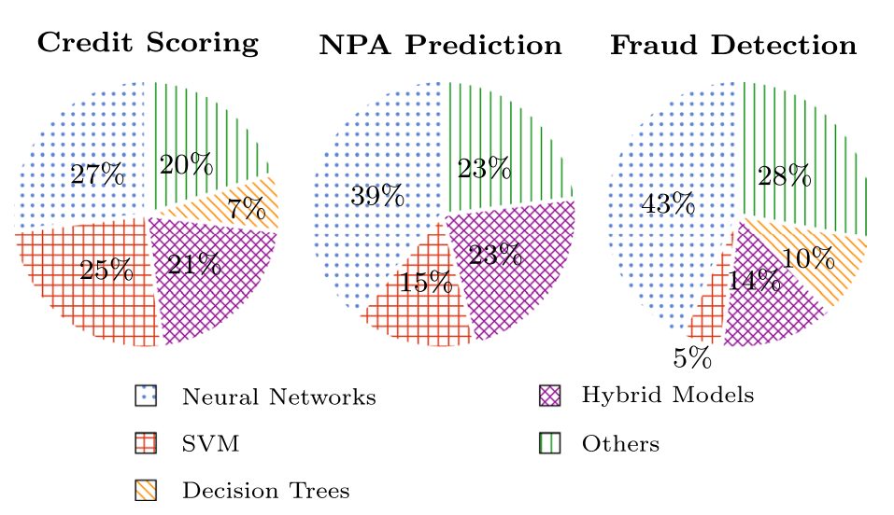

Figure 2.1 Distribution of ML techniques for credit risk assessment (Bhatore et al., 2020)

### Challenges in existing AI credit assessment system

#### Lack of Transparency and Explainability

Advanced AI models demonstrated outstanding ability to classify risk status of loan applications, reducing cost of underwriting (Sachan et al., 2020). However, AI models are highly non-linear with complex interrelationships between explanatory and dependent variables. The complexity and opacity make it challenging to estimate each variables’ contributions to a prediction, causing criticism as black-boxes (de Lange et al., 2022). Despite providing high performance, the opacity of AI models doesn’t provide sufficient assurance and confidence for their lending decisions (Misheva et al., 2021). The lack of explainability and transparency poses challenges for banking officers who are tasked with critical decision-making regarding loan approvals and credit risk management. Without a clear understanding of how and why decisions are made, it is difficult to let the lenders and borrowers to understand the models’ decision-making process (Nwafor et al., 2024). Banking officers are unable to confidently rely on AI-driven insights, thereby limiting the adoption of advanced AI systems in routine credit risk assessment (Bowden et al., 2024).‌

#### Fairness and Biases

Sachan et al. (2020) emphasised automating processes with AI models will raise ethical concerns. If the training data only reflects a limited range of loan underwriting practices, the AI/ML models may only accurately assess borrowers like those in the historical data. This can disadvantage minority borrowers with unusual or non-standard applications, leading to unintentional discrimination and unfair results. Study by Blattner and Nelson (2021) as cited in Bogiatzis-Gibbons et al. (2024), highlighted credit scores are noisier estimates of default risk for minority applicants, as they are more likely to have shorter or no credit histories. Heaven (2021) revealed that differences in mortgage approval between minority and majority groups are not just due to bias but also to the fact that minority and low-income groups have less data in their credit histories.

#### Regulatory Concerns

The stringent regulatory requirements highlighted the need for transparency and explainability in AI-driven credit assessment system. According to Leslie (2020), the Articles (13-15) in General Data Protection Regulation (GDPR) required providing individuals with meaningful information about the logic, significance, and consequences of AI-assisted decisions. In August 2023, UK Government introduced a pro-innovation approach in AI Regulation; one of its five principles is ‘Appropriate Transparency and Explainability’, which applies to all AI technologies. In EU AI Act, AI credit scoring is categorised in high-risk AI applications; providers must ensure the systems operation is sufficiently transparent to enable users to interpret and appropriately use the system's output. The Financial Stability Board warns lack of interpretability and auditability in AI and ML could pose a macro-level risk (FSB, 2017). From 2018, German Federal Financial Supervisory Authority, BAFIN will explicitly reject the use of black-box AI systems (Misheva et al., 2021).

## Explainable Artificial Intelligence (XAI)

### What is XAI

Explainable Artificial Intelligence (XAI) refers to approaches to clarify how AI models works by focusing on accuracy, transparency, and results. Unlike traditional AI, which emphasised achieving high performance and accurate predictions, XAI aims to provide human-understandable explanations as well as foster user comprehension and trust in the decisions made by the AI model (Yang et al., 2023). *Figure 2.2* showed the workflow of XAI in explaining the decisions made by AI models. *Figure 2.3* described the difference between AI and XAI.

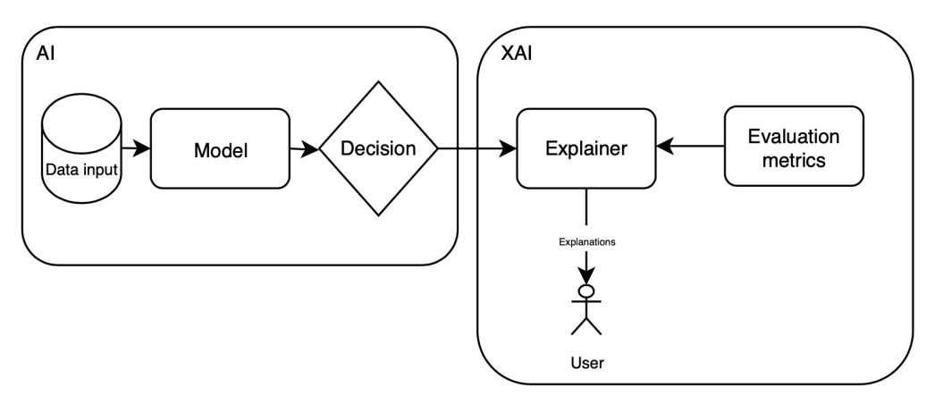

Figure 2.2 *Architecure of XAI Process (Coroama and Groza, 2022)*

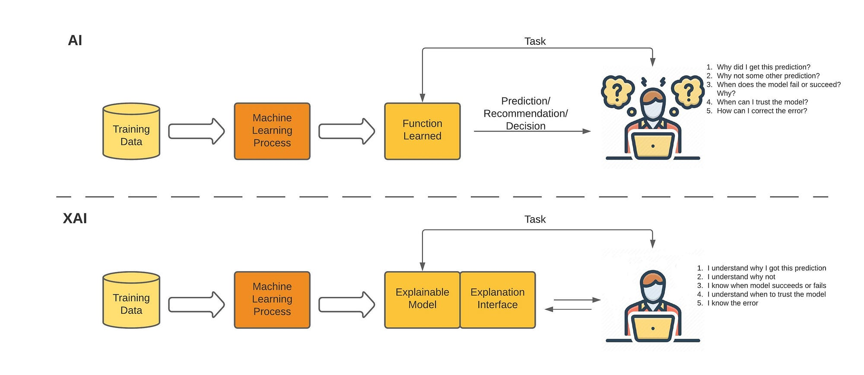

Figure 2.3 *Differences between AI and XAI (Kasaraneni, 2021)*

### Historical Development

The concept of explaining AI model decisions and its internal processes emerged in the 1970s, which driven by the need to test and build user trust in expert systems (Stein, Preece & Boicu, 2018).Early work of XAI existed in some expert systems that explained their outputs through applied rules (Xu et al., 2019). Due to the recent advancements in AI, there is an increasing deployment of ML-based systems across various domains (Dwivedi et al., 2022). By 2020, explainability has been recognized as a crucial factor for the widespread adoption of AI systems. As intelligent systems became more common in areas like autonomous vehicles, medical diagnosis, and financial services, it became essential in providing explanations for the decisions made by these automated systems to users, developers, and regulators (Confalonieri et al., 2020). This has made XAI to re-emerge as a critical research area due to the lack of transparency and explainability of current AI systems.

### XAI Concepts

#### Explainability

**Explanation** means to make something clear and understandable. **Explainability** refers to how an AI system reaches a decision, providing suitable explanations for its output. **Interpretability** is concerned with understanding of the system's underlying logic and its decision-making process (Sachan et al., 2020).

Explainability categorised into local and global scope (Ding et al., 2022). **Local** explainability emphasises understanding model’s decision-making process for specific input instances. Techniques such as feature importance and LIME help revealing the factors influencing individual predictions by making small adjustments to the input features and then examining how these changes influence the model's output for that specific datapoint (Goel, 2023).

**Global** explainability emphasises understanding of overall decision-making logic of the models across entire dataset. It aims to provide a broad understanding of the model’s learned representations and its overall behaviour. They are particularly useful for diagnosing trained models and extracting knowledge from them. However, creating global explanations is often challenging due to the complexity of modern ML/DL models. They are most effective when used to explore and analyse the model's predicted outcome distributions and its general reasoning processes. In finance domain, global explanation is useful in identifying the most influential features, such as credit history or income, in evaluating credit risk across all borrowers (Ding et al., 2022, Goel, 2023).

#### Bias

**Bias** refers to the tendency of AI systems to favour certain data subgroups over others due to inherent biases in the data trained on or flaws in the model's design. This causes the AI to weigh, prejudge, or show preference towards specific groups (Ding et al., 2022).

#### Black Box and White Box

An algorithm is ‘black box’ if its internal workings, like design, functions, logic, and parameters, are inaccessible and incomprehensible to humans. Conversely, if these internal workings are transparent and readily understandable, the algorithm is ‘white box’ (Ding et al., 2022). Examples of black box included deep neural networks or complex ensembles, which have opaque architectures that make it difficult to understand feature importances or interactions in predictions (Dwivedi et al., 2022).

*Figure 2.4* demonstrated how XAI differs from black boxes. XAI provides more trust as it reveals the transparency and rationale on how AI makes decisions, making a model more like white box (Hashemi-Pour et al., 2024).

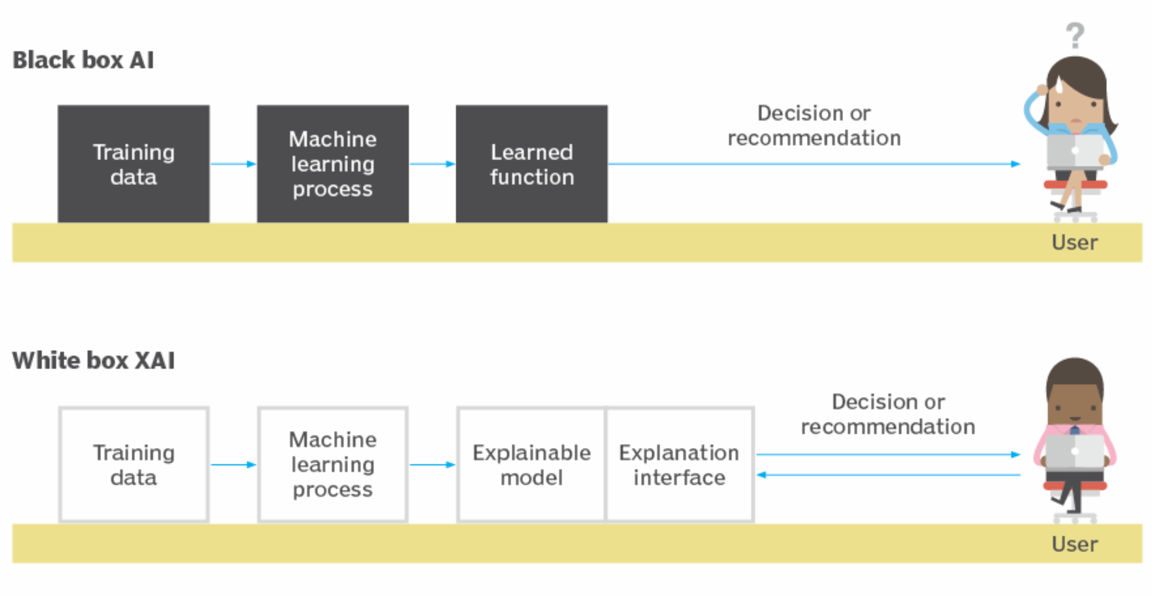

Figure 2.4 *Black Box AI vs White Box XAI (Hashemi-Pour et al., 2024)*

### Importance of XAI and Explainability

XAI is crucial in credit risk management as it provides transparency and explanations to AI-driven decisions by explaining the important and less important features in AI models, enabling financial institutions to understand and validate the factors influencing credit assessments, leading to more informed and accountable decisions (Yang et al., 2023). According to OECD (2021), lack of explainability in AI system would erode trust among users and regulators. Sachan et al. (2020) emphasized improving explainability could benefit organisations in establishing confidence among executives responsible for the potential negative outcomes of AI-driven decisions, fostering trust among financial consumers and regulators. XAI also hold promise for optimised loan portfolio management, the model explainability can help assess investment risks more effectively by revealing underlying factors driving market performance (Nallakaruppan et al., 2024).

Datrics (2024) emphasised XAI approaches are crucial for visualising the impact of individual features. It enhances model interpretability by illustrating how each feature contributes to the final prediction. Using a base value as a starting point and employing Shapley values represented as arrows, they provide a clear depiction of each feature's influence, effectively explain the prediction process. This visualization of feature impact is a powerful XAI technique that makes complex model outputs more understandable.

XAI could address the bias challenges. Bias has been a long-standing risk in training AI models which could lead to unfair decisions by AI systems (Nwafor et al., 2024). The difference between production data and training data can cause the AI performance data to decline (IBM, 2023). One of the bias mitigation is achieving transparency as it clarifies how AI models make the decisions and make them understandable to humans; SHAP is frequently used in previous studies to achieve transparency (Nwafor et al., 2024).

XAI help address the compliance with the regulatory requirements of AI of the financial institutions. It ensures financial institutions meet the legal obligations such as GDPR, pro-innovation AI regulation, and EU AI Act as well as satisfy the AI standards from regulatory authorities such as BaFin or FSB.

### XAI Techniques

XAI techniques consist of interpretable models and post-hoc interpretations (Abusitta et al., 2024). Post-hoc Explanations are used after the predictions to understand why a model produced a particular output. They offer insights into how input features affect the outcome without modifying the model's inner structure. Interpretable models like decision trees and linear regression are inherently interpretable as their decisions are based on certain traceable calculations or rules, making them naturally easier to understand (Lavanathan, 2024). Two popular XAI approaches included LIME and SHAP (Bussman et al., 2020).

#### Local Interpretable Model-Agnostic Explanations (LIME)

**LIME** is a post-hoc method designed to provide local explanations for specific predictions. It simplifies complex models by approximating them with interpretable surrogate models, such as linear regression around the instance being explained (Salih et al., 2024).

It works by perturbing input data by introducing small random changes to generate synthetic data points. It then fits a simple, interpretable model to the perturbed data to approximate the behaviour of the original model near the instance being explained, producing feature importance scores and visualizations specific to the instance. *Figure 2.5* demonstrated the workflow of LIME.

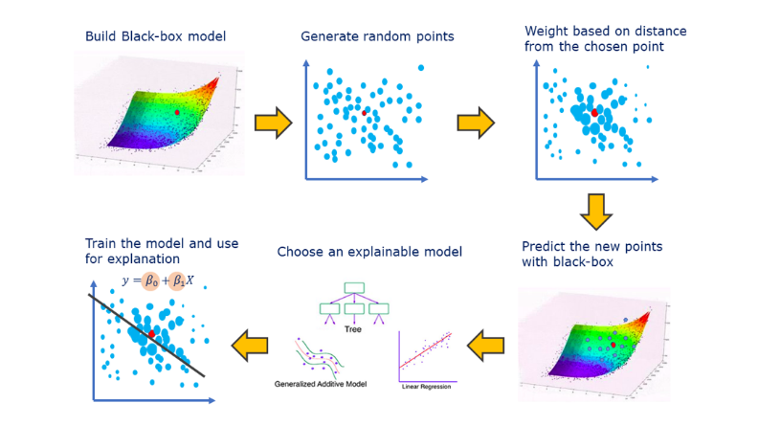

Figure 2.5 *How LIME works (Visani, 2021)*

#### Shapley Additive Explanations (SHAP)

**SHAP** is a XAI technique where the concept is based on game theory. It provides explanation by calculating the contribution of each feature to the model prediction by treating features as players and the model output as the payoff (Salih et al., 2024).

SHAP works by considering all possible combinations (coalitions) of features to evaluate their marginal contributions. It computes a SHAP value for each feature, representing its average contribution across all coalitions. This method provides both local (instance-specific) and global (model-level) explanations, making it versatile and comprehensive. *Figure 2.6* describes the how SHAP works.

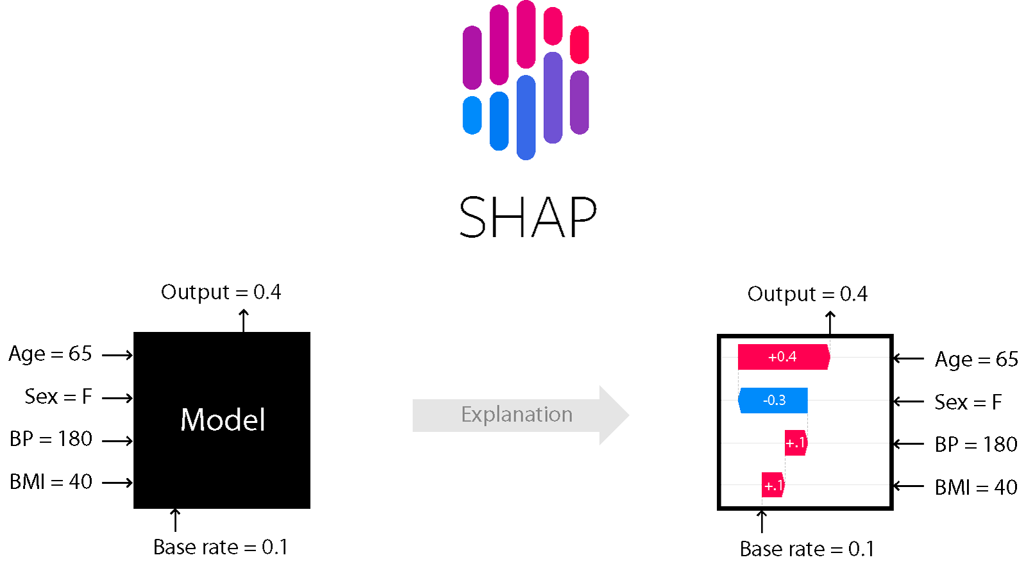

Figure 2.6 *Illustration of SHAP Mechanism (Bhattacharya, 2022)*

#### Comparative Analysis

Salih et al. (2024) highlighted the strengths and limitations of LIME and SHAP.

LIME has several strengths; first is faster and less computationally intensive, making it suitable for explaining predictions of any type of model. Its intuitive nature makes it easier for users to understand. However, it’s limited to local explanations and cannot provide global insights into the model. It relies on linear surrogate models, which may fail to capture non-linear relationships. It assumes features are independent, making it sensitive to collinearity. Additionally, results can vary depending on the sampling of perturbations and the instance being explained. LIME is commonly used to interpret predictions for individual instances where local interpretability is critical.

SHAP has several strengths. It can capture non-linear relationships, depends on the model. This is ideal for credit scoring as SHAP provide a comprehensive understanding of feature importance globally and locally (Fathima, 2024). It could produce various informative visualizations, such as forceplot, beeswarm and waterfall plots. There are some limitations of SHAP; first is computationally expensive especially with high-dimensional datasets as KernelExplainer has slower runtime. It assumes feature independence, which can lead to unreliable results when features are collinear. Additionally, SHAP is model-dependent, meaning outcomes may vary across different models. Misinterpretation of SHAP values is possible if users are not aware of their theoretical basis.

|  |  |  |
| --- | --- | --- |
| **Metrics** | **LIME** | **SHAP** |
| **Concept** | Fit a local surrogate model to explain complex model | Apply to model as-is |
| **Theory** | Feature perturbation | Additive Feature Attribution based on game theory |
| **Non-linear Decision** | Depends on the used model | Incapable |
| **Scope of Explanation** | Local | Global, Local |
| **Computing Time** | Lower | Higher |
| **Visualisation** | One Single Plot | Forceplot, Watefall, Beeswarm, Summary Plots |
| **Type** | Post-hoc model-agnostic | |
| **Datatype** | Images, tabular data, signals | |

*Table 1: Comparison of LIME and SHAP (Salih et al., 2024)*

### Evaluation Metrics of XAI

Abusitta et al. (2024) emphasised assessing explanations quality of XAI models is essential for their effective use in real-world scenarios. These metrics include objective and subjective.

**Objective** metrics evaluate explanations based on measurable aspects of a model's behaviour. Key metrics include **fidelity**, which checks how well the explanation matches the model's decision-making process. **Completeness** ensures all important factors influencing decisions are included. **Accuracy** verifies that the explanation correctly represents the model. Task-specific metrics like **diversity** offers different perspectives, and **feasibility** ensures suggested changes are realistic for applications like recommendation systems or counterfactuals.

**Subjective** metrics emphasise how users perceive the explanations. They include **interpretability**, which measures how easy the explanation is to understand. **Trust** reflects user confidence in the model's decisions. **Usability** looks at how practical and helpful the explanation is for decision-making. These metrics rely on human feedback especially from domain experts (Coroama and Groza, 2022). but user experience, design, and personal biases can affect the results. Clear and simple explanations are essential to improve user understanding and trust.

### XAI Applications in Loan Credit Assessment

#### How XAI works in credit assessment

*Figure 2.7* describes XAI workflows in credit assessment system. Customers apply for a loan services product. Financial institutions will receive the applications. AI algorithms will analyse customers’ data such as transaction histories and social profiles to assess creditworthiness. Then, they make decisions and pass through XAI models to interpret and explain the predictions by identifying the most influential features and illustrating their impact on the decision-making process. XAI models generate visual and textual explanations, like explanation graphs, providing insights into AI models' operations to be delivered to stakeholders.

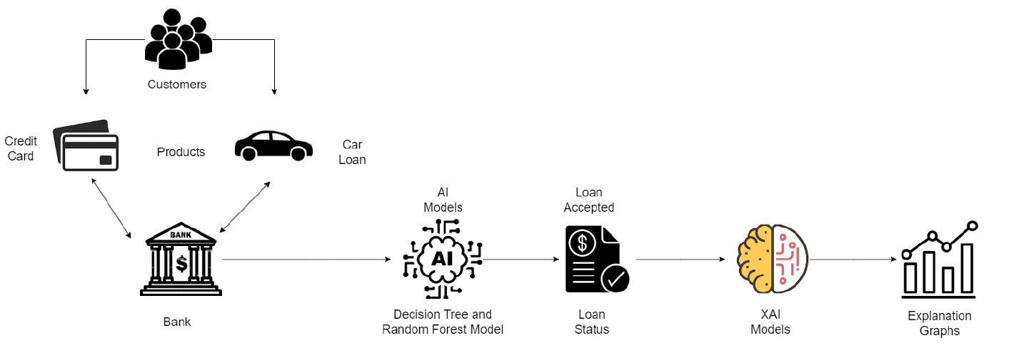

Figure 2.7 Architecture of XAI-driven Credit Risk Assessment (Nallakaruppan et al., 2024)

#### Related Work of XAI in Credit Assessment

Patil et al. (2024) used Logistic Regression, Random Forest, XGBoost, LightGBM, and Artificial Neural Networks to conduct credit risk analysis on a real-world dataset. SHAP and LIME are implemented to determine which features significantly affected the loan approval decisions produced by those ML models. XAI demonstrated the ability to achieve balance in accuracy and interpretability in credit risk decision making.

Bussman et al. (2020) employed Logistic Regression and XGBOOST in predicting credit risk of borrowers in a proposed peer-to-peer lending system on a sample of 15,000 SME companies. SHAP is applied to explain the loan decisions made by the ML models. Shapley values are effective in improving transparency and explainability of complex ML models for credit risk assessment while improving prediction accuracy, but they might face technical limitations when applied to larger datasets which typically used by financial service providers.

Misheva et al. (2021) implemented LIME and SHAP in the prediction output from a ML-based credit scoring model and utilised ML models like Neural Networks, SVM, Random Forest, XGBOOST and Logistic Regression. Both techniques provide consistent explanations in line with financial logics. SHAP values stood out as the most robust and effective techniques in explaining the importance of the model’s different features. Due to the high computational cost, SHAP may take a long time to generate the values in the case of many features.

Ariza-Garzón et al. (2020) employed SHAP values to address the lack of explanatory power in high-performing ML algorithms, including Logistic Regression, Decision Tree, Random Forest and XGBOOST in credit risk models for P2P lending. SHAP values enabled identification of aspects of the relationship between each feature and target variable that overlooked by linear models by offering graphical representation such as curved relationships, structural breaks, heteroscedasticity and outlying behaviour.

Davis et al. (2022) implemented LIME, SHAP and Diverse Counterfactual Explanations (DiCE) in explaining the ML output from home equity credit risk predictions using real-world dataset. ML algorithms used include neural networks, random forest, inductive logic programming and optimal trees. Results highlighted with appropriate XAI approaches, black-box models could provide more trustable explanations on how the decisions are made, offering insights into feature importance, model behaviour under various conditions, and potential biases in credit risk modelling.

### Limitations of XAI

#### Trade-off between Complexity and Explainability

Complex models often excel at uncovering hidden patterns in data and achieving higher prediction accuracy (Ndungula, 2022). Model’s explainability and prediction accuracy are usually in inverse relationship; the higher the predictability, the lower the explainability (Xu et al., 2019). This could hinder the XAI’s adoption and utility, especially in fields like healthcare and finance where interpretability is paramount. Overly simplistic explanations can be distrusted by users, while excessively complex explanations can be incomprehensible for non-experts (Abusitta et al., 2024). The challenge is addressed by exploring hybrid models to balance trade-off and post-hoc explanations to simplify complex model behaviours.

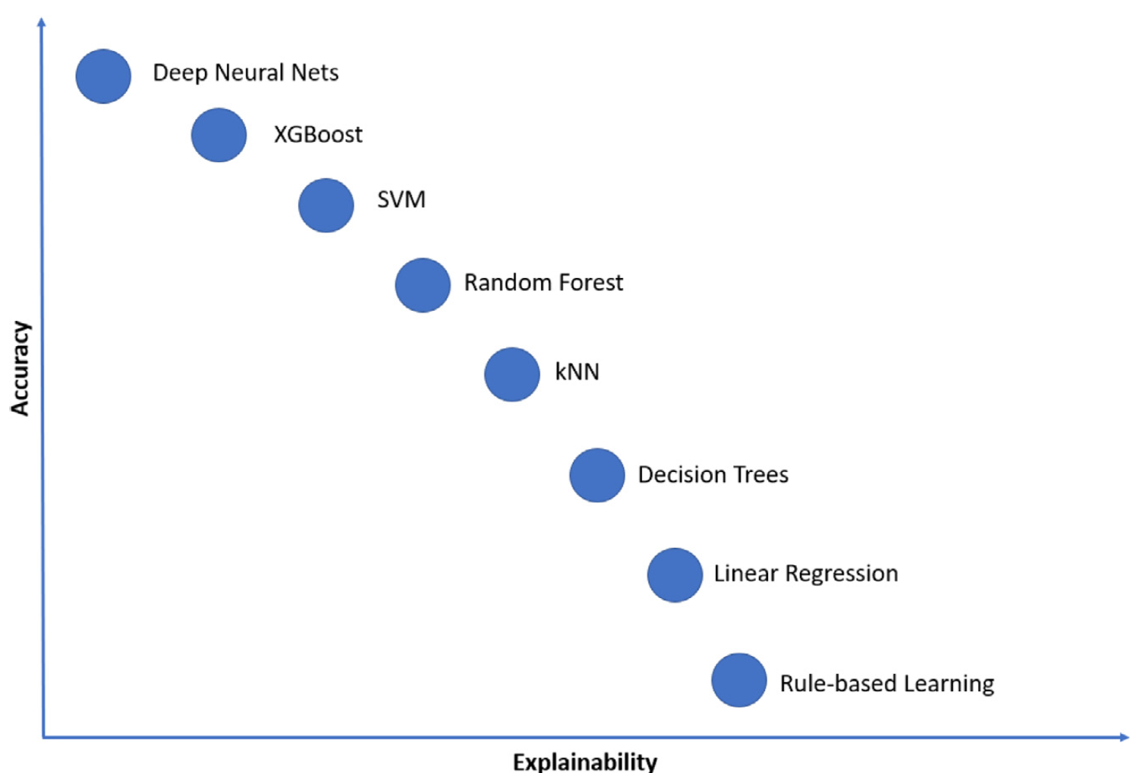

Figure 2.8 Trade-off between Accuracy and Explainability (Abusitta et al., 2024)

# Requirements

This section emphasised on the identification and description of the type of users and key requirements of the XAI credit assessment system.

## User Stories

Users that involved in the XAI Loan Credit Assessment System are loan borrowers, loan officers, AI Engineer, and Administrator. The user stories are structured in table 2 below.

|  |  |
| --- | --- |
| **User Role** | **User Story** |
| Borrowers | *As a* **Borrower**, I *want to …*   * Apply for loan * Track loan application status * Receive explanations for AI loan decisions * Raise a dispute against the AI loan decision |
| Loan Officers | *As a* **Loan Officer**, I *want to* …   * Review loan application details and explanatory reports * Check loan application records * Override the predicted loan decisions if necessary |
| AI Engineer | *As an* **AI Engineer**, I *want to* …   * Manage ML models and upload new models * Evaluates the results of AI decisions and explanatory reports * Monitor AI model performance and accuracy |
| Administrator | *As an* **Administrator**, I *want to* …   * Manage users’ accounts and roles * Monitor system activities |

*Table 2 : User Stories of XAI Credit Assessment System*

## Requirement Engineering

### MOSCOW

According to Ahmad et al. (2017), requirement engineering is the process of determining the functional (FR) and non-functional (NFR) requirements of software to meet stakeholder needs. MoSCoW is a prioritisation approach to determine which requirements yield to the most optimal return. It is categorised into:

|  |  |
| --- | --- |
| **Priority** | **Explanation** |
| 1. Must Have | Critical features that compulsory to be implemented for successful project |
| 1. Should Have | Important requirements that are not critical but could provide significant value to the project |
| 1. Could Have | Non-essential features that would enhance the project, they are implemented only if there are extra time and resources |
| 1. Won’t Have | Features that are not planned for the current development but may be considered for future implementation |

*Table 2: MosCow Priority Level*

### Functional Requirements

Functional requirements specify what a system must do to achieve its goals. They describe the system’s core operations, such as input, processing, and output.

|  |  |  |  |
| --- | --- | --- | --- |
| **ID** | **Priority** | **Description** | **Rationale** |
| FR-01 | MUST | Distinguish between borrowers and lenders/staffs, providing appropriate access, workflows, and interfaces based on different type of users. | Ensure that users interact with the system based on their role, preventing unauthorized access |
| FR-02 | MUST | Allow borrowers to input personal and financial details in the form. | Enables borrowers to provide necessary financial information for accurate credit assessment |
| FR-03 | MUST | Allow borrowers to submit loan applications with all required personal and financial details. | Facilitates loan processing by collecting complete borrower information for AI-based evaluation |
| FR-04 | MUST | Validate borrower’s input data to ensure completeness and correctness before being processed by AI models. | Prevents errors, missing information, and inaccurate predictions by ensuring high-quality input data |
| FR-05 | MUST | Preprocess the borrower’s input data to be readily used by the machine learning model. | Ensures the data is clean, consistent, and properly formatted, enabling the machine learning model to make accurate and reliable predictions. |
| FR-06 | MUST | Make automated lending decision (approve / reject) using machine learning model | Automates decision-making to improve efficiency and reduce human biases in loan approvals. |
| FR-07 | MUST | Implement XAI models to provide explainability for the model predictions | Enhances transparency and trust in AI-driven decisions by allowing stakeholders to understand how predictions are made |
| FR-08 | MUST | Present the lending decision whether is approved or rejected to the borrowers | Ensures borrowers receive timely updates on their application status. |
| FR-09 | MUST | Provide explanations of the lending decision to borrowers by presenting in an interpretable manner using graphs, tables, and charts. | Advocate transparency and help borrowers understand the reasoning behind AI-based lending decisions |
| FR-10 | MUST | Generate detailed and insightful analysis dashboard and explanatory insights to lenders/staff. | Empowers banking officers with a comprehensive view of borrower risk profiles for informed decision-making. |
| FR-11 | MUST | All submitted applications and records must be stored securely in the database. | Ensures data integrity, security, and compliance with financial regulations. |
| FR-12 | SHOULD | Loan officers must be able to override the approval and rejection decision in case of any misjudgement of the AI models | Provides human oversight to correct AI misclassifications and ensure fair outcomes |
| FR-13 | SHOULD | Include user management module (CRUD) for administrator to add, edit, or remove users’ data | Allows administrators to maintain and update borrower records efficiently. |
| FR-14 | SHOULD | Allow staff to filter and sort the loan application records | Improves data accessibility and enhances decision-making by allowing staff to focus on specific risk categories. |
| FR-15 | SHOULD | Allow borrowers to raise a dispute if the automated loan decision is unsatisfactory | Provides borrowers with an opportunity to clarify loan decisions and explore alternatives. |
| FR-16 | COULD | Allow AI Engineers to update and manage ML models through the GUI. | Enables ML model version control |
| FR-17 | COULD | Enable comparison of borrowers' credit scores against benchmarks or industry averages. | Helps lenders assess borrower risk in the context of industry trends and standards. |
| FR-18 | COULD | Allow lenders to export loan data in various formats such as CSV or PDF | Supports record-keeping, reporting, and external analysis needs. |
| FR-19 | COULD | The system could allow users to securely recover forgotten passwords and change their existing passwords. | Enhances user experience and security by enabling users to regain access and manage their credentials independently. |
| FR-20 | WON’T | For current state, the system doesn’t support Natural Language Processing on the uploaded documents from borrowers | NLP integration is out of scope for now due to complexity and resource constraints. |
| FR-21 | WON’T | For current state, the system will not include real-time communication with financial institutions for loan disbursement. | Loan disbursement processing is out of current system’s scope and handled externally. |
| FR-22 | WON’T | For current state, the system will not include a live AI chatbot | Chatbot features is not a priority in the initial development phase. |

*Table 3: Functional Requirements*

### Non-Functional Requirements

Non-functional requirements focus on the quality and performance of the system rather than its operations. They address aspects like usability, reliability, scalability, and security.

|  |  |  |  |
| --- | --- | --- | --- |
| **ID** | **Priority** | **Description** | **Rationale** |
| NFR-01 | MUST | GUI must be intuitive and user-friendly, adhering to usability best practices. | Ensure the ease of use for all users |
| NFR-02 | MUST | The results and explanatory reports must be easy comprehensible to all user types regardless of technical or non-technical. | Make AI-driven decisions understandable for all users to enhance trust and transparency |
| NFR-03 | MUST | Provide robust error handling and display meaningful error messages to users. | Improve system reliability by helping and guiding users resolve issues without confusion |
| NFR-04 | MUST | Comply with GDPR and UK financial regulations for data privacy. | Ensure legal compliance and protects user data from unauthorized access. |
| NFR-05 | MUST | The system must ensure that the explainability module outputs are clear and easily interpretable by non-technical users like borrowers. | Support XAI principles by ensuring that loan decisions are transparent and understandable. |
| NFR-06 | MUST | The system must accurately display all applicants' data without omissions or duplication | Prevent data inconsistencies that could affect decision-making and reporting. |
| NFR-07 | MUST | The system must produce consistent predictions when the same input data is provided multiple times | Ensure reliability and fairness in AI-driven credit assessments. |
| NFR-08 | MUST | The machine learning model must achieve a prediction accuracy of at least 90% based on test data. | Guarantee a minimum level of accuracy to ensure reliable credit risk assessments. |
| NFR-09 | MUST | The system must maintain a decision-making accuracy rate of at least 90%. | Ensure that AI-based lending decisions are precise and trustworthy. |
| NFR-10 | SHOULD | Compatible with major browsers, such as Chrome, Edge, Safari, and Firefox | Improve accessibility and ensures usability across different platforms. |
| NFR-11 | SHOULD | Support both desktop and mobile devices with a responsive design | Enhance user experience by allowing access from multiple devices. |
| NFR-12 | SHOULD | The system should be modular, allowing easy addition of new features. | Ensure flexibility for future system enhancements. |
| NFR-13 | COULD | |  | | --- | |  |   The system could support integration with email and SMS gateways for notifications. | Improve customer communication by notifying users about loan status updates. |

|  |
| --- |
|  |

*Table 4: Non-Functional Requirements*

## UML Diagrams

Siau and L (2001) emphasised UML diagrams help in providing clear visual presentation of system interactions and understanding to system requirements. They act as communication bridge between stakeholders and developers by providing a common language for communication.

### Use Case Diagram

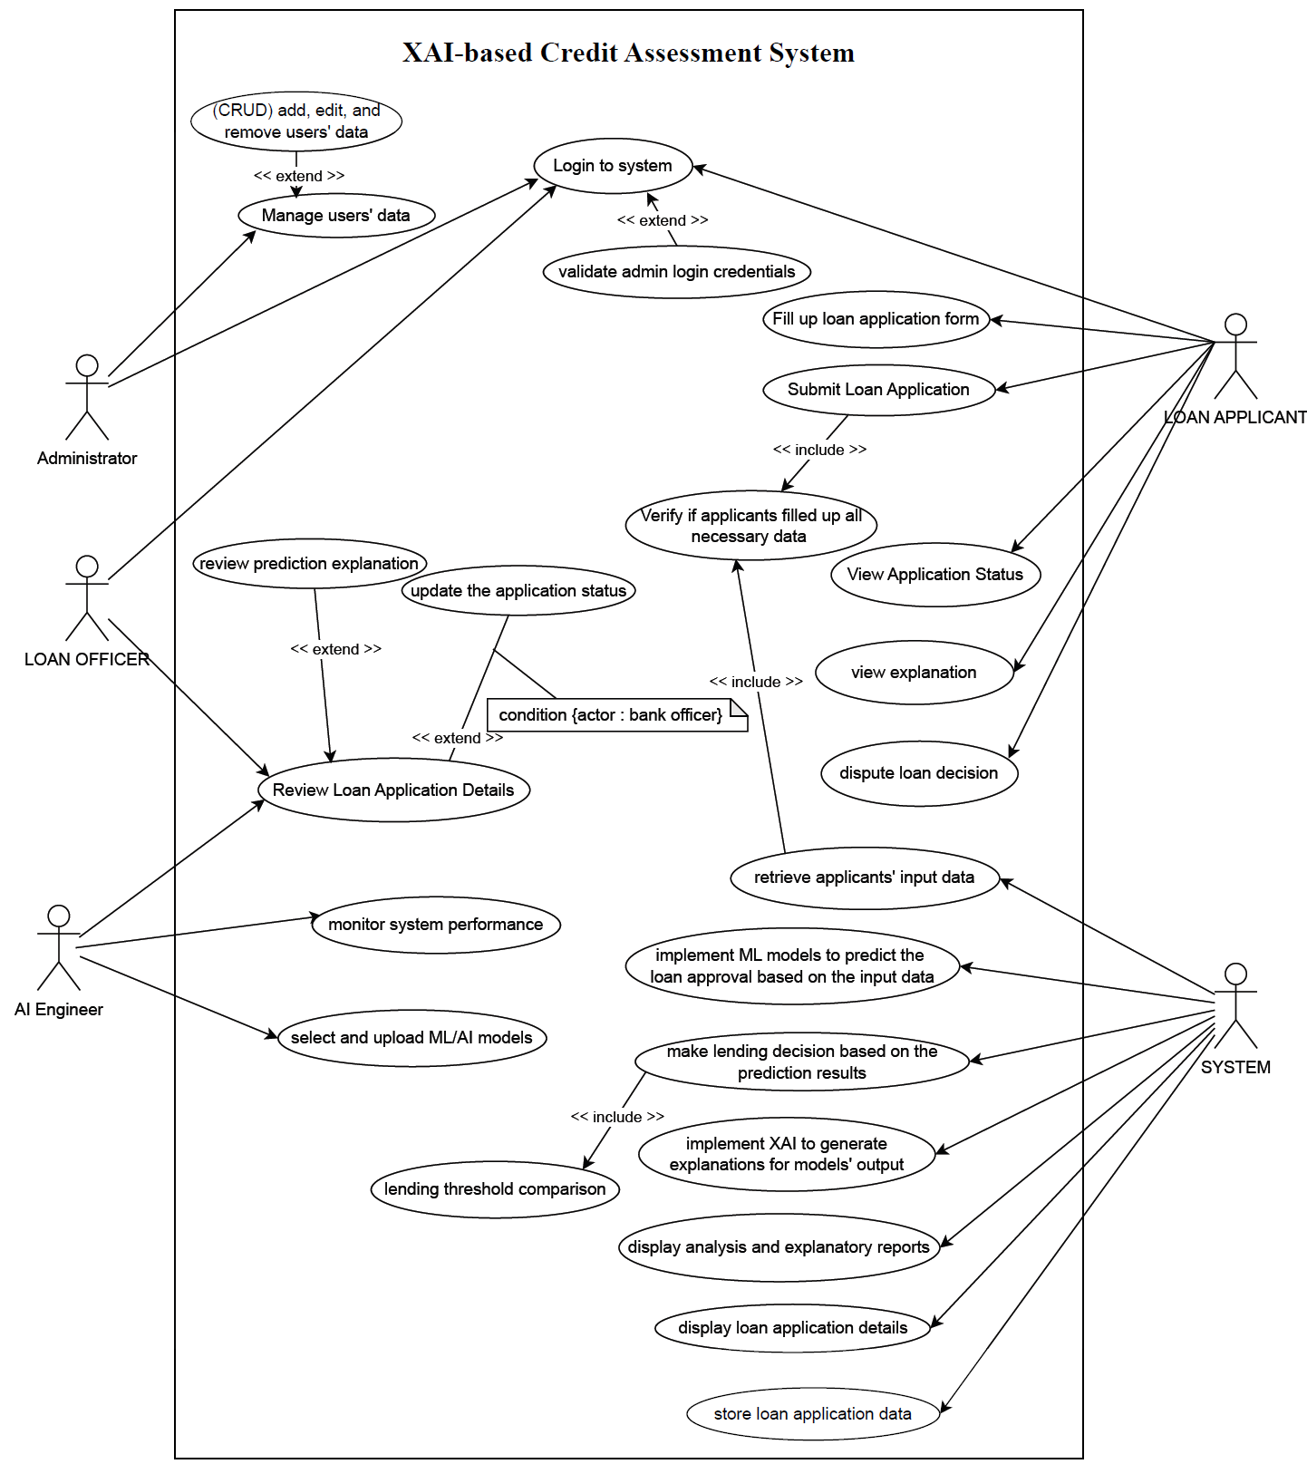

Figure 3.1 Use Case Diagram

### Activity Diagram

1. Activity Diagram 1: Borrower Submitting a Loan Application

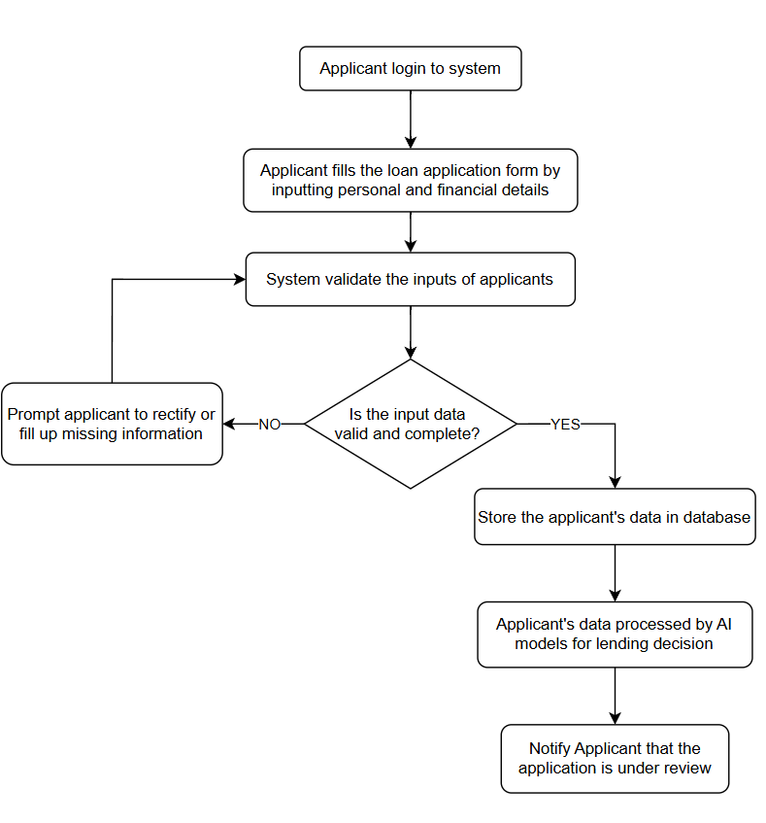

Figure 3.2 Activity Diagram 1

1. Activity Diagram 2: Machine Learning Workflow for Credit Scoring

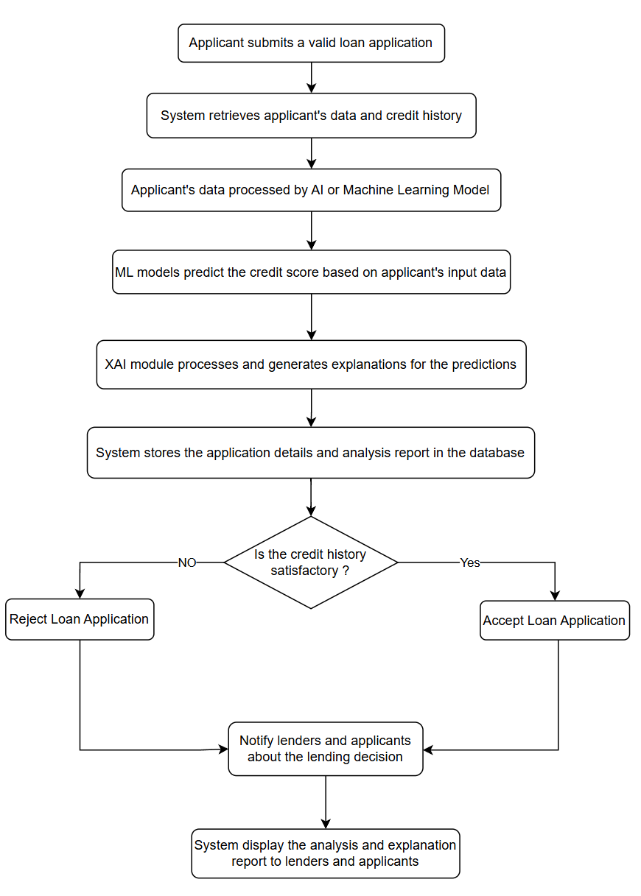

Figure 3.3 Activity Diagram 2

1. Activity Diagram 3: Lender Reviewing the decision of a Loan Application

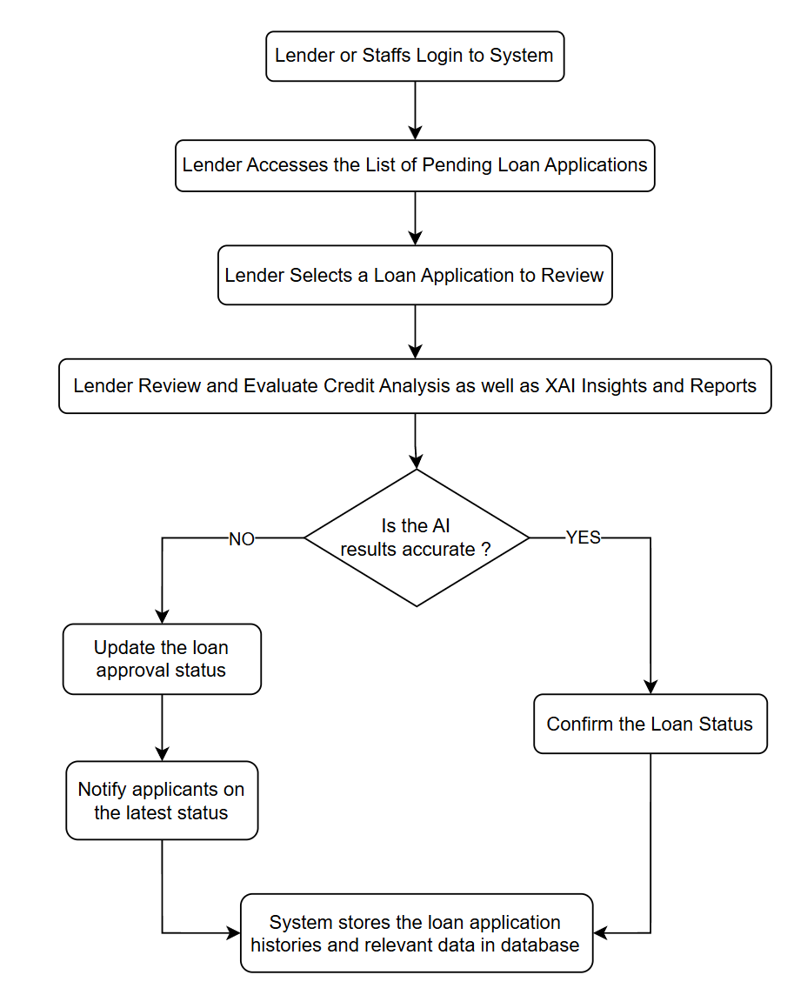

Figure 3.4 Activity Diagram 3

# 4.0 Methodology

This section explains the approaches used in the project development: Agile Software Development and Scrum framework, as described in *Software Engineering* by Sommerville (2016).

## Agile Software Development

### Concept

Agile is an iterative software development framework that breaks projects into manageable phases and emphasizes continuous collaboration, flexibility and improvement (Naidu, 2024). It enables user-centered development, ensures continuous adaptability, and facilitates incremental delivery through sprints.

Agile Manifesto by Beck et al. (2001), outlined four core values:

1. **Individuals and Interactions** over Processes and Tools
2. **Working Software** over Comprehensive Documentation
3. **Customer Collaboration** over Contract Negotiation
4. **Responding to Change** over Following a Plan

### SCRUM

Abrahamsson et al. (2002) discussed Scrum is an Agile framework that enhance collaboration, adaptability, and iterative development. It structures work into short development cycles called sprints, ensuring continuous progress and frequent delivery of working software.

Scrum defines three key roles. **Product Owner** is responsible for defining the system vision, prioritizing backlog items, and ensuring that the development aligns with business objectives. The **Scrum Master** facilitates the Scrum process, removes obstacles, and ensures adherence to Agile principles. The **Development Team** collaborates to build, refine, and enhance the system throughout the development lifecycle.

Scrum follows a structured process involving essential events. **Sprint Planning** defines the tasks to be completed in the upcoming sprint. **Daily Scrum** meetings help the team track progress, discuss challenges, and align goals. **Sprint Review** provides an opportunity to present completed work and gather stakeholder feedback, while the **Sprint Retrospective** focuses on evaluating the sprint's effectiveness and identifying areas for improvement.

Key Scrum artifacts include the **Product Backlog**, which lists all system features and improvements, the **Sprint Backlog**, which outlines tasks for the current sprint, and the **Increment**, which represents a working version of the system. These components ensure an organized and transparent development process, allowing for continuous refinement and alignment with project objectives.

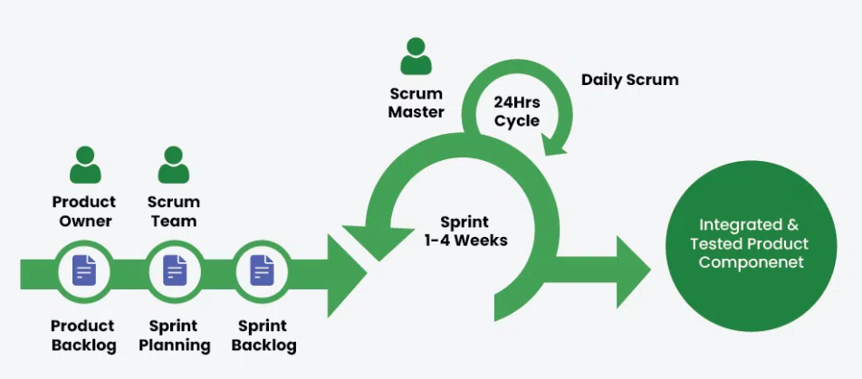

Figure 4.0.1 Scrum Cycle (GeeksforGeeks, 2023)

## Justification

Agile methodology is preferrable for my project development due to its structured and flexible approach. It allows me to break the project into manageable tasks, ensuring stable progress. First, Agile emphasises on continuous feedback. By working in sprints, I can regularly incorporate my supervisor’s feedback, refining the system incrementally rather than making last-minute revisions, which aligns with academic expectations. Agile supports self-management by providing clear workflows through defined sprints and backlog, facilitating the systematic development of machine learning models, explainability features, and the GUI while effectively tracking progress. The iterative nature of Agile is crucial for refining both ML and XAI models throughout the development process. By testing different algorithms, adjusting hyperparameters, and validating performance in multiple sprints, I can systematically identify and select the most optimal models for deployment. This ensures that my credit assessment system remains accurate, reliable, and aligned with project requirements and objectives. Lastly, Agile helps me stay organized and meet deadlines by structuring development into focused cycles. This approach ensures a well-documented project that balances predictive performance with explainability.

## Sprint Planning

Sprint is a time-boxed development cycle in Scrum, typically lasting between one to four weeks. Each sprint begins with planning and ends with a review to evaluate progress and gather feedback. Sprint’s iterative nature ensures continuous improvement, allowing adjustments based on new insights and evolving requirements (Abrahamsson et al., 2002). In this project, sprints enable incremental enhancements in ML model performance, explainability features, and overall system usability.

|  |  |  |  |
| --- | --- | --- | --- |
| **Sprint** | **Sprint Goal** | **Key Tasks** | **Deliverables** |
| **1** | ML and XAI Service  Development | * Data Collection and Preparation * Exploratory Data Analysis (EDA) * Data Preprocessing * ML Model Training & Evaluation * Model Serialization * ML and XAI Deployment | * Well-trained and serialized ML models * Ready-to-use ML and XAI service API |
| **2** | Django Base Architecture Setup and Admin Functionality | * Database and settings configurations * Django backend framework (REST API, routing, etc) * Authentication and role-based control * Docker containerization * Develop user management functionality * Initial Interface Structure setup * Develop admin UI | * Dockerized Django Application * Core Django backend configurations * Initial front end interface structure * Authentication and role control system * Admin user management functionality * Admin UI |
| **3** | Loan Applicant and Loan Officer Functionality | * ML and XAI Service Deployment * Develop loan application and dispute system functionality * Integrate deployed ML prediction service and XAI explanations * Develop loan records management functionality * Create related frontend UIs | * End-to-end loan application workflow * Integrated ML predictions and XAI explanations services * Loan records management * Loan Applicant and loan officer UIs |
| **4** | AI Engineer Functionality  and System Deployment | * Develop ML model management functionality * Develop view loan records functionality * Develop frontend UI for AI Engineers | * ML models management functionalities * AI Engineer UI |

*Table 5: Sprint Planning*

## Project Timeline and Planning

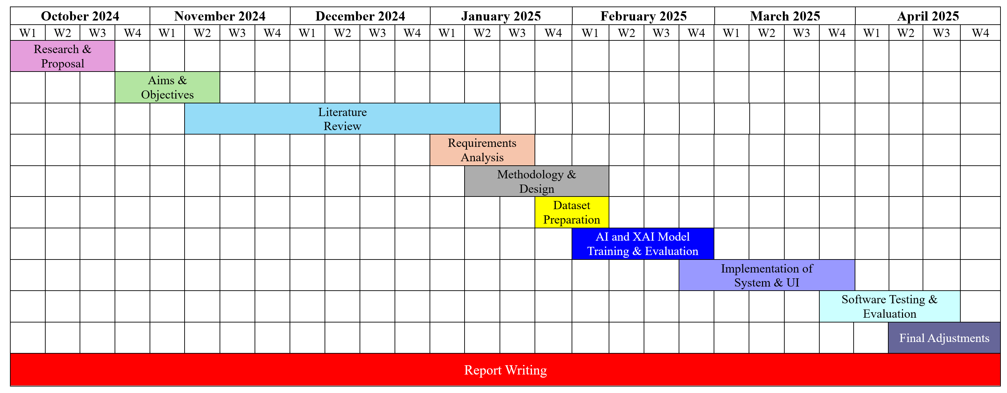

Figure 4.0.2 Project Gantt Chart

# 5.0 Design

## 5.1 High-Level Design

### 5.1.1 System Architecture

System architecture diagram provides an overview of components and their interactions within a system. features a web-based front end that provides users (loan applicants, loan officers, AI engineers, and administrators) with role-based dashboards, loan application forms, prediction results with explanations, record management system, and profile settings. User requests are handled by the back end, which manages users, ML models, prediction records, and authentication, while interacting with a database that stores user data, predictions, explanations, loan applications, ML models, and staff activity. The back end calls a dedicated ML service API responsible for ML models loading, data preprocessing, predictions, and SHAP explanations by utilizing models stored or uploaded in a file storage system. This architecture ensures secure, explainable AI-driven automated loan decision-making with comprehensive recordkeeping and model management.

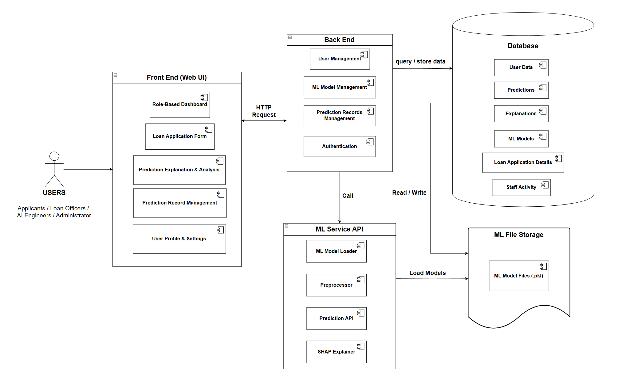

Figure 5.0.1 System Architecture

### 5.1.2 User Interface Design

This project aims to develop a comprehensive user interface of a web application. Figure 5.2 demonstrated the initial layout of some important interfaces. Firstly, users will see the homepage. Each of the user types (applicants, loan officers, administrators or AI engineers) will have their own dashboard with buttons that direct to different pages of functionalities after logging into the system. Loan applicants will be directed to a prediction form page, and then will be directed to the prediction results and explanation page with a loan confirmation section. The main interface for loan officers is an loan records management page to manage or override the loan decisions. AI Engineers will have a ML model management page to set a selected model as active or upload a newly trained model and also a similar records management page to view the loan records.

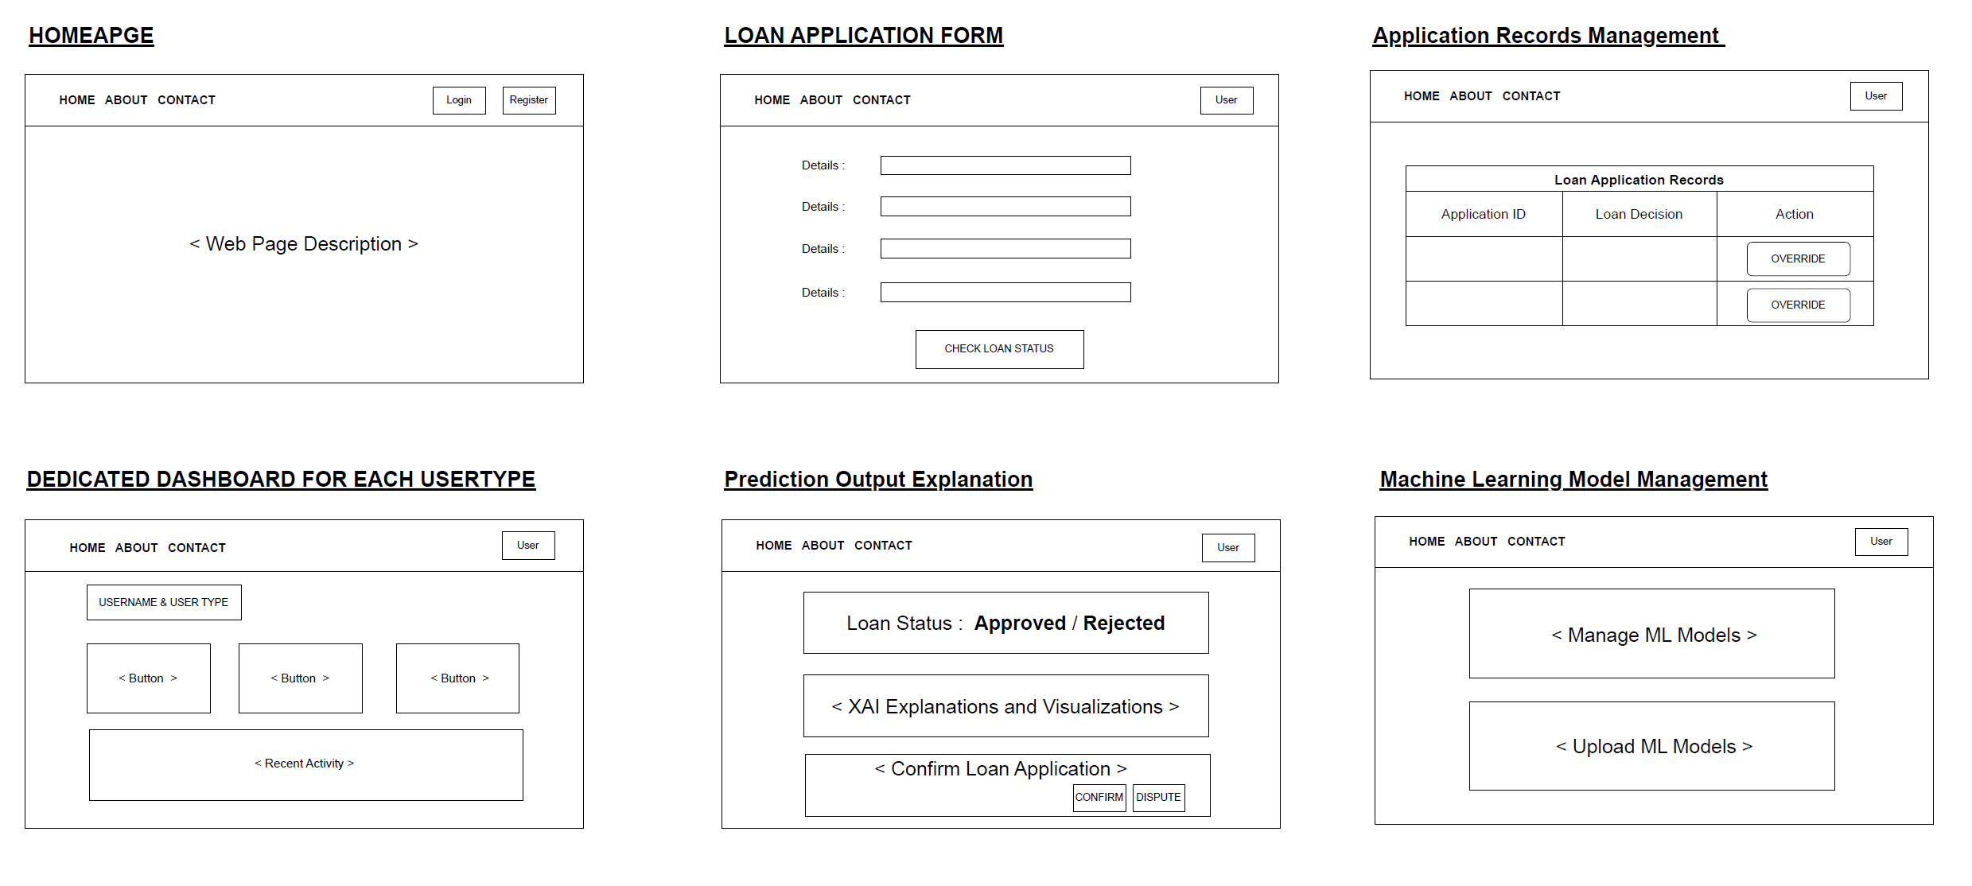

Figure 5.0.2 User Interface Designs (Wireframe)

### 5.1.3 Database Design

Figure() below shows the anticipated database architecture for the system to support robust user management, model versioning, application processing, and XAI-driven predictions. The core entities include User, MLModel, LoanApplication, Prediction, Explanation, and StaffActivity. Users can submit loan applications and receive predictions with explanations. ML models are versioned and tracked through the MLModel entity, allowing traceability of model usage. Loan applications capture applicants’ details. The Explanation entity stores SHAP values and related interpretability data for each prediction. All staff interventions or overrides are logged in StaffActivity, ensuring an auditable trail. The relationships between these entities enable traceability from user actions through to model predictions and their explanations, supporting both operational needs and regulatory compliance.

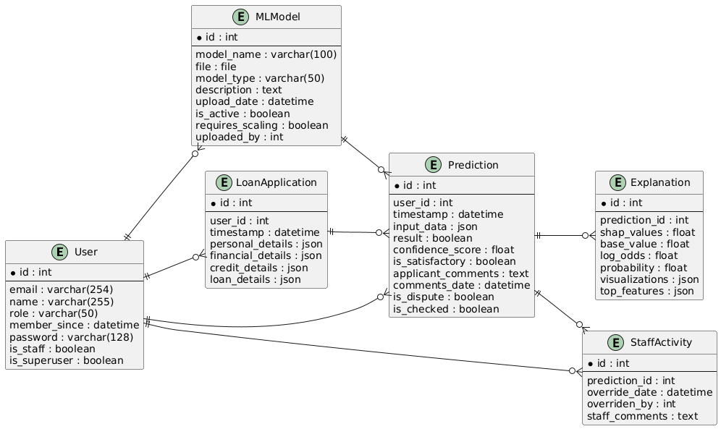

Figure 5.0.3 Database Design – Entity Relationship Diagram

## 5.2 Low-Level Design

### 5.2.1 Class Diagram

The class diagram models the structure and relationships of the key components within the loan credit assessment system. It depicts how users (Admin, Staff, AI Engineer, Loan Applicant) interact with various system modules, such as applying loan, reviewing predicted loan decisions with explanations, and managing loan records, ML models, user accounts, and system activity. The relationships between these classes capture the flow of data and user actions, which support a modular and extensible system design.

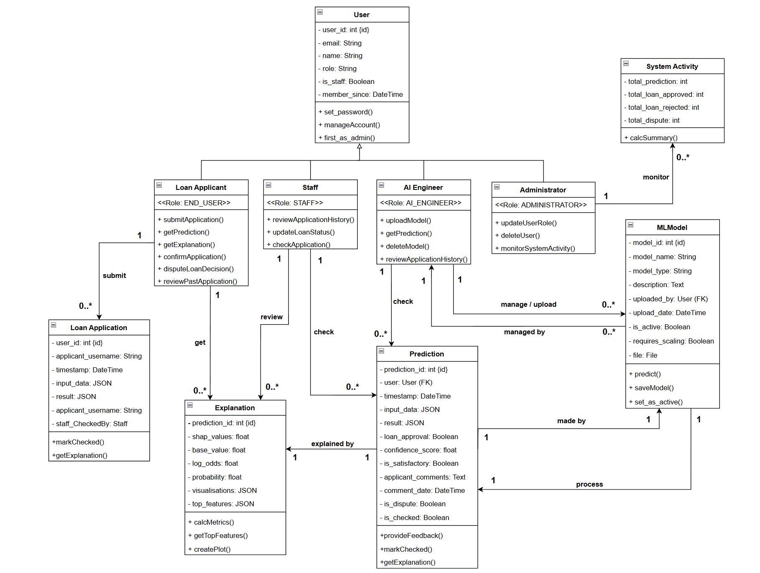

Figure 5.4 UML Class Diagram

### 5.2.2 Sequence Diagram

Sequence diagrams below illustrate the interactions between objects and provide examples of how different types of users interact with the system. They demonstrate how a loan applicant can apply for a loan, view loan decision and explanations, and dispute decisions if necessary; how a loan officer can review applications and their details and override loan decisions; how an AI engineer can perform CRUD operations on ML models; and how an administrator can manage users, roles, and system activities.

#### 5.2.2.1 Loan Applicant

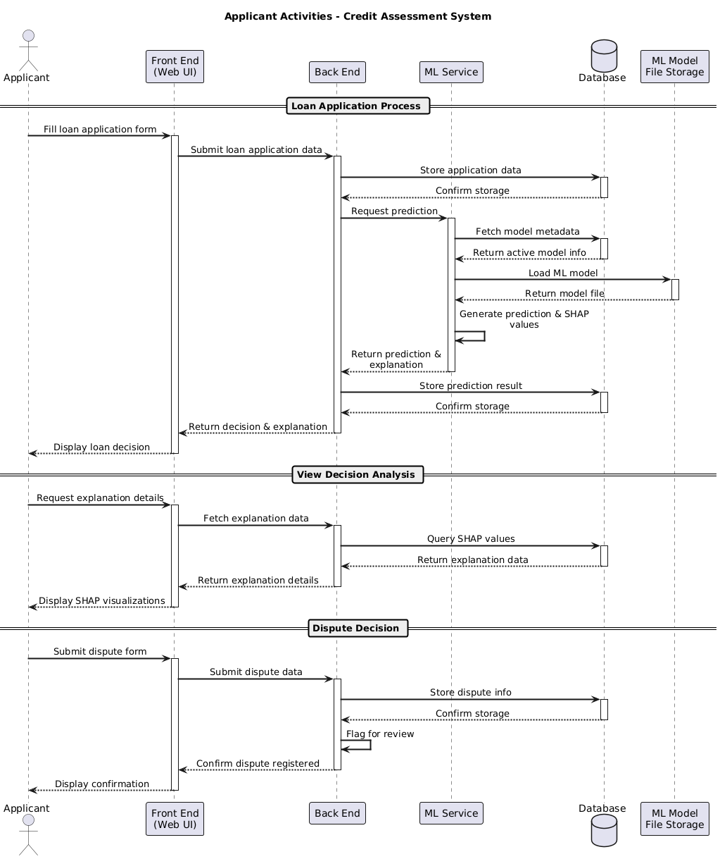

*Figure 5.5 : Sequence Diagram 1 – User Type: Loan Applicants*

#### 5.2.2.2 Loan Officer

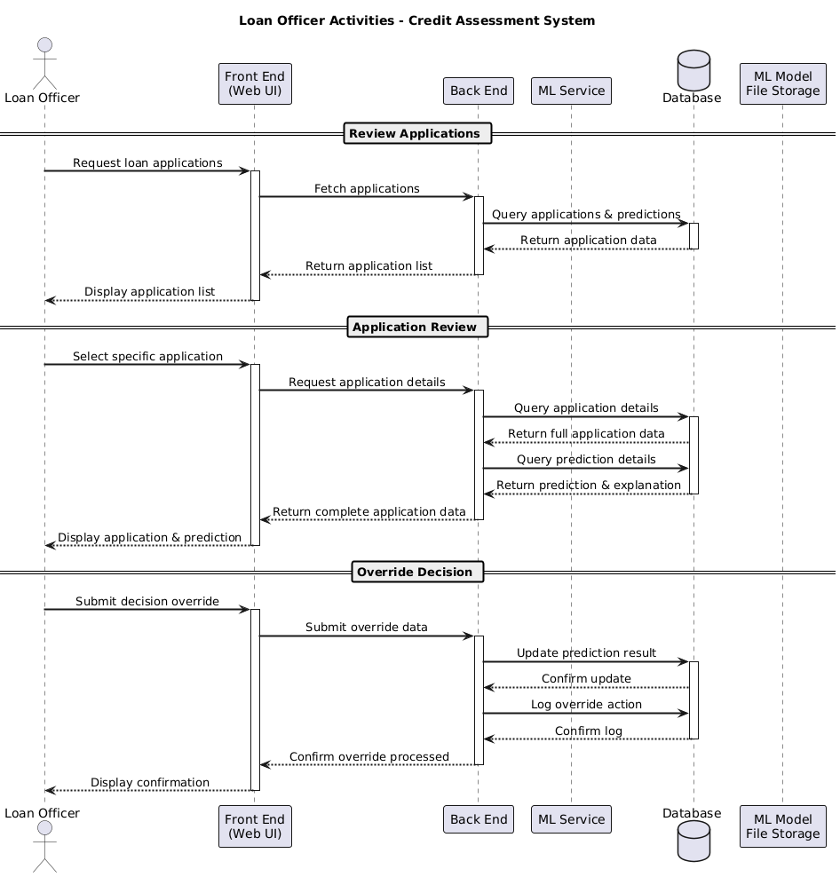

*Figure 5.6 : Sequence Diagram 2 – User Type: Loan Officers*

#### 5.2.2.3 AI Engineer

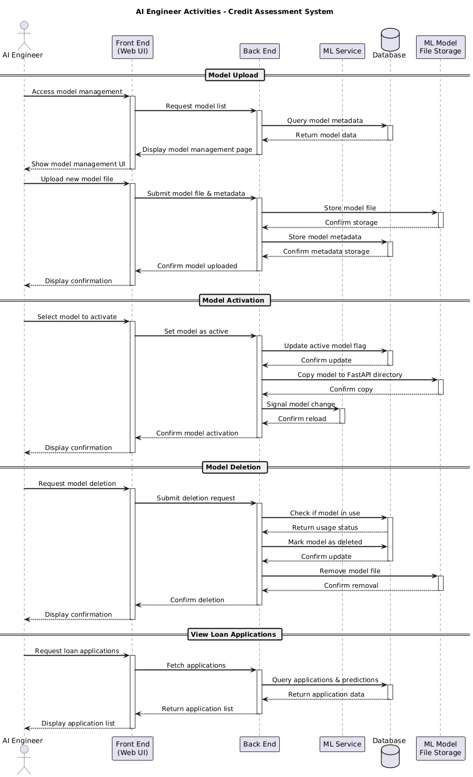

*Figure 5.7: Sequence Diagram 3 – User Type: AI Engineers*

#### 5.2.2.4 Administrator

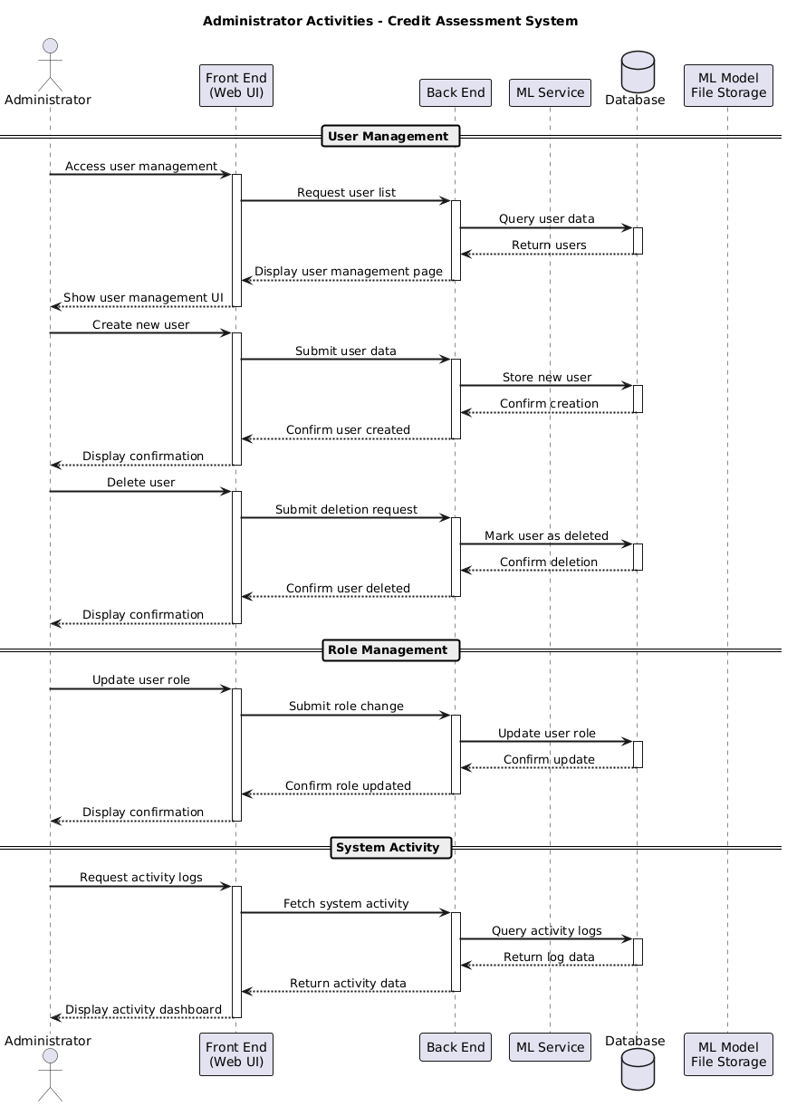

*Figure 5.8: Sequence Diagram 4 – User Type: Administrator*

### 5.2.3 State Diagram

State diagram is used to represent the status of the system, or parts of the system, at specific moments in time. The state diagrams below capture the transitions between various states within the system, focusing on core use cases such as applicants submitting loan applications and receiving prediction results and explanations; loan officers reviewing and validating loan decisions; AI engineers uploading and managing models; and administrators creating new accounts. This diagram provides a clear visualization of how the system responds to different user actions and events.

#### 5.2.3.1 Applicant make loan applications and receive predictions results and Loan Officers review and validating loan decisions

*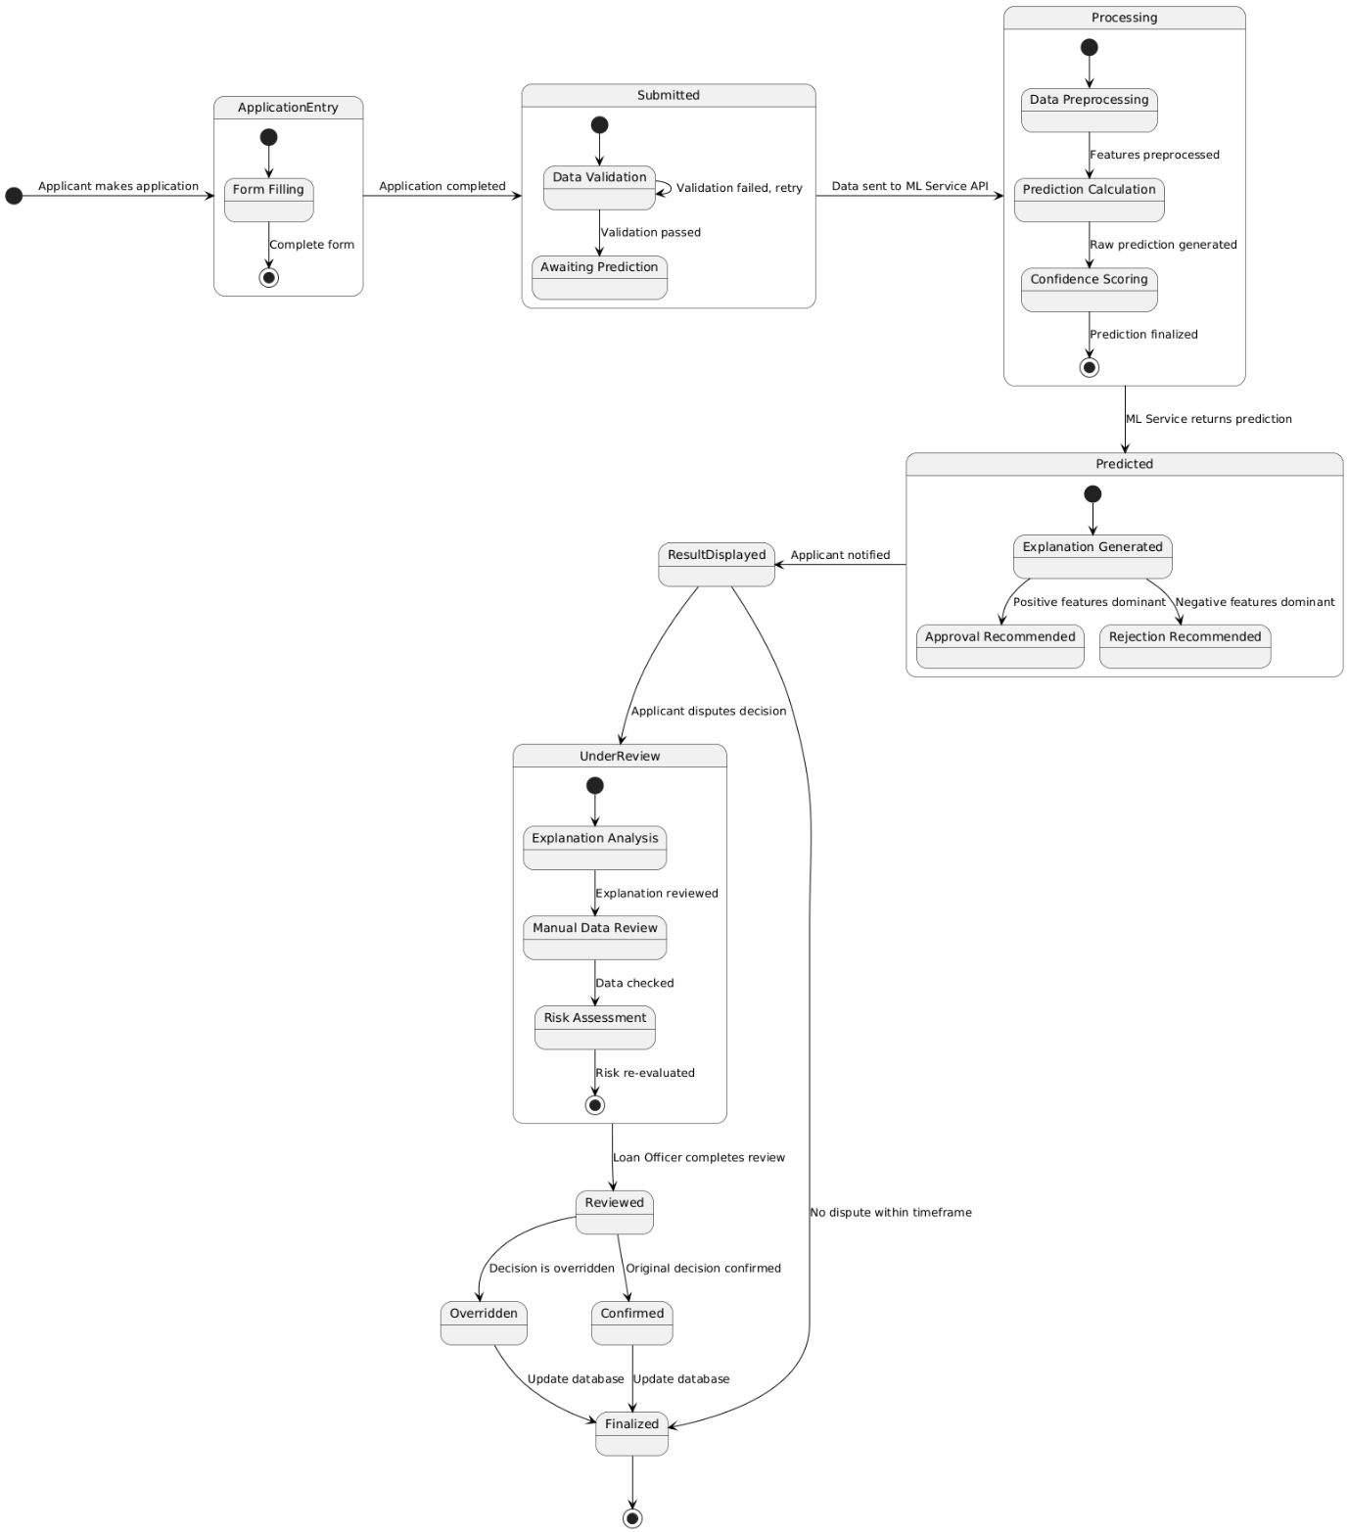 Figure 5.9: State Diagram 1 – Loan Application*

#### 5.2.3.2 AI Engineers upload and manage ML models

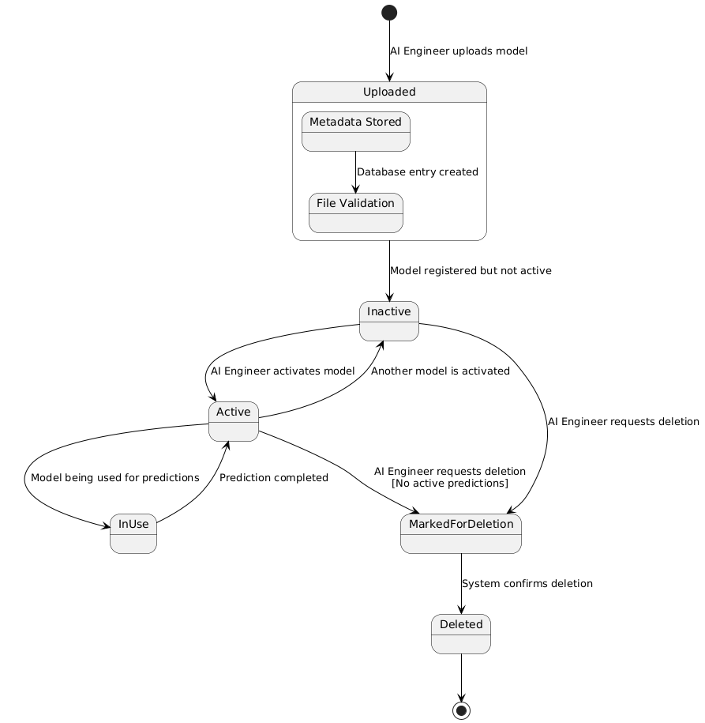*Figure 5.10: State Diagram 2 – AI Engineer Uploads Model*

#### 5.2.3.3 Administrator create and manage user roles

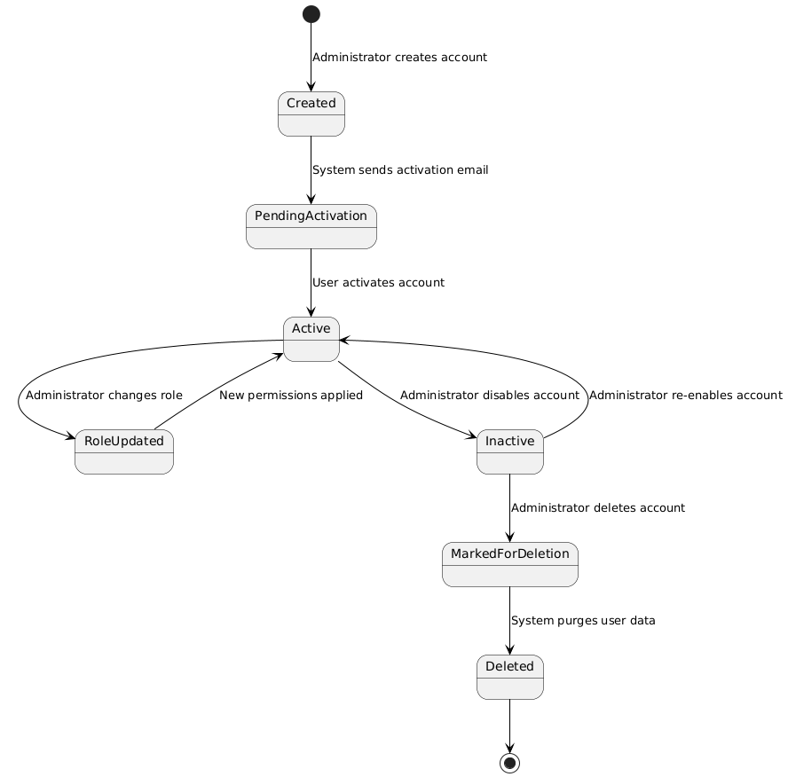 *Figure 5.11: State Diagram 3 –Administrator Creates an Account*

## 5.3 Tools and Framework

The primary programming language used for this project is **Python**, and **Visual Studio Code** serves as the integrated development environment. For the system backend, **Django** is employed as the main web development framework to handle HTTP requests, authentication, define views, URLs routing, and API endpoints implementations. **FastAPI** is used for the machine learning services deployment . **PostgreSQL** is selected as the relational database system for data storage. On the front end, **Bootstrap** and **custom CSS** are utilized to create a responsive layout and provide customized styling and theming for the system**. Jupyter Notebook** within VSCode is used for machine learning workflows. For explainable AI, **SHAP (SHapley Additive Explanations)** is used to interpret prediction outputs. Finally, **Docker** is used for containerizing the system components and streamlining deployment.

## 5.4 SHAP Classification Explanation

To explain a classification prediction, such as whether a loan application is approved or denied, the SHAP (SHapley Additive exPlanations) method is applied to break down the model’s output into comprehensible components that reveal how each input feature contributed to the final decision. SHAP achieves this by first establishing a base value, which is the average prediction of the model for all data points, typically expressed in log-odds for classification problems. For an individual prediction, the method then computes SHAP values for each feature, quantifying how much each one pushes the prediction away from the base value toward either class (approval or denial). The sum of these SHAP values, added to the base value, gives the model’s raw output (log-odds), which is subsequently transformed into a probability using the logistic sigmoid function. This process not only identifies the most influential features for each prediction but also provides a transparent, additive explanation that stakeholders can interpret and trust. The mathematical foundation for this approach, including the additive nature of SHAP values and their transformation from log-odds to probabilities, is thoroughly detailed in the original SHAP paper by Lundberg and Lee (2017), which demonstrates how SHAP values offer a consistent and locally accurate method for attributing contributions to input features in both regression and classification tasks. The official SHAP documentation further illustrates these concepts with practical examples, showing how each prediction can be dissected to show the role of every feature in the model’s output, thereby facilitating fair and interpretable machine learning decisions (Lundberg & Lee, 2017). This robust and interpretable methodology will be adopted in my project to explain the predictions of the classification model, ensuring that each loan approval decision can be justified in a way that is both transparent and understandable to users and stakeholders.

## 5.5 Test Design

The test case template outlined below will be used to systematically record and evaluate each test conducted throughout the project. The complete set of test cases will be included in the Appendix under “Full Test Case” and will be executed at the end of each sprint to ensure system functionality and quality. This structured approach enables comprehensive tracking of testing activities and ensures that all system requirements are thoroughly validated.

|  |  |  |  |  |  |  |
| --- | --- | --- | --- | --- | --- | --- |
| Identifier | Description | Input | System State | Expected Result | Actual Result | Pass / Fail |
|  |  |  |  |  |  |  |

*Table 6: Test Case Template*

# Implementation

This section discusses the implementation of the sprint planning table described in 4.3, including any challenges encountered and the solutions applied. The system is implemented part by part, with each phase focusing on a specific user type and their related functionalities. For every part, the frontend and backend are developed simultaneously.

## 6.1 SPRINT 1 – ML and XAI Development

### 6.1.1 Machine Learning

There are some essential libraries utilized. **Pandas** and **NumPy** are used for data organization, cleaning, and manipulation. **Matplotlib** and **Seaborn** provide visualization of data and model results. **Scikit-learn** supplies tools for preprocessing, building, training, and evaluating machine learning models. Specialized frameworks such as **LightGBM**, **XGBoost**, and **CatBoost** deliver efficient gradient boosting, and **TensorFlow/Keras** supports deep learning model development. **SHAP** is utilized for interpreting model predictions, and **Joblib** ensures efficient saving and loading of trained models.

#### 6.1.1.1 Data Preparation

The selected dataset, “Financial Risk for Loan Approval,” is sourced from Kaggle. It is a synthetic dataset which contains 20,000 instances with 36 columns. This dataset offers a rich set of features encompassing demographic data (such as age, gender, marital status), financial characteristics in USD (annual income, credit score), employment details (employment type, years employed), and historical credit information (previous defaults, number of open loans). The dataset’s size and diversity provide a robust foundation for training and evaluating machine learning models. The primary objective of this dataset is to serve for classification problem, which is to predict the binary target variable, loan approval status, which indicates whether an applicant’s loan application is likely to be approved (1) or rejected (0). This allows for the development of data-driven risk assessment models that can support automated, fair, and transparent lending decisions.

I faced challenges in obtaining a real-world historical loan dataset with adequate number of instances from the UK, primarily due to strict data privacy regulations and the sensitive nature of financial and loan information. These privacy concerns and legal restrictions significantly limit the public availability of such datasets for research purposes; therefore, I choose to use a synthetic dataset found from Kaggle.

#### 6.1.1.2 Data Preprocessing

Upon analysis, there are some unnecessary columns that were dropped. *Application_Date* is a time-related identifier that does not directly influence approval decisions and could introduce unwanted temporal bias. *Risk_Score*, *Base_Interest_Rate*, *Interest_Rate*, and *Monthly_Loan_Payment* are either derived from the outcome or are determined after the approval decision, meaning they could leak future information to the model. Removing these columns ensures the model predicts approval based only on applicant information available at decision time, preventing data leakage and maintaining the integrity of the prediction process.

In this part, I encountered a data leakage issue. Initially, I performed feature encoding on the entire dataset before applying the train-test split and used the fit_transform method on both the training and test sets for feature encoding and scaling. This approach led to data leakage, as the encoders and scaler inadvertently learned patterns and categories from the test data, causing overly optimistic model performance estimates.

To address this, I revised my workflow by first applying the train-test split and then employing appropriate encoding strategies tailored to each categorical feature. Specifically, I used one-hot encoding for nominal features such as Employment_Status, Marital_Status, Home_Ownership_Status, and Loan_Purpose, transforming each category into a distinct binary vector using scikit-learn’s **OneHotEncoder**.

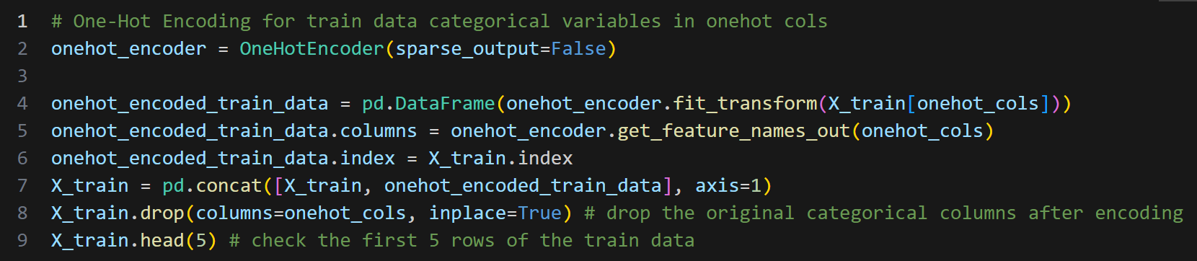

Figure 6.1

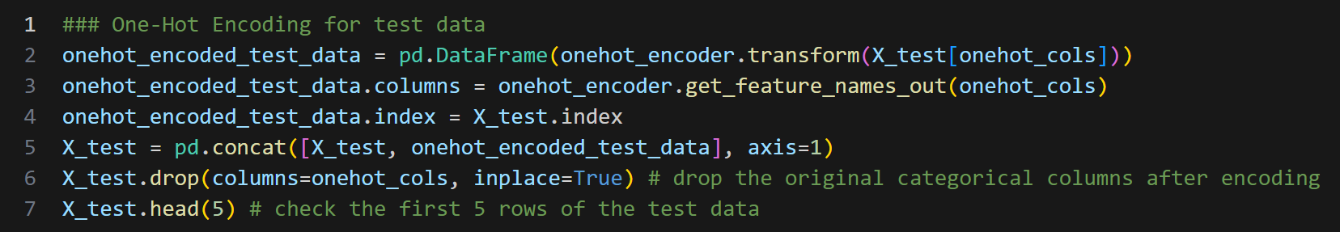

Figure 6.2

For the ordinal feature Education_Level, which has an inherent order, I applied ordinal encoding with **OrdinalEncoder**, mapping categories to ordered integers.

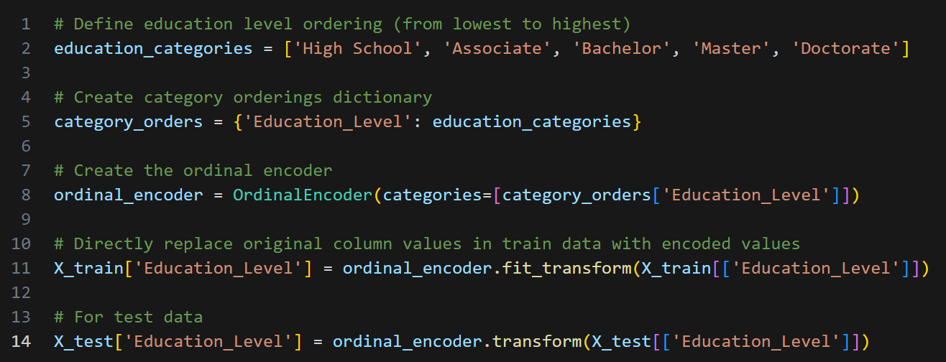

Both encoders were fitted exclusively on the training data using fit_transform, ensuring they learned categories solely from the training set, and then transform on the test data to maintain consistency and prevent any information from the test set from influencing the model. This revised approach eliminated data leakage and ensured a valid and reliable evaluation of model performance. After that, I applied the standardization using **StandardScaler** with the same approach.

#### 6.1.1.4 Model Training

My model training approach followed a two-phase strategy to efficiently identify the best performing model. In the first phase, I trained multiple classification algorithms with their default parameters, including Logistic Regression, SVM, MLP, Decision Trees, Random Forest, XGBoost, LightGBM, CatBoost, AdaBoost, and ensemble methods (Voting and Stacking Classifiers). After evaluating all models on key metrics (accuracy, precision, recall, F1-score, and AUC), I identified the four best performing models: XGBoost, LightGBM, CatBoost, and Stacking classifier. In the second phase, I conducted extensive hyperparameter tuning using RandomizedSearchCV with 100 iterations and 5-fold cross-validation for each selected model, exploring various hyperparameter spaces to optimize performance.

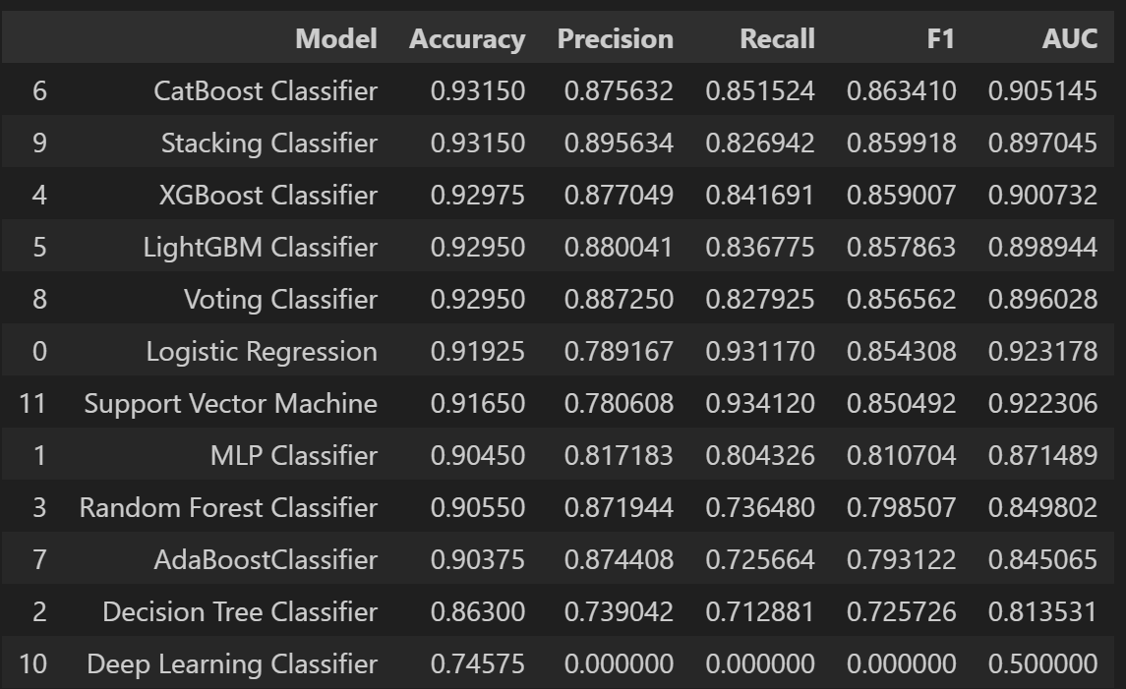

Figure(): Trained Model Performance

#### 6.1.1.5 Model Evaluation and Selection

In the context of loan approval prediction, both false positives (approving a risky applicant) and false negatives (rejecting a creditworthy applicant) have significant consequences for the business. The F1 score is the harmonic mean of precision and recall, providing a single metric that balances both the ability to correctly identify approved applicants (precision) and the ability to capture all actual approved cases (recall). This focus is critical for making fair and responsible lending decisions, where both types of errors are costly. Therefore, F1-score is prioritized when evaluating and selecting the best model.

|  |  |  |  |  |  |
| --- | --- | --- | --- | --- | --- |
| MODEL | **Test Data Performance** | | | | |
| Accuracy | Precision | Recall | F1 | AUC |
| XGBoost Classifier | 0.93550 | 0.894081 | 0.846608 | 0.869697 | 0.906207 |
| LightBGM Classifier | 0.93525 | 0.891529 | 0.848574 | 0.869521 | 0.906687 |
| Stacking Classifier | 0.93525 | 0.894792 | 0.844641 | 0.868993 | 0.905391 |
| CatBoost Classifier | 0.93425 | 0.893528 | 0.841691 | 0.866835 | 0.903749 |

*Table 7: Top Performance model with hyperparameter tuning*

|  |  |  |  |  |  |
| --- | --- | --- | --- | --- | --- |
| MODEL | **10-Fold Cross Validation (Weighted)** | | | | |
| Accuracy | Precision | Recall | F1 | AUC |
| XGBoost Classifier | 0.9284 | 0.8662 | 0.8228 | 0.8437 | 0.9778 |
| LightBGM Classifier | 0.9292 | 0.8660 | 0.8272 | 0.8459 | 0.9786 |
| Stacking Classifier | 0.9304 | 0.8747 | 0.8219 | 0.8472 | 0.9787 |
| CatBoost Classifier | 0.9307 | 0.8747 | 0.8234 | 0.8480 | 0.9787 |

*Table 8: Cross Validation results on the top performance model*

Although the stacked classifier achieved a second high F1 score, I decided not to select it as the final model due to its inherent challenges in explainability. As mentioned in the literature review, the limitation of XAI is the trade-off between model complexity and explainability. Stacked classifiers exist as a complex ensemble whose decision logic is significantly more difficult to interpret. SHAP can provide meaningful explanations for single models, but applying these methods to an ensemble as intricate as a stacked classifier is more complicated, often resulting in explanations that are less intuitive for stakeholders. In the context of credit assessment, regulatory requirements and business needs demand clear, transparent, and easily interpretable model decisions. Therefore, for the sake of accountability and to meet explainability standards, I prioritized **XGBoost**, with **LightGBM** and **CatBoost** as second and third options that offer both strong predictive performance and straightforward interpretability.

#### 6.1.1.6 Model Serialization

Model serialization is the process of converting trained machine learning objects into a persistent file format that can be stored and later loaded for inference in production environments. **Joblib** is utilized to export all selected trained models (XGBoost, LightGBM, CatBoost) along with their associated preprocessing components, including *onehot_encoder*, *ordinal_encoder*, *standard_scaler*, which maintain the exact transformation parameters fitted on the training data. Each component is saved in the Python pickle format (.pkl). During deployment, these serialized artifacts are dynamically loaded into the machine learning service.

### 6.1.2 ML Service Deployment

To deploy the machine learning service, I created a FastAPI directory, with FastAPI and Uvicorn libraries installed, create a FastAPI app, and run it using the uvicorn command.

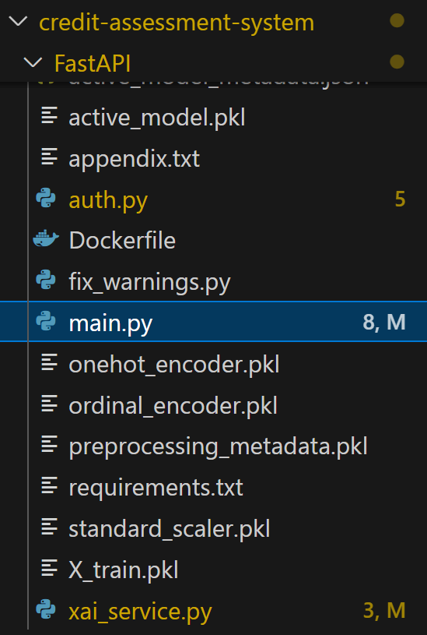

Handle JWT Authentication

XAI Service Functionality

Full ML Service

Handle Errors

Deployed Model (XGBoost Classifier)

First, the ModelManager class will handle handles model loading with thread safety and automatic detection of model updates. If the file name “active_model.pkl” exists or being updated, the model will be loaded using joblib.load to ensure that the latest version of model is used.

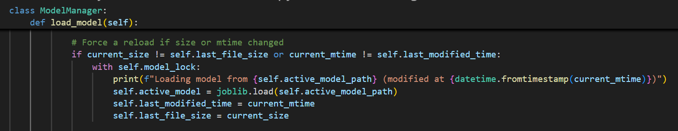

*Figure(): ModelManager class*

All the serialized preprocessors and metadata are loaded.

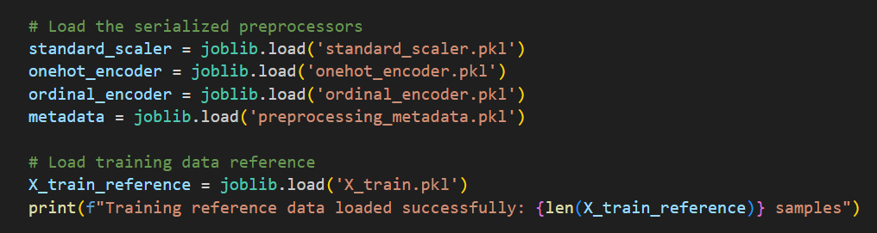

*Figure(): Loaded Preprocessor*

The `PredictionRequest` class is a Pydantic data model that defines and validates the input structure for loan applications. It specifies 30 required fields with their data types, descriptions, and validation constraints. Binary fields like Bankruptcy_History accept both text values ("Yes"/"No") and numeric values (0/1). This structure ensures all prediction requests contain properly formatted data before processing, preventing errors from invalid inputs and providing automatic documentation in the API interface.

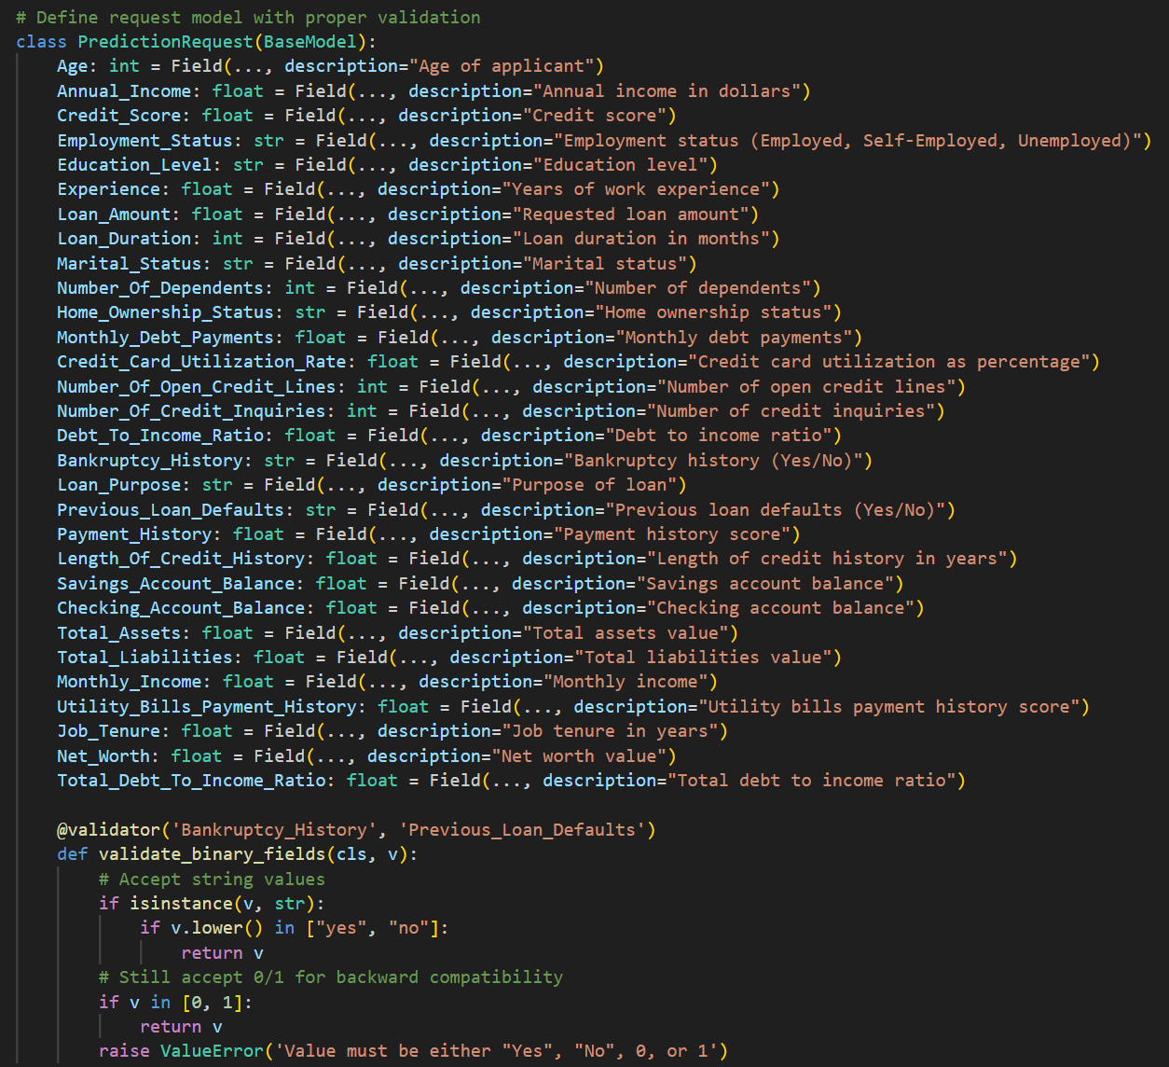

*Figure(): PredictionRequest class*

The preprocess_input function implements a comprehensive data preprocessing pipeline that prepares raw input data for machine learning models. This function plays a critical role in ensuring data consistency between training and prediction phases. It begins by creating a copy of the input data, converting it to a dictionary format. This ensures that the original input remains unchanged while the function performs various transformations on the data.

Firstly, the function identifies binary fields from a predefined list and checks if they exist in the input data. If these fields contain string values ('Yes' or 'No'), they are converted to numeric values (1 or 0) to ensure consistency and make sure it matches the ML model expected data.

Next, is the one-hot encoding and ordinal encoding part, the preprocessor checks the metadata to identify features in the input data that require one-hot encoding or ordinal encoding. After that, it will apply the pre-trained one-hot encoder and ordinal encoder on the matched features to transform these categorical values. Then it retrieves the feature names generated by the encoder and adds each encoded feature (binary column) to the data dictionary. Lastly, it updates the original column values in the data dictionary with their encoded values.

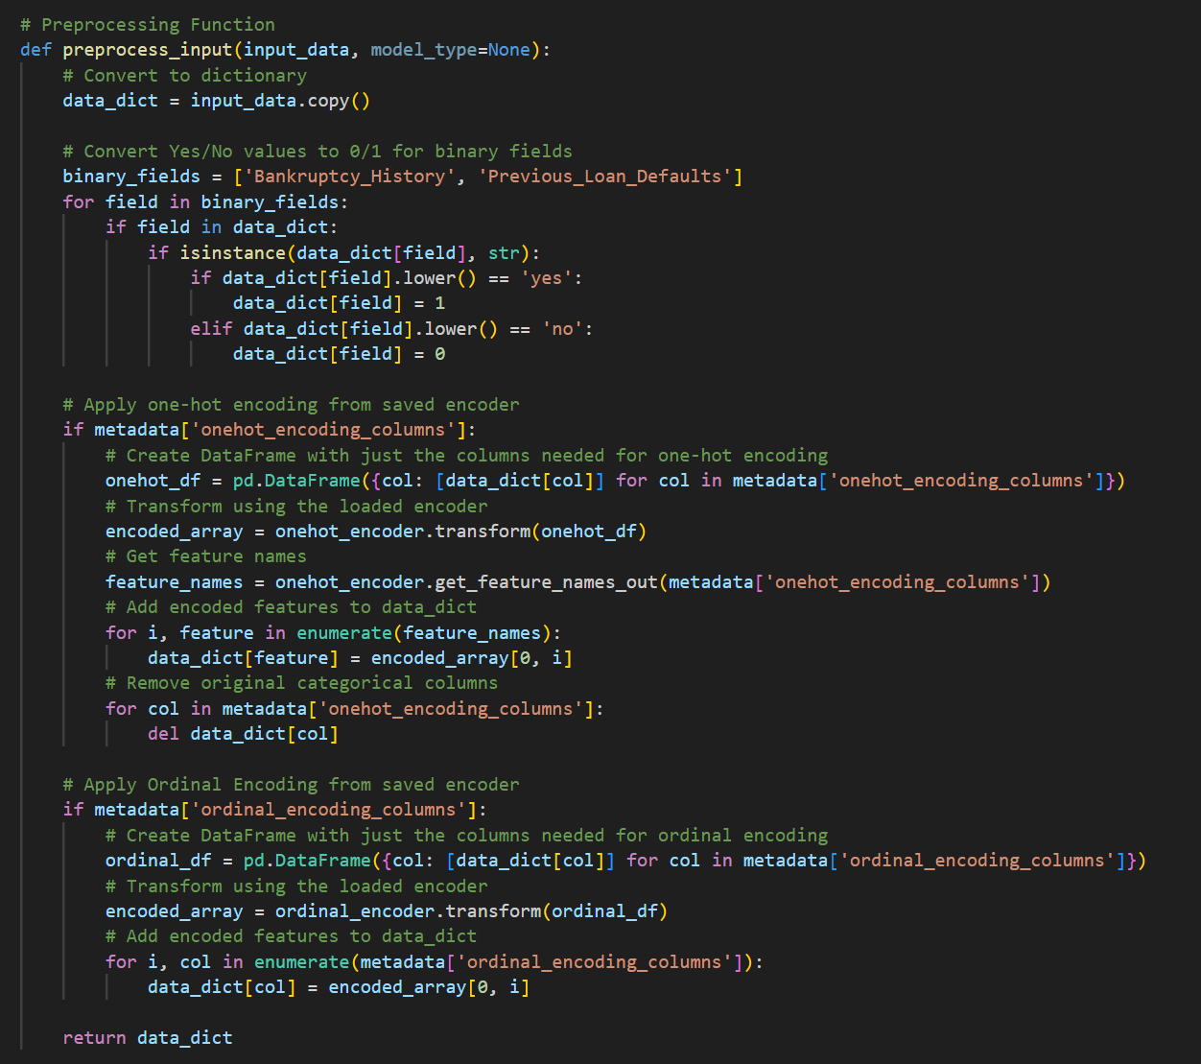

Ordinal Encoding

One Hot Encoding

Binary Encoding

*Figure(): preprocess_input function*

The conditional feature scaling function will applies standardization using the loaded standard scaler only when needed by the current model, as determined by the model_manager.requires_input_scaling() check. The function includes robust error handling to gracefully continue with unscaled data if any scaling errors occur, preventing prediction failures. This approach ensures input data consistency with the model's training data distribution while maintaining flexibility to support both models that require scaling and those that don’t.

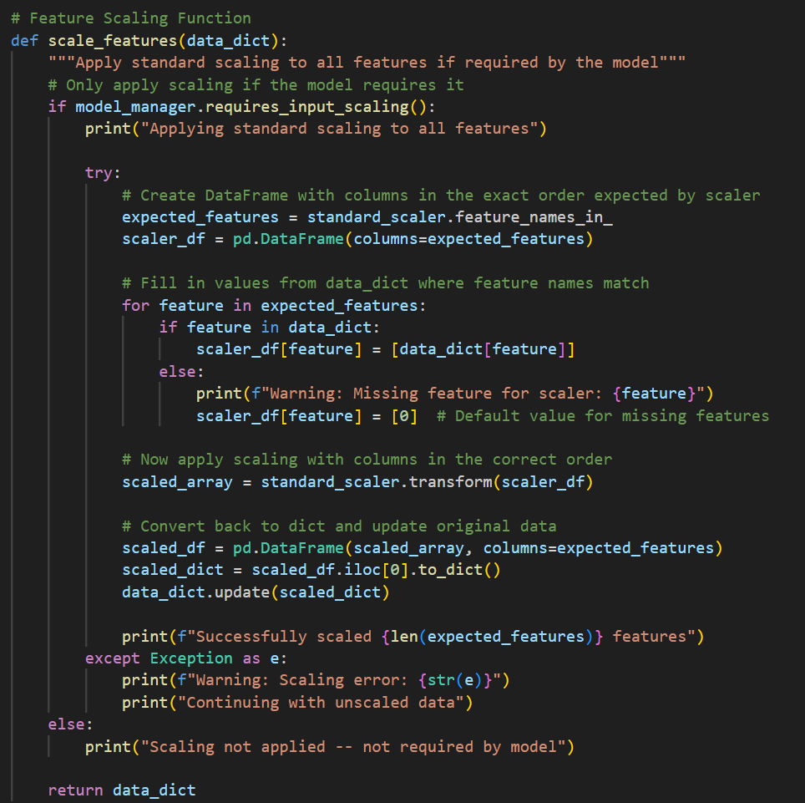

*Figure(): scale_features function*

The `/predict` endpoint processes loan applications and generates predictions with explanations. It loads the machine learning model, transforms raw input data using the preprocess_input function, and aligns the processed data with the model's expected feature format. It then makes a prediction, calculates confidence scores, and generates comprehensive XAI explanations from xai_service.py, showing which factors influenced the approval or rejection decision. The endpoint returns a structured response containing the loan decision, confidence level, model information, and visual/textual explanations of the prediction factors.

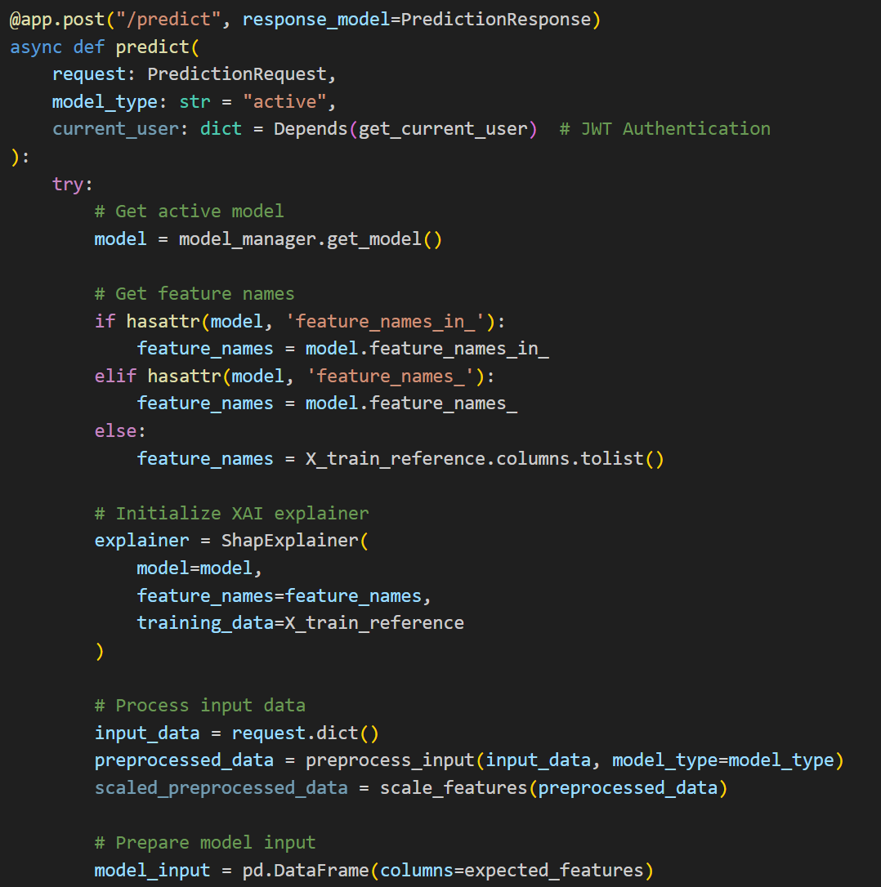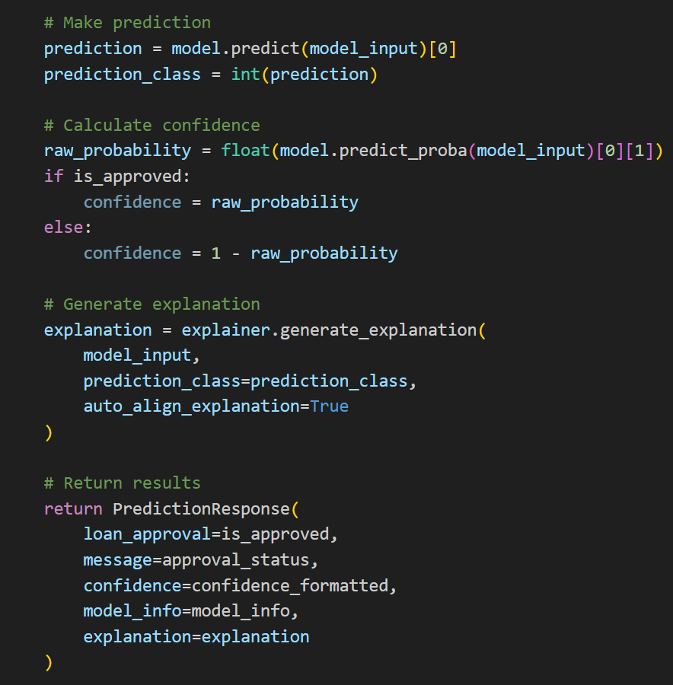

*Figure (): FastAPI Prediction Endpoint*

### XAI Service Deployment

I created a xai_service.py in the FastAPI directory for implementing Explainable AI service, which allows users to understand why the machine learning model made specific approval or rejection decisions. At the core of this service is the `ShapExplainer` class, which leverages the SHAP library to generate interpretable explanations for model predictions. The service automatically adapts to different model types, generates multiple visualization formats, and produces human-readable explanations of model decisions.

The `ShapExplainer` initialization process establishes the foundation for XAI capabilities by accepting a trained machine learning model, feature names, and reference training data.

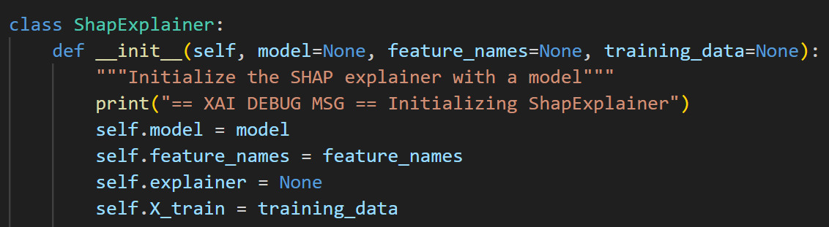

*Figure(): ShapExplainer class*

For model-specific explainer selection, I implemented a detection system in the `_ensure_explainer` method that automatically selects the SHAP explainer based on the model type. For tree-based models like Random Forest, XGBoost, and LightGBM, it uses the computationally efficient `TreeExplainer`. For neural networks, it employs `DeepExplainer` with background data sampling. Linear models utilize `LinearExplainer`, and for any unrecognized model type, it falls back to the universal `KernelExplainer`. This adaptive approach ensures optimal explanation performance regardless of the underlying model architecture.

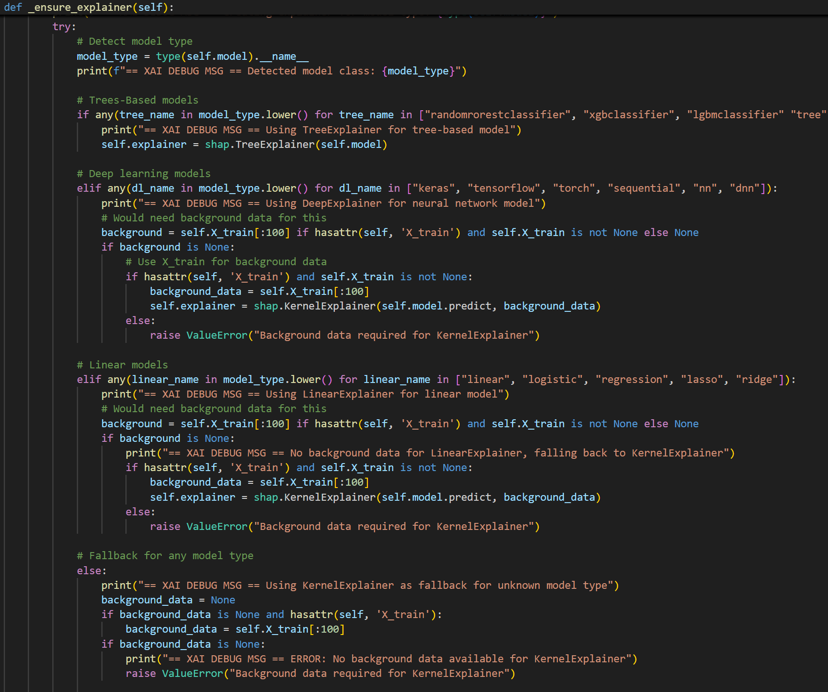

*figure(): _ensure_explainer function*

TreeExplainer is used to explain the deployed ML models (XGBoost, CatBoost, and LightGBM)

The SHAP value calculation process implemented in `_calculate_shap_values` forms the mathematical foundation of the explanations. This method handles the complexity of different model outputs, automatically detecting multi-class prediction structures and extracting the appropriate values for the specified prediction class. It manages the conversion between various data formats, ensuring input data is properly structured as a DataFrame before processing. The method returns a comprehensive dictionary containing original SHAP values, plotting-ready values, expected values (baseline predictions), and processed values for feature importance, providing all necessary data for subsequent explanation generation.

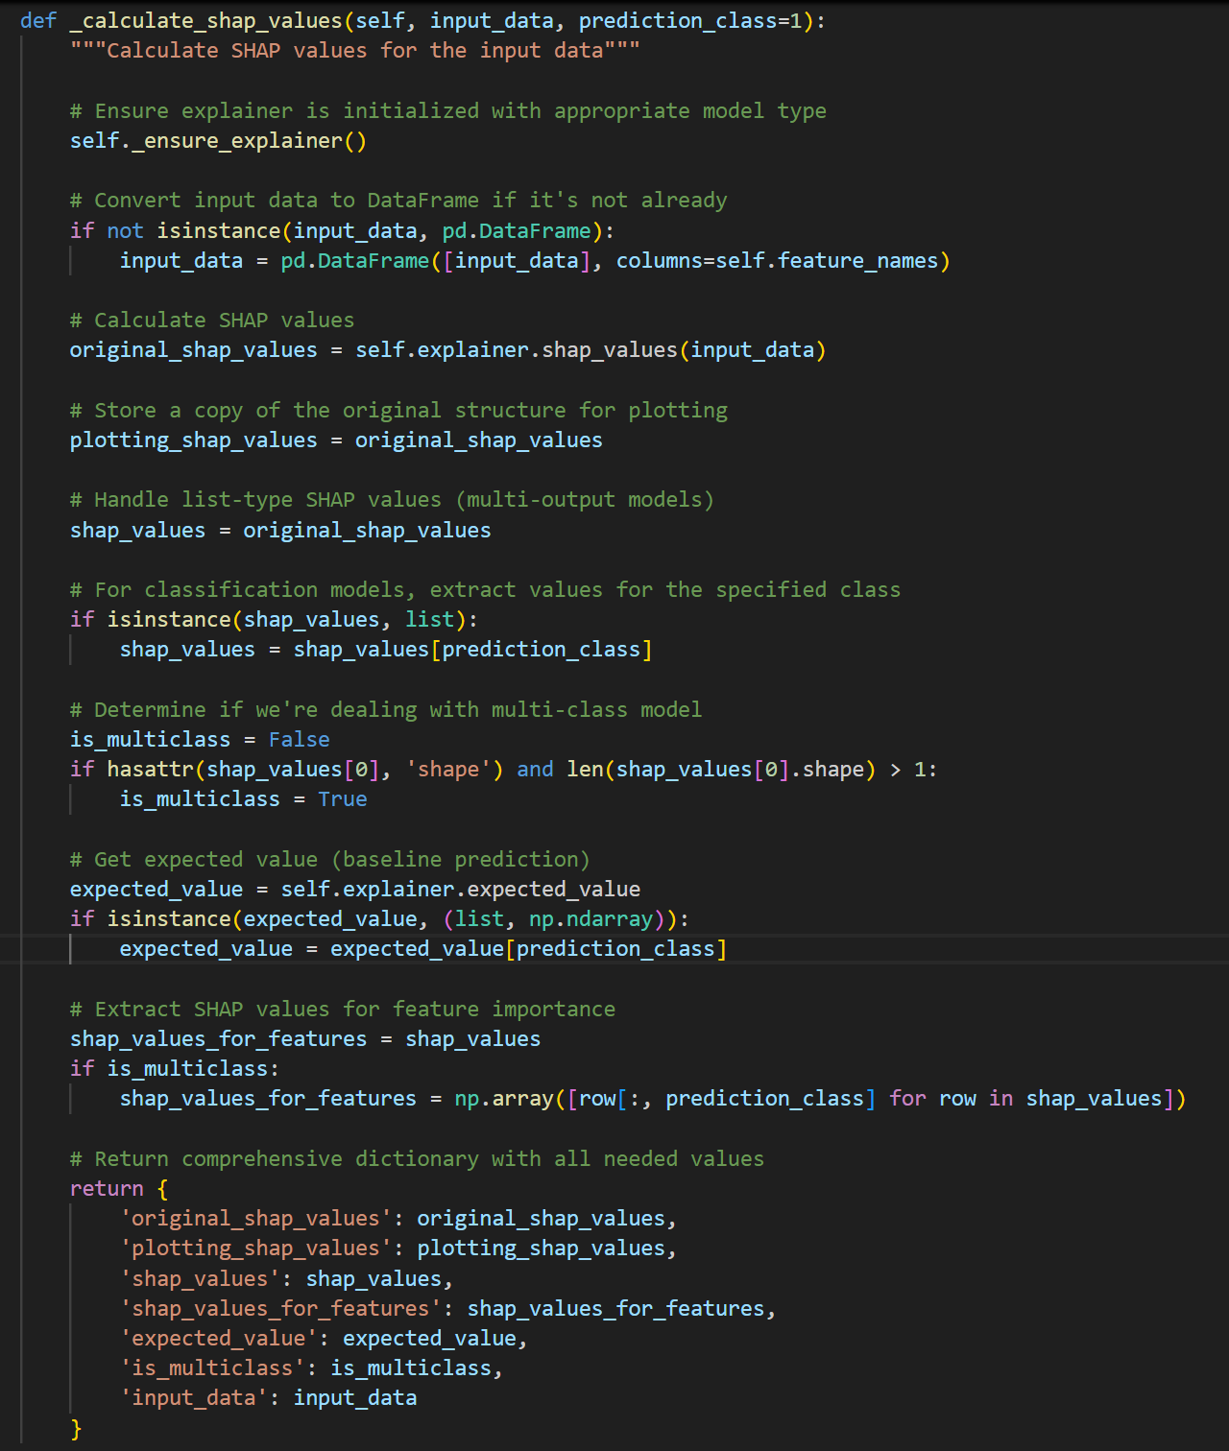

Compute the

SHAP Value

Compute the

Expected Value

(Base Value)

*Figure(): ‘_calculate_shap_values’ function*

The prediction metrics calculation in `_compute_prediction_metrics` transforms raw SHAP values into interpretable statistical metrics. This function will:

* Compute the **total impact of all features** and final prediction in **log-odds space**
* Convert log-odds to **probability space**
* Handle the differences between approval and rejection classes. For rejection probabilities, it performs appropriate transformations to ensure consistent interpretation. These metrics provide the statistical foundation for human-readable explanations and confidence assessments.

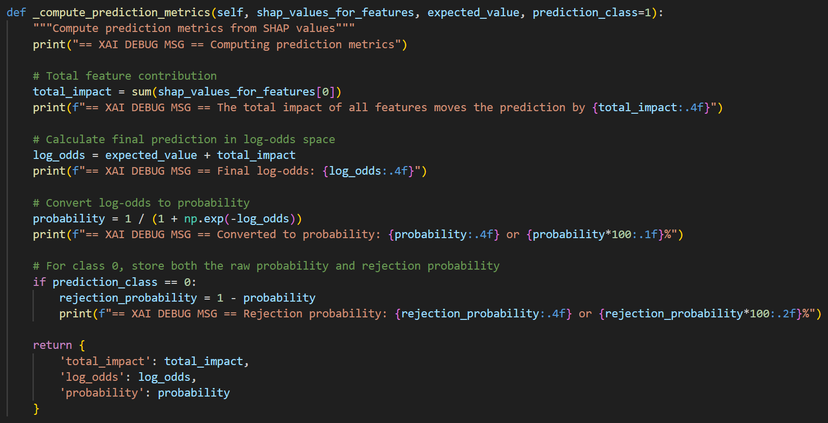

*Figure(): ‘_compute_prediction_metrics’ function*

Convert Log-odds to probability

Compute the log-odds

Compute the total feature contribution

For SHAP visualizations, I implemented three complementary visualization types to provide multifaceted insights into model decisions. The `_create_summary_plot` method generates feature importance bar charts that show the overall impact of each feature on predictions.

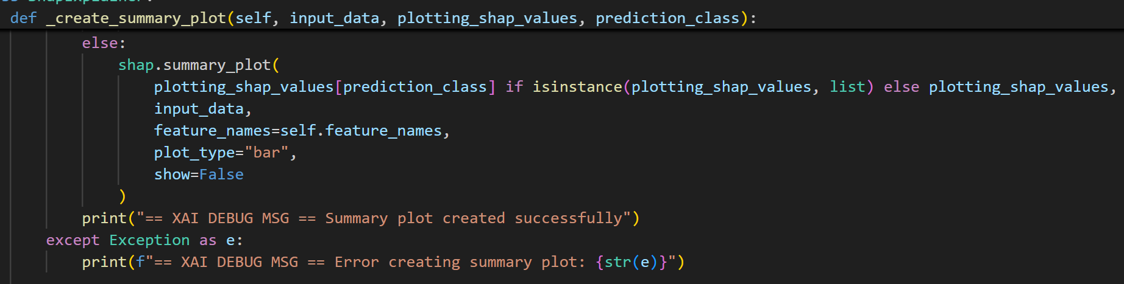

*Figure(): ‘_create_summary_plot’ function*

The `_create_waterfall_plot` method creates a SHAP waterfall plot, which is a detailed visualization showing how each feature pushes the prediction away from the baseline value.

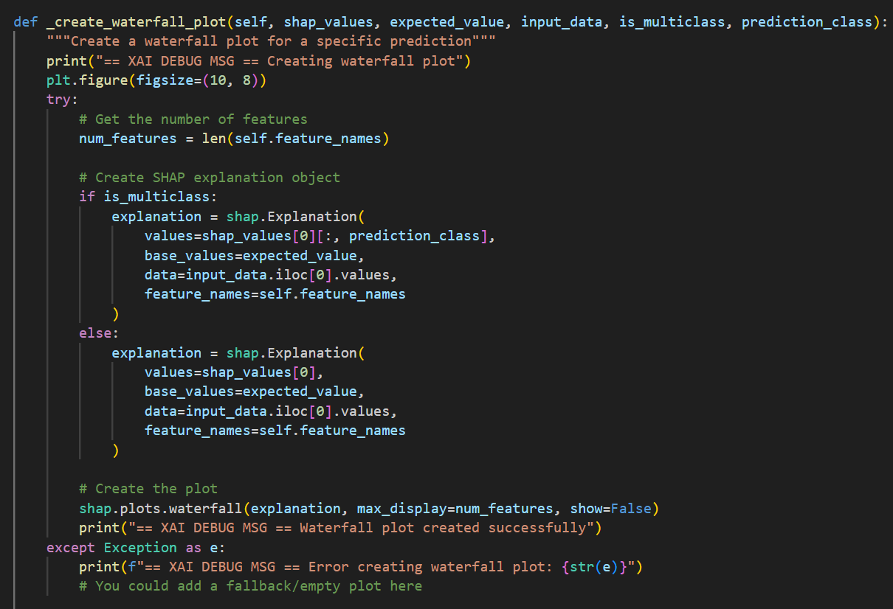

*Figure(): ‘_create_waterfall_plot’ function*

The `_create_force_plot` function produces a force plot, which is a force-based visualization that shows how features interact to produce the final prediction.

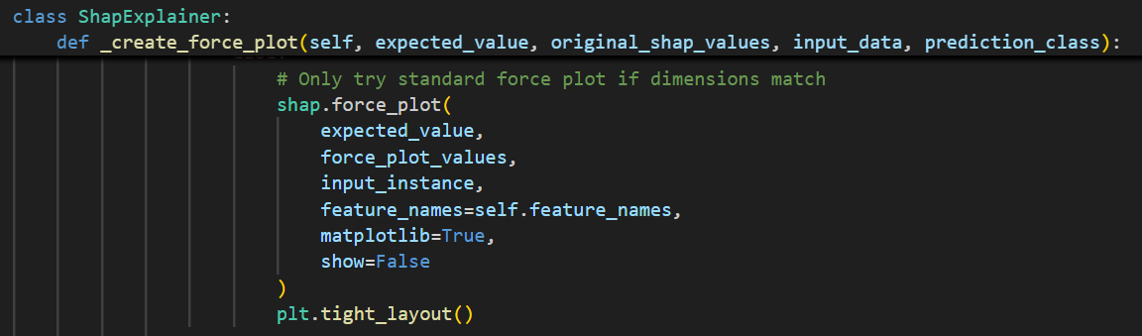

*Figure(): `_create_force_plot` function*

At the end of all 3 functions to create plots above, the plots are converted into web-compatible format through a series of transformations. First, it creates an in-memory binary buffer (BytesIO()) to eliminate the need for physical file storage. The plot is then saved directly to this buffer as a PNG image with optimized settings (bbox_inches='tight', dpi=100). After closing the plot to free memory resources, the buffer position is reset to the beginning with seek(0). Finally, the binary image data is read from the buffer, converted to Base64 format, and decoded to a UTF-8 string. This Base64-encoded string allows complex visualizations to be embedded directly in or included in JSON API responses without requiring separate image file handling or storage.

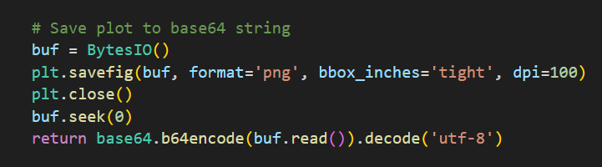

*Figure(): Plots Serialization*

The `_generate_explanation_summary` function is significant to translate the technical SHAP values into accessible language. This method handles the complex interpretation differences between approval and rejection classes, adjusting the impact direction accordingly. For approval decisions (class 1), interpretation is straightforward: positive SHAP values increase approval likelihood and negative values decrease it. However, for rejection decisions (class 0), the function inverts the signs of all SHAP values. This critical step ensures consistency in interpretation, as a feature that would push toward approval should be interpreted as pushing away from rejection. The function handles this with an elegant solution:

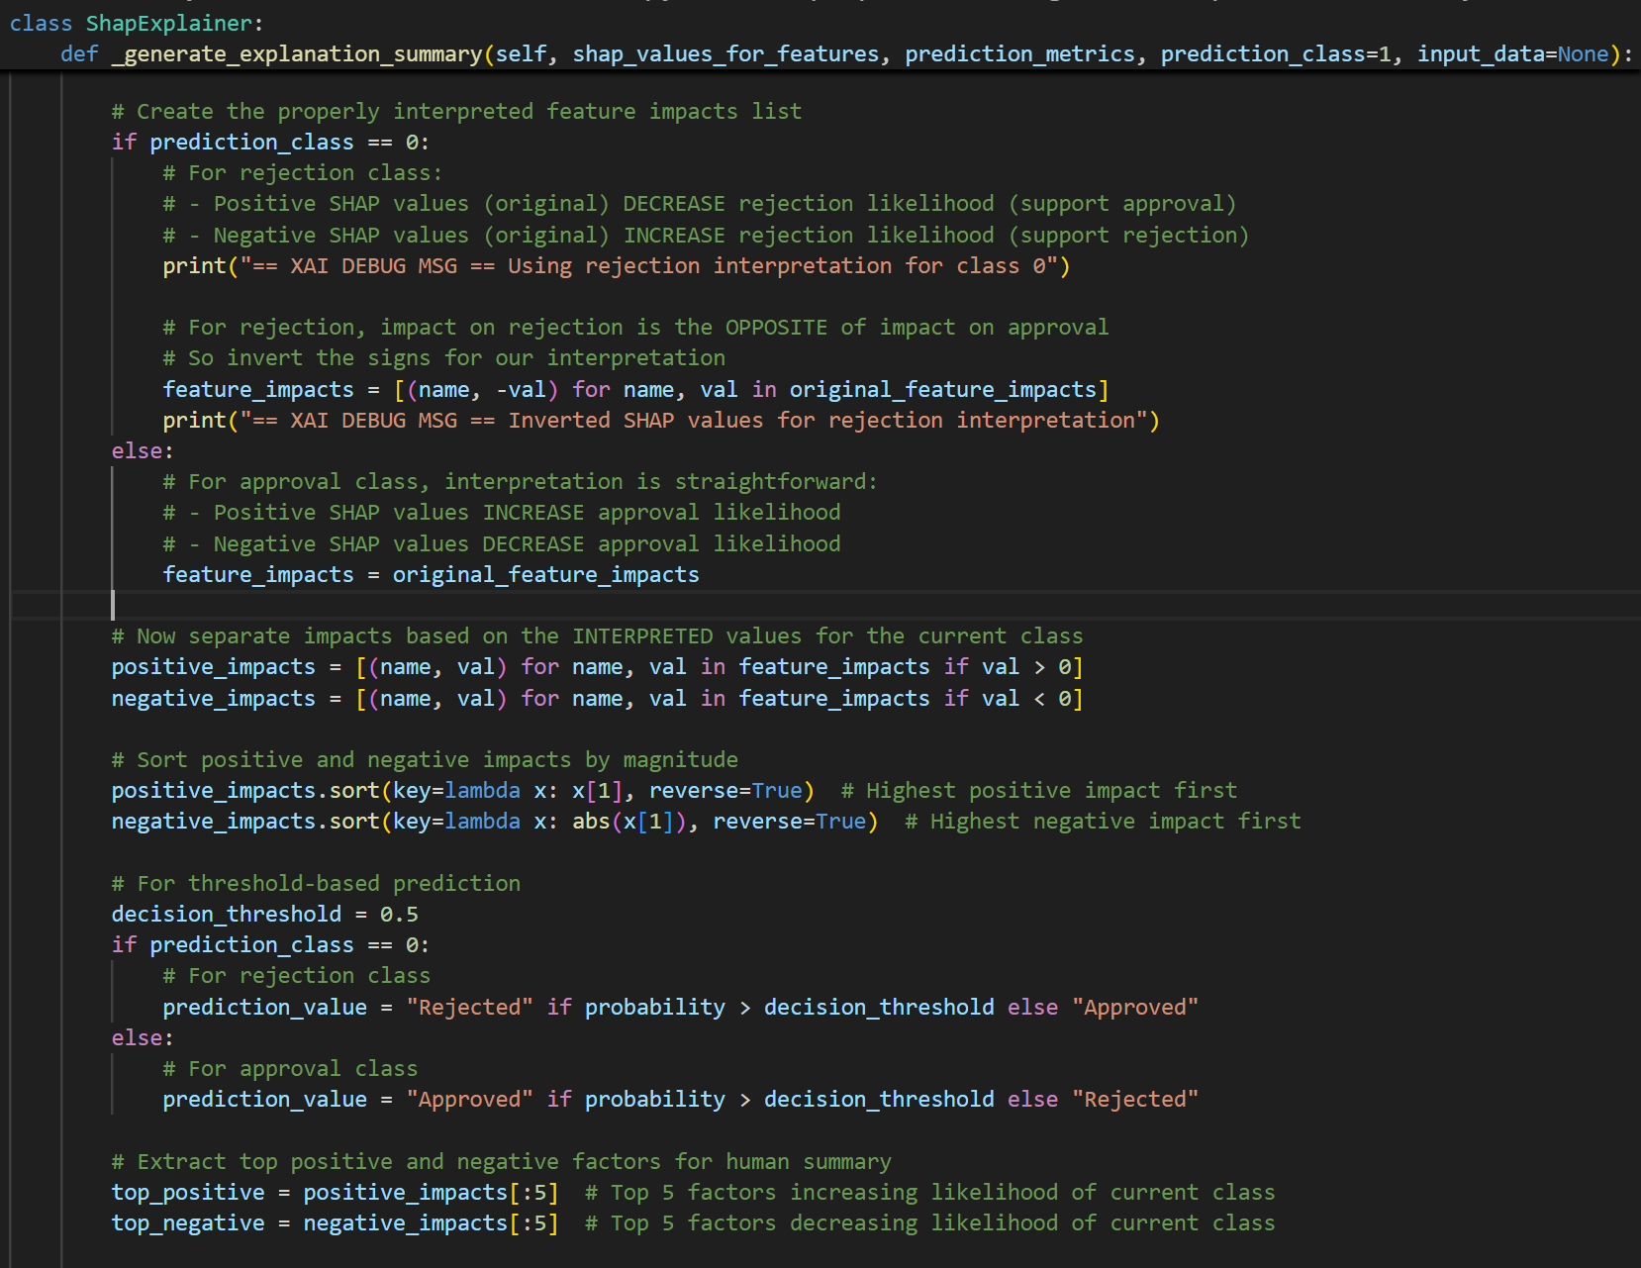*Figure(): class specific interpretation*

After properly interpreting the values, the function separates positive and negative impacts and sorts them by magnitude to identify the most influential factors. It extracts the top five factors in each direction and transforms them into natural language descriptions.

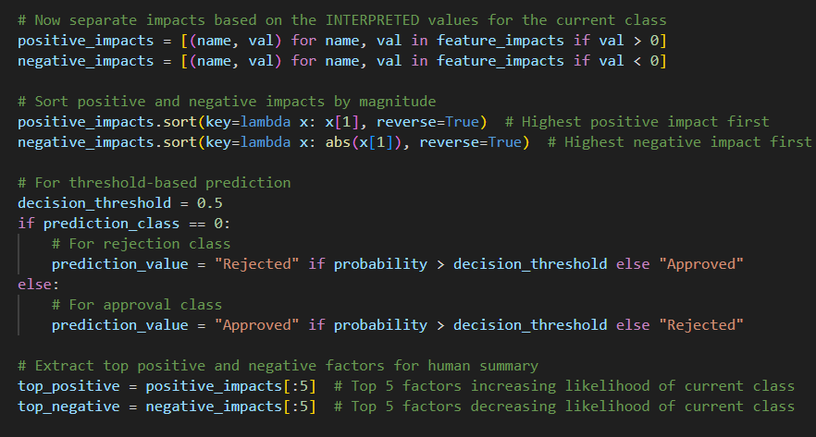

*Figure(): categorize features based on impacts*

The function crafts a structured summary containing the decision outcome, confidence percentage, certainty level, and lists of positive and negative factors. Each factor is accompanied by its impact value and a human-readable description.

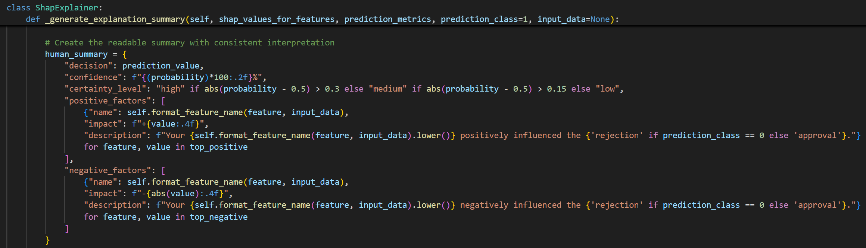

*Figure(): structured explanation summary*

Lastly, the main `generate_explanation` method orchestrates the entire explanation process. It implements an intelligent explanation alignment that can automatically adjust explanations to match the actual prediction class, ensuring explanations are always consistent with model outputs. The method returns comprehensive explanation object containing visualizations, feature importance rankings, statistical metrics, and human-readable explanations, providing a complete explanation package that can be directly accessed and rendered in the front end to be presented to users.

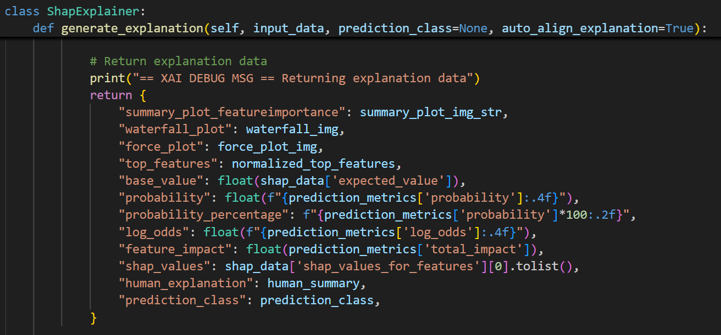

*Figure(): generate_explanation function*

The class and the functions are then called in the main.py (ML Service) to generate explanations for the prediction.

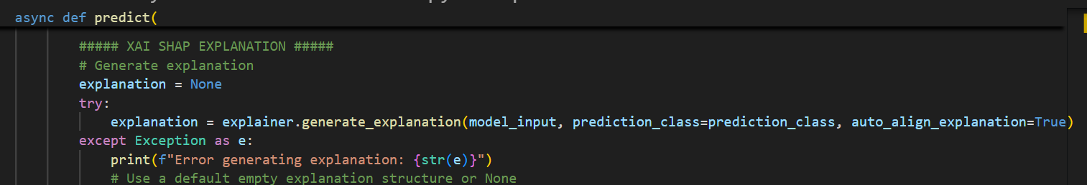

*Figure() : access explanation service in main.py*

## 6.2 SPRINT 2 – Django Setup and Admin Functionalities

This sprint aims to set up the Django backend framework and develop the functionalities and UI for administrator.

### 6.2.1 Django Backend Framework

The project backend will be organized by Django MVT (Model-View-Template) pattern, which separates the database, business logic, and user interface into clear sections. To make it easy for the frontend or other applications to communicate with the backend. Django REST Framework is used to create REST APIs. This setup will let the project handle both web pages and API requests efficiently, keeping the code clean and maintainable.

#### 6.2.1.1 Project Setup

The Django project is set up using commands such as ‘Django-admin startproject credit-assessment’ and ‘Django-admin startapp api’.

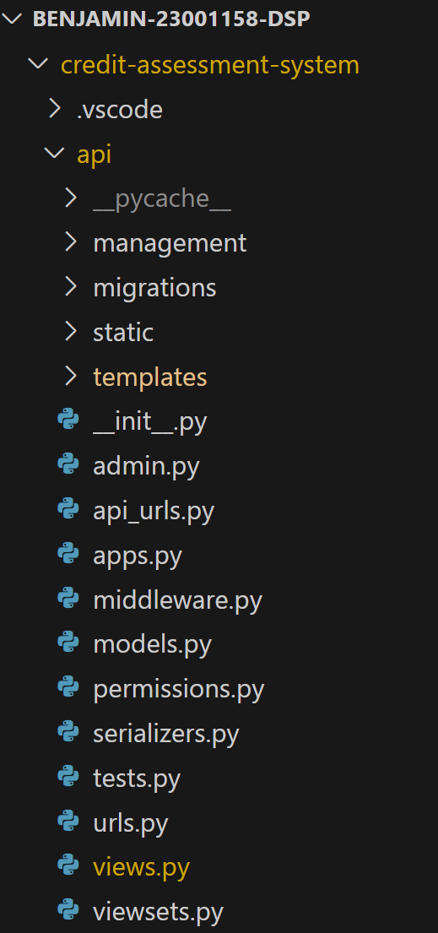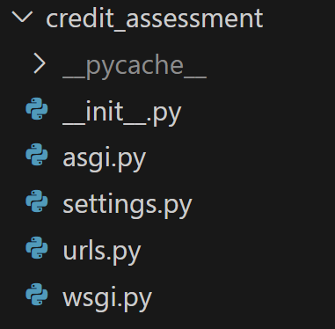

*Figure(): Project Directory for Loan Credit Assessment System*

#### 6.2.1.2 Database Setup

PostgreSQL is used as a database management system, the configuration is implemented in settings.py, using environment variables for secure credential management.

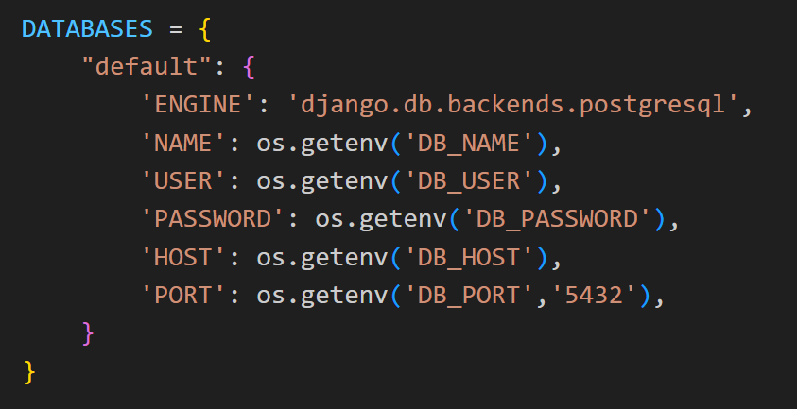

*Figure(): Database configuration*

3 essential database models are defined to establish the system foundation. The **User** model implements a role-based authentication system with four distinct roles (Admin, Staff, AI Engineer, and End User), controlling access to different system capabilities while storing essential user information. The **Prediction** model serves as the central repository for loan applications, storing applicant input data, ML-generated results including SHAP explanations, approval decisions, confidence scores, and a comprehensive feedback tracking system that enables both customer dispute handling and staff review workflows. Finally, the **MLModel** model manages the machine learning infrastructure, tracking uploaded models with their metadata, version history, and activation status. These three models create a robust, scalable database architecture. The User Class demonstrates how a class and its fields are defined in the models.py file.

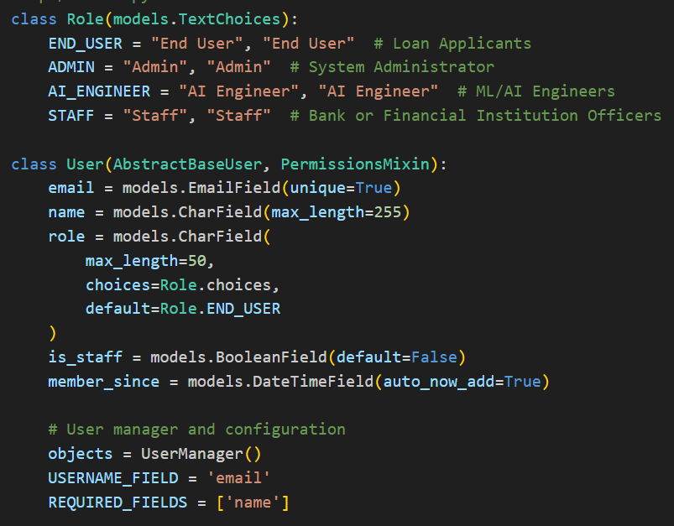

*Figure() :User Model Class*

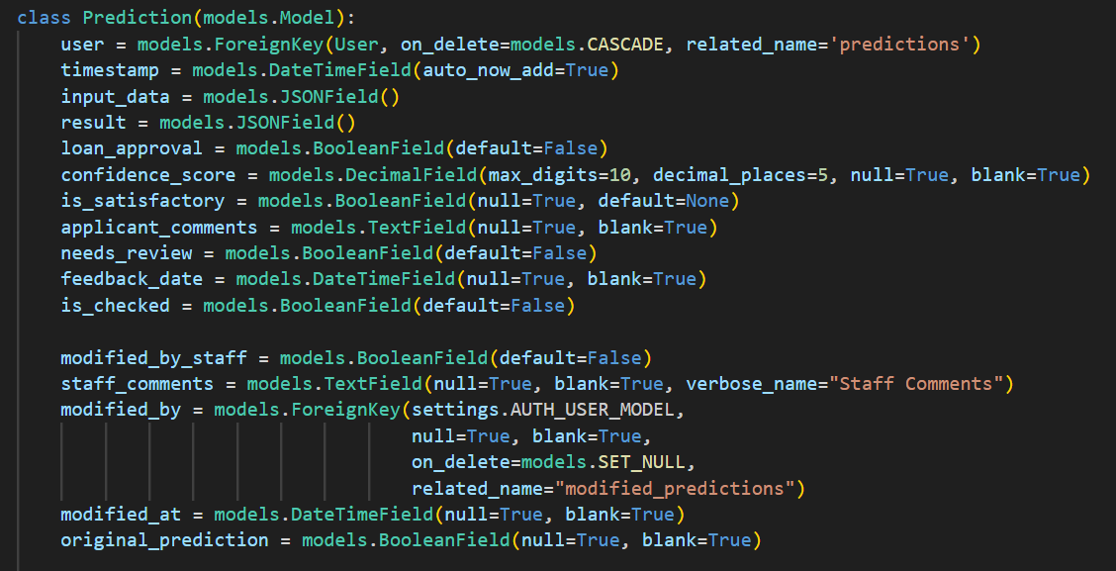

*Figure(): Prediction Class*

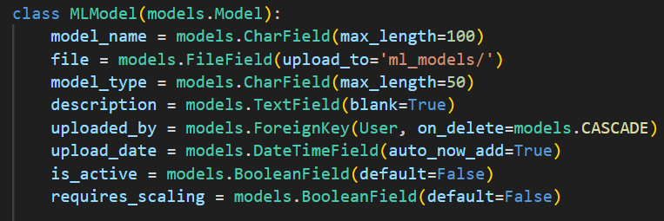

*Figure(): MLModel Class*

#### 6.2.1.3 Containerization

The components of the project (database, api and ml_api) is containerized in docker compose file to ensure consistent deployment across environments.

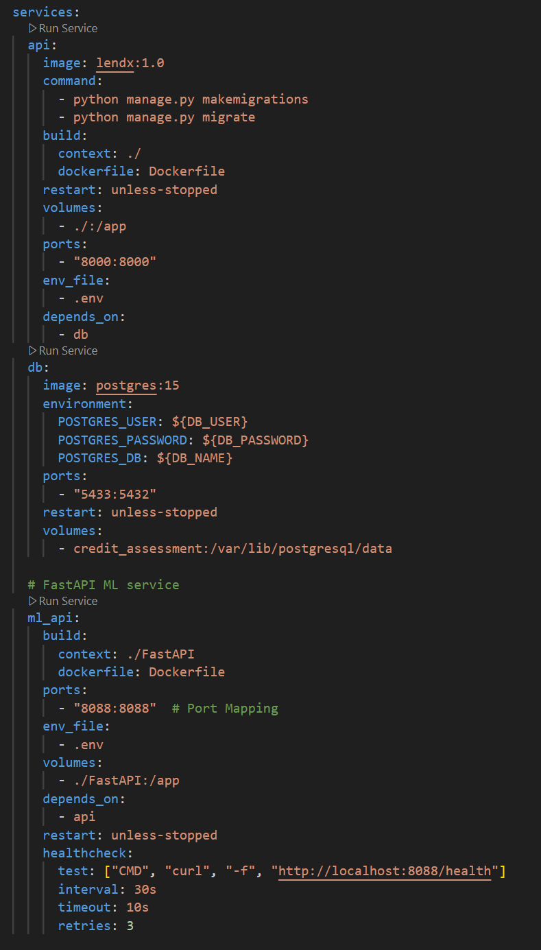

FastAPI (ML Service) Container

Postgresql Database Container

Django Application Container

*Figure(): Docker Compose Configuration*

### 6.2.2 Authentication and Role-based Control

The middleware implementation and cookie-based security enhancement work together to create a robust authentication system. In the middleware, JWTCookieMiddleware intercepts each request, extracting the JWT token from HttpOnly cookies through the get_user_from_token function. This function converts the cookie-based token into a standard Bearer token format in the request headers, validates its signature and expiration using Django REST's JWTAuthentication, and then loads the corresponding user. By using SimpleLazyObject, authentication only occurs when the user object is actually needed, improving performance. This cookie-based approach provides stronger security than client-side storage alternatives while creating a seamless authentication experience that transparently maintains user sessions across the application.

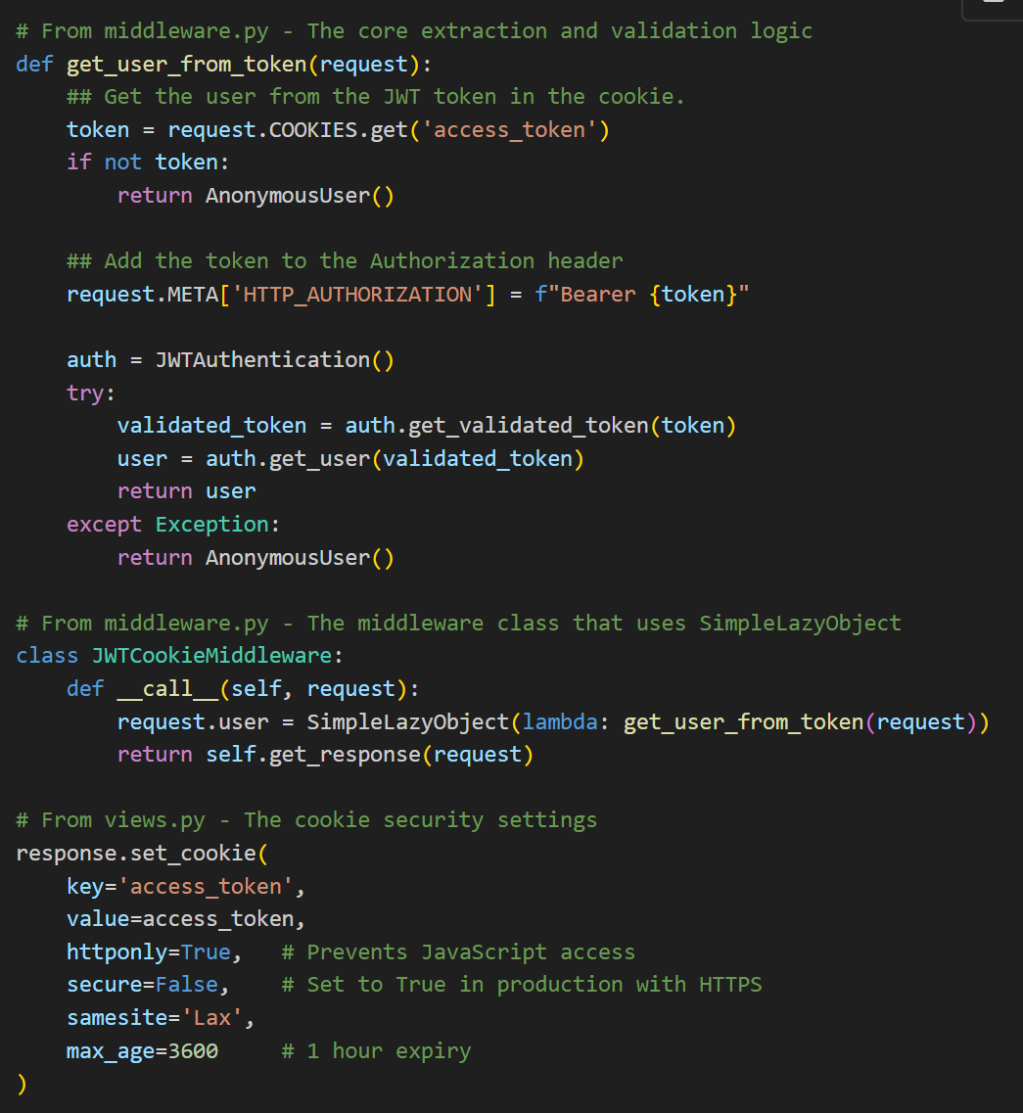

This multi-layered approach to authentication and authorization ensures that users can only access functionality appropriate to their role, maintaining security and separation of concerns. In this system, the first registered user will be assigned with an ‘admin’ role automatically.

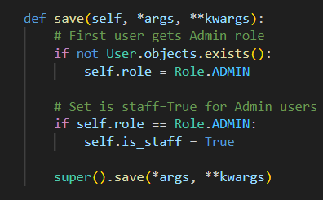

*Figure() : Function to set first user as admin*

### 6.2.3 Initial Interface Setup

This project aims to create an interface structure with a home page, directing each user to a dedicated dashboard based on their role, as demonstrated below.

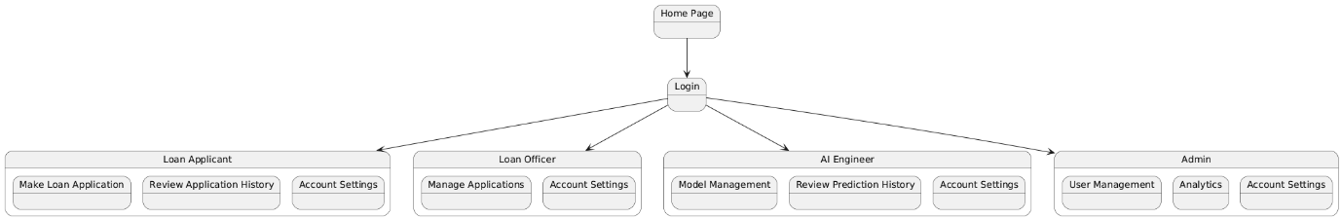

*Figure(): System Navigation Structure*

#### 6.2.2.1 Base Template Structure

Bootstrap 5 is used as the main front-end framework to create responsive layouts and consistent components. Custom CSS is added to give the system its own unique look, with the main stylesheet using CSS variables for the color palette. The templates are organized using Django’s template inheritance. There is a main base template (base-template.html) that contains the overall layout, such as the navigation bar and footer. Other page templates extend this base template, filling in sections like the title and content, and can also add extra styles or scripts as needed.

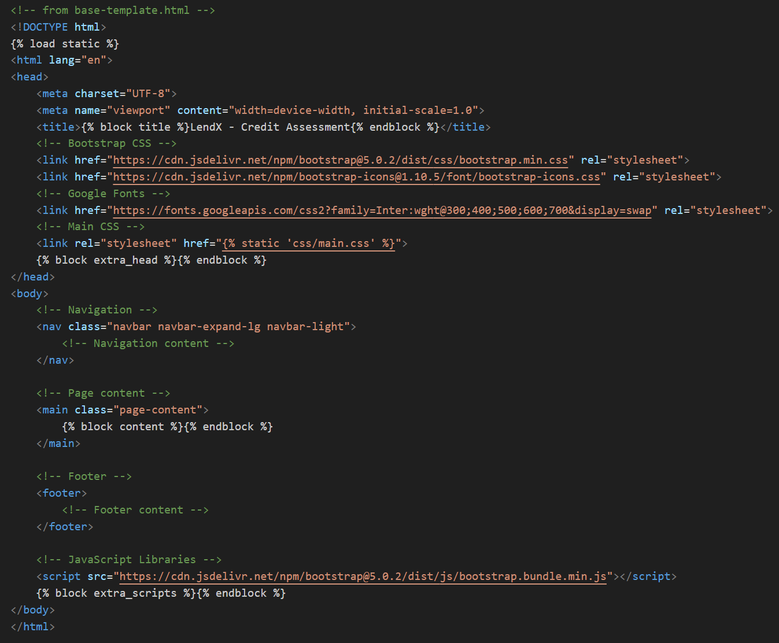

*Figure(): Partial Code of base-template.html*

#### 6.2.2.2 Role-based Dashboard

Firstly, the home page, login page and register page are created.

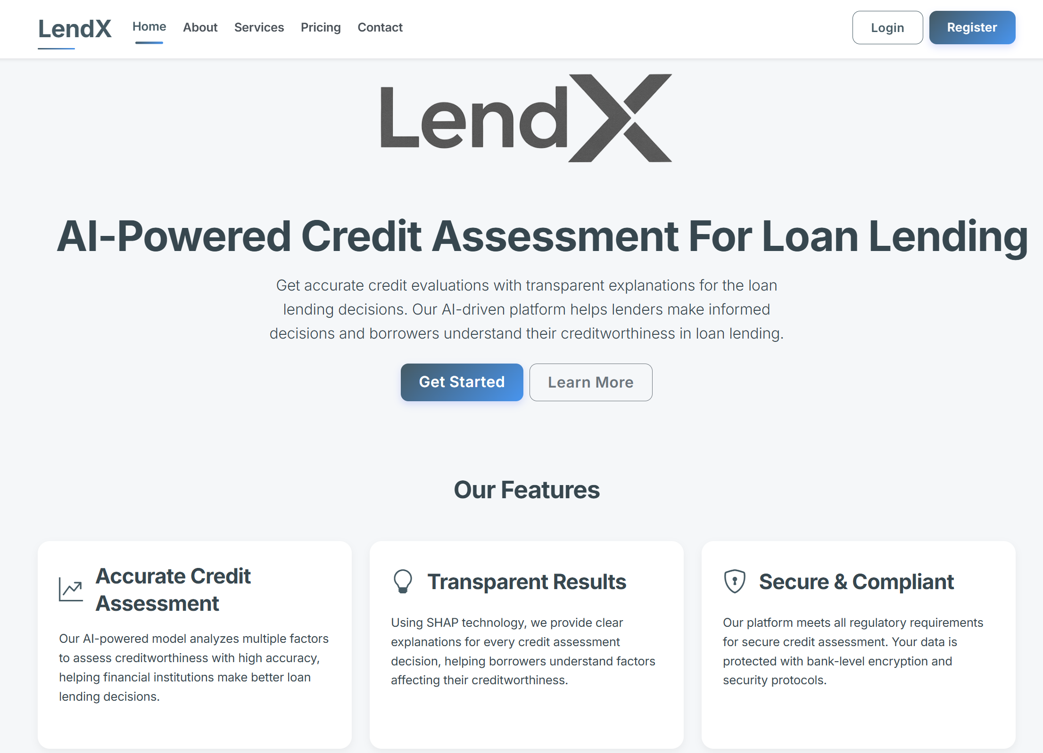

*Figure(): Home Page of Loan Credit Assessment System*

**

*Figure() : Create Account Page*

**

*Figure() : Login Page*

The dashboard page will dynamically adjust its appearance and content based on the users’ roles. Each user will be directed to their dedicated dashboard based on their role with different functionalities after they login with correct credentials.

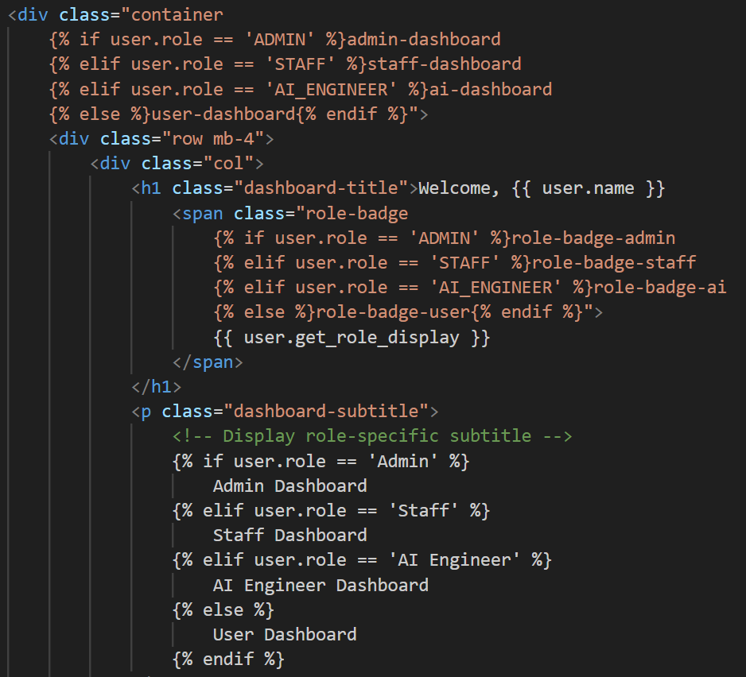

*Figure() : Role-Based Dynamic Dashboard Interface*

 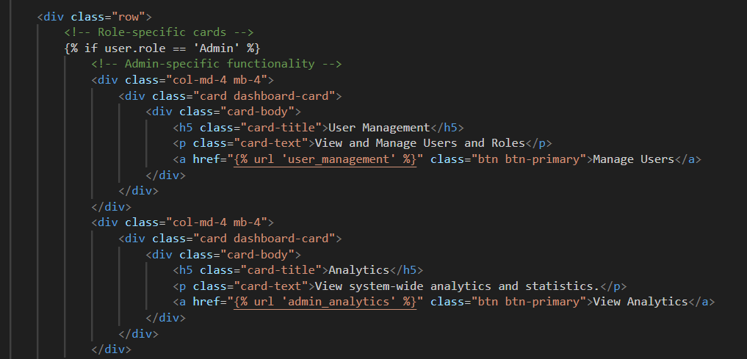

*Figure() : Administrator Dashboard View*

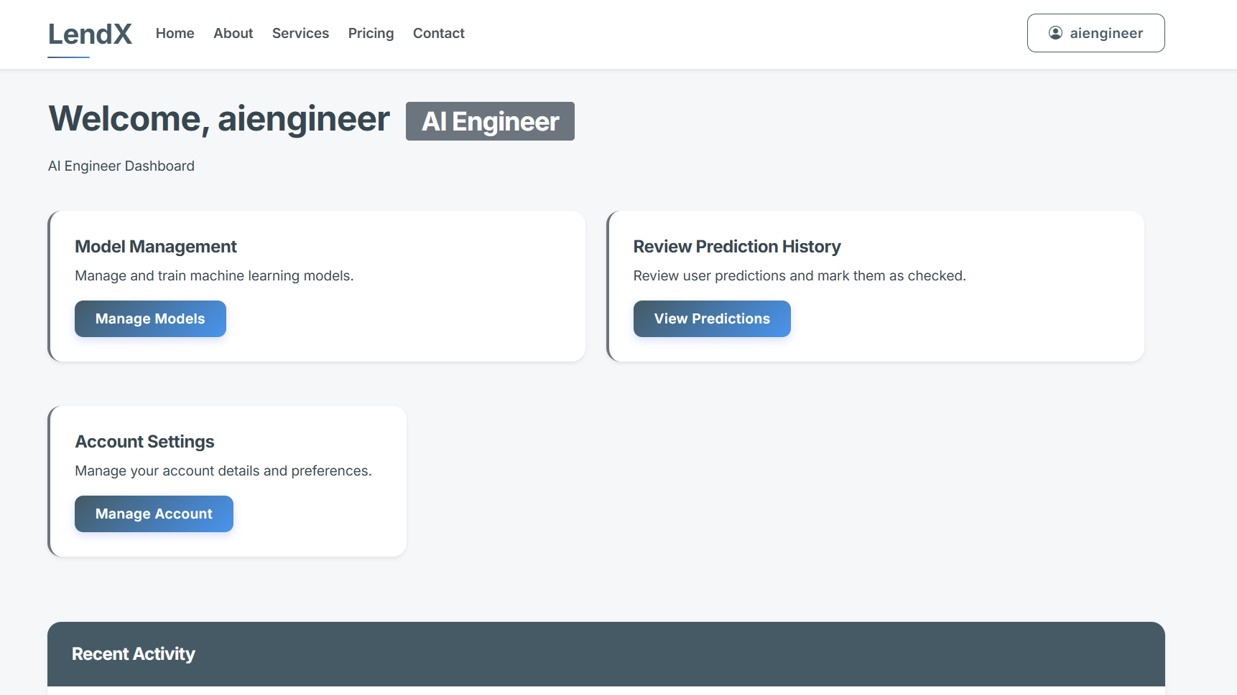 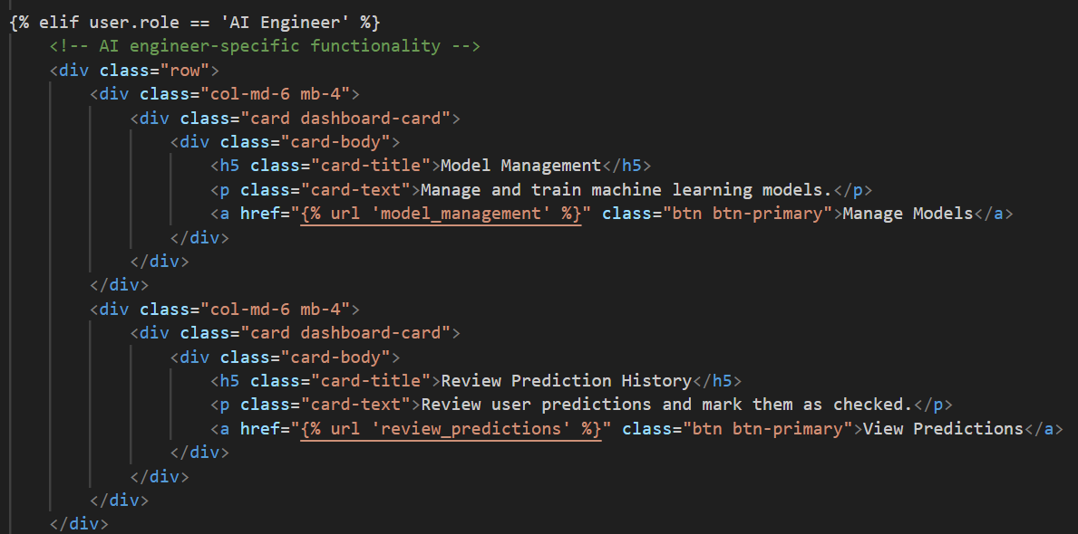

*Figure() : AI Engineer Dashboard View*

 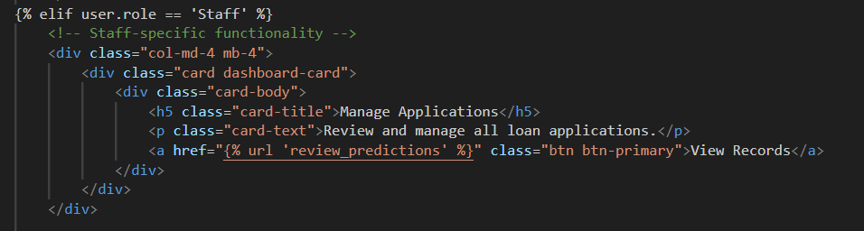

*Figure() : Loan Officer Dashboard View*

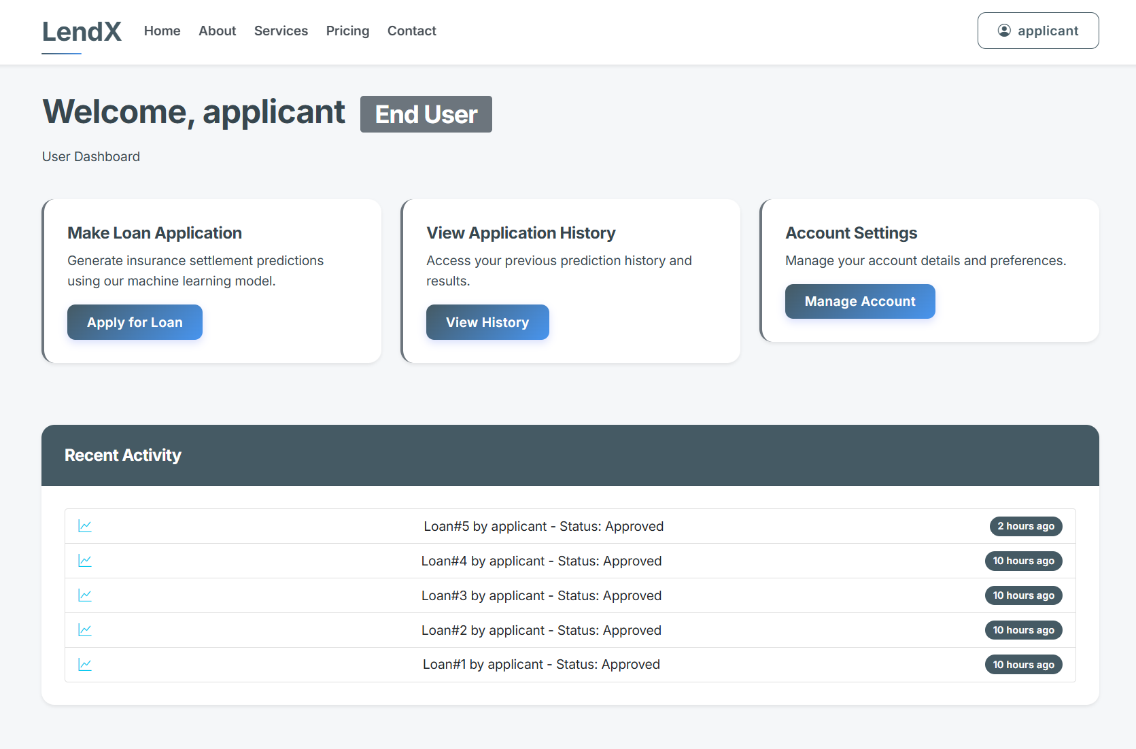 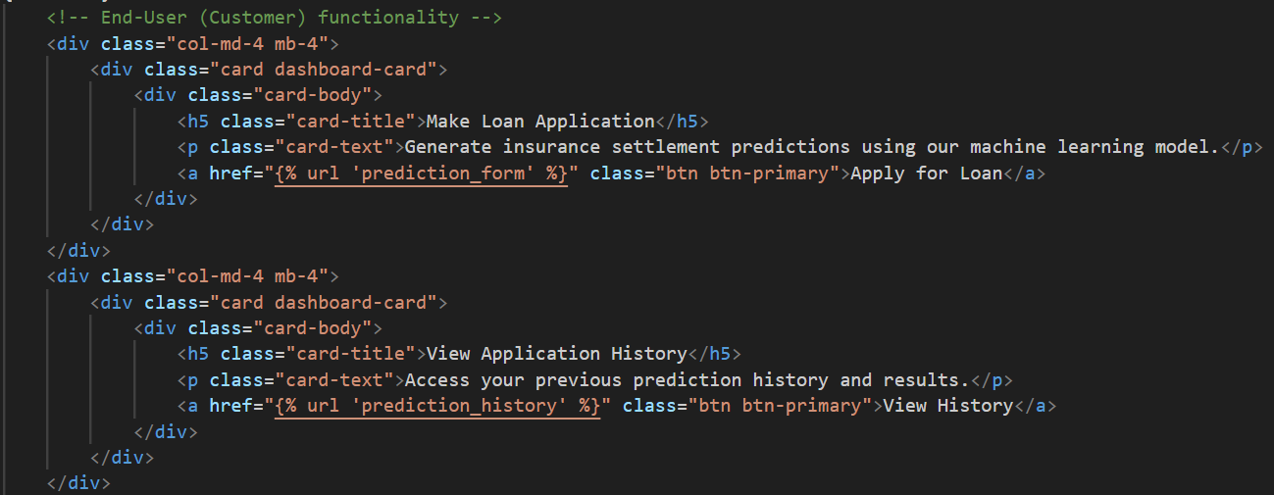

*Figure() : Loan Applicant Dashboard View*

All dashboards are provided with account settings to update passwords.

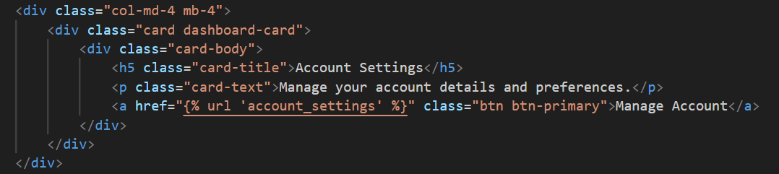*Figure() : Account Management*

### 6.2.4 Admin Functionalities Development

A full CRUD (Create, Read, Update, Delete) operation is developed for administrators to manage the users’ data. This user management functionality is implemented through a series of views and templates.

Function to display all registered users and provide options for filtering.

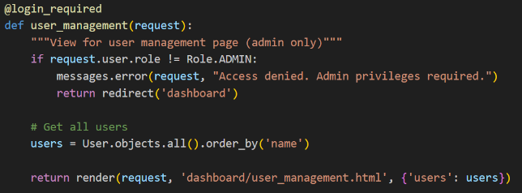

*Figure(): user_management view*

Function to let admin create a new user account and assign role to the new user.

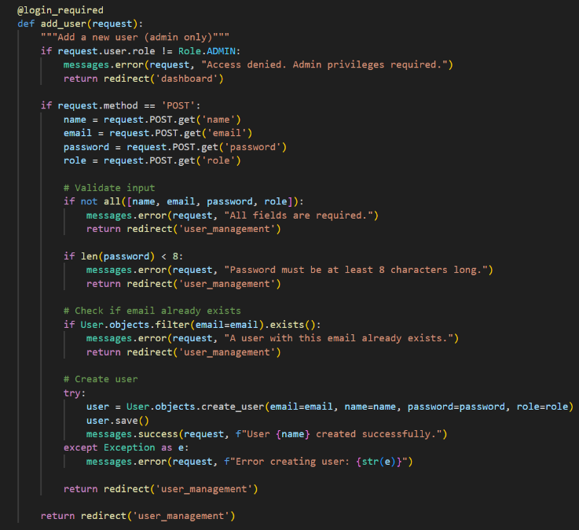

*Figure(): add_user view*

Function to update user information such as name and email address.

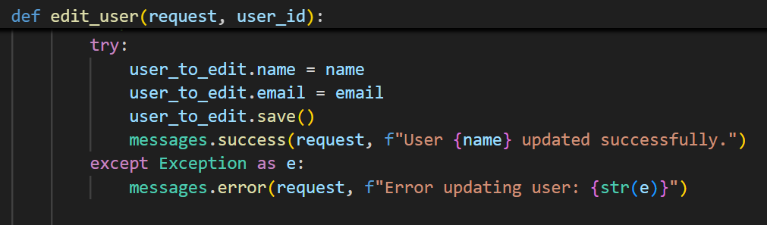

*Figure(): edit_user view*

Function to change the user’s current role.

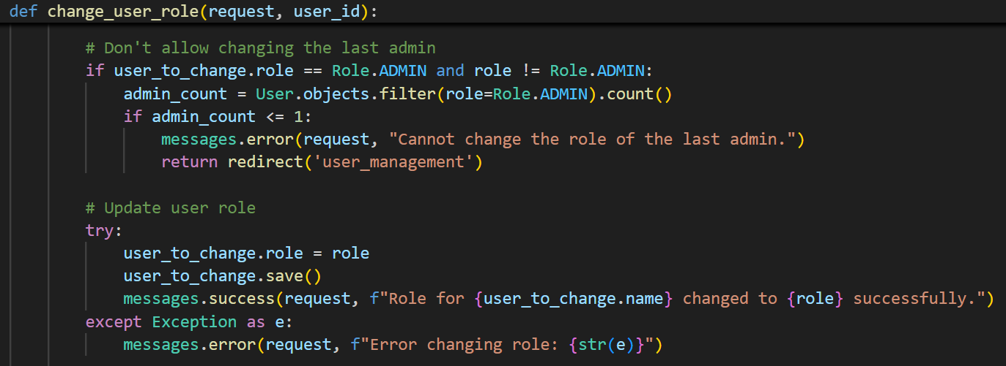

*Figure(): change_user_role view*

Function to remove the current users from the system.

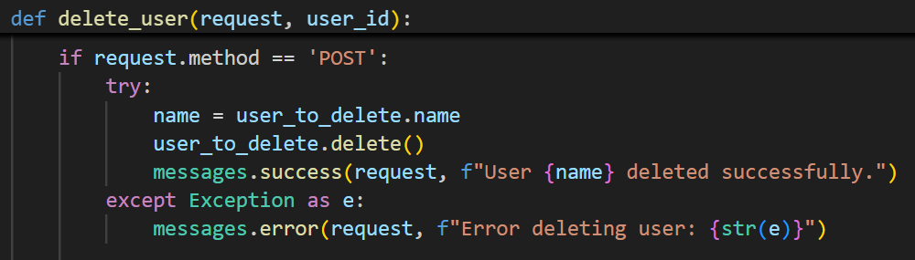

*Figure(): delete_user view*

A user management interface is created for admin to manage the users.

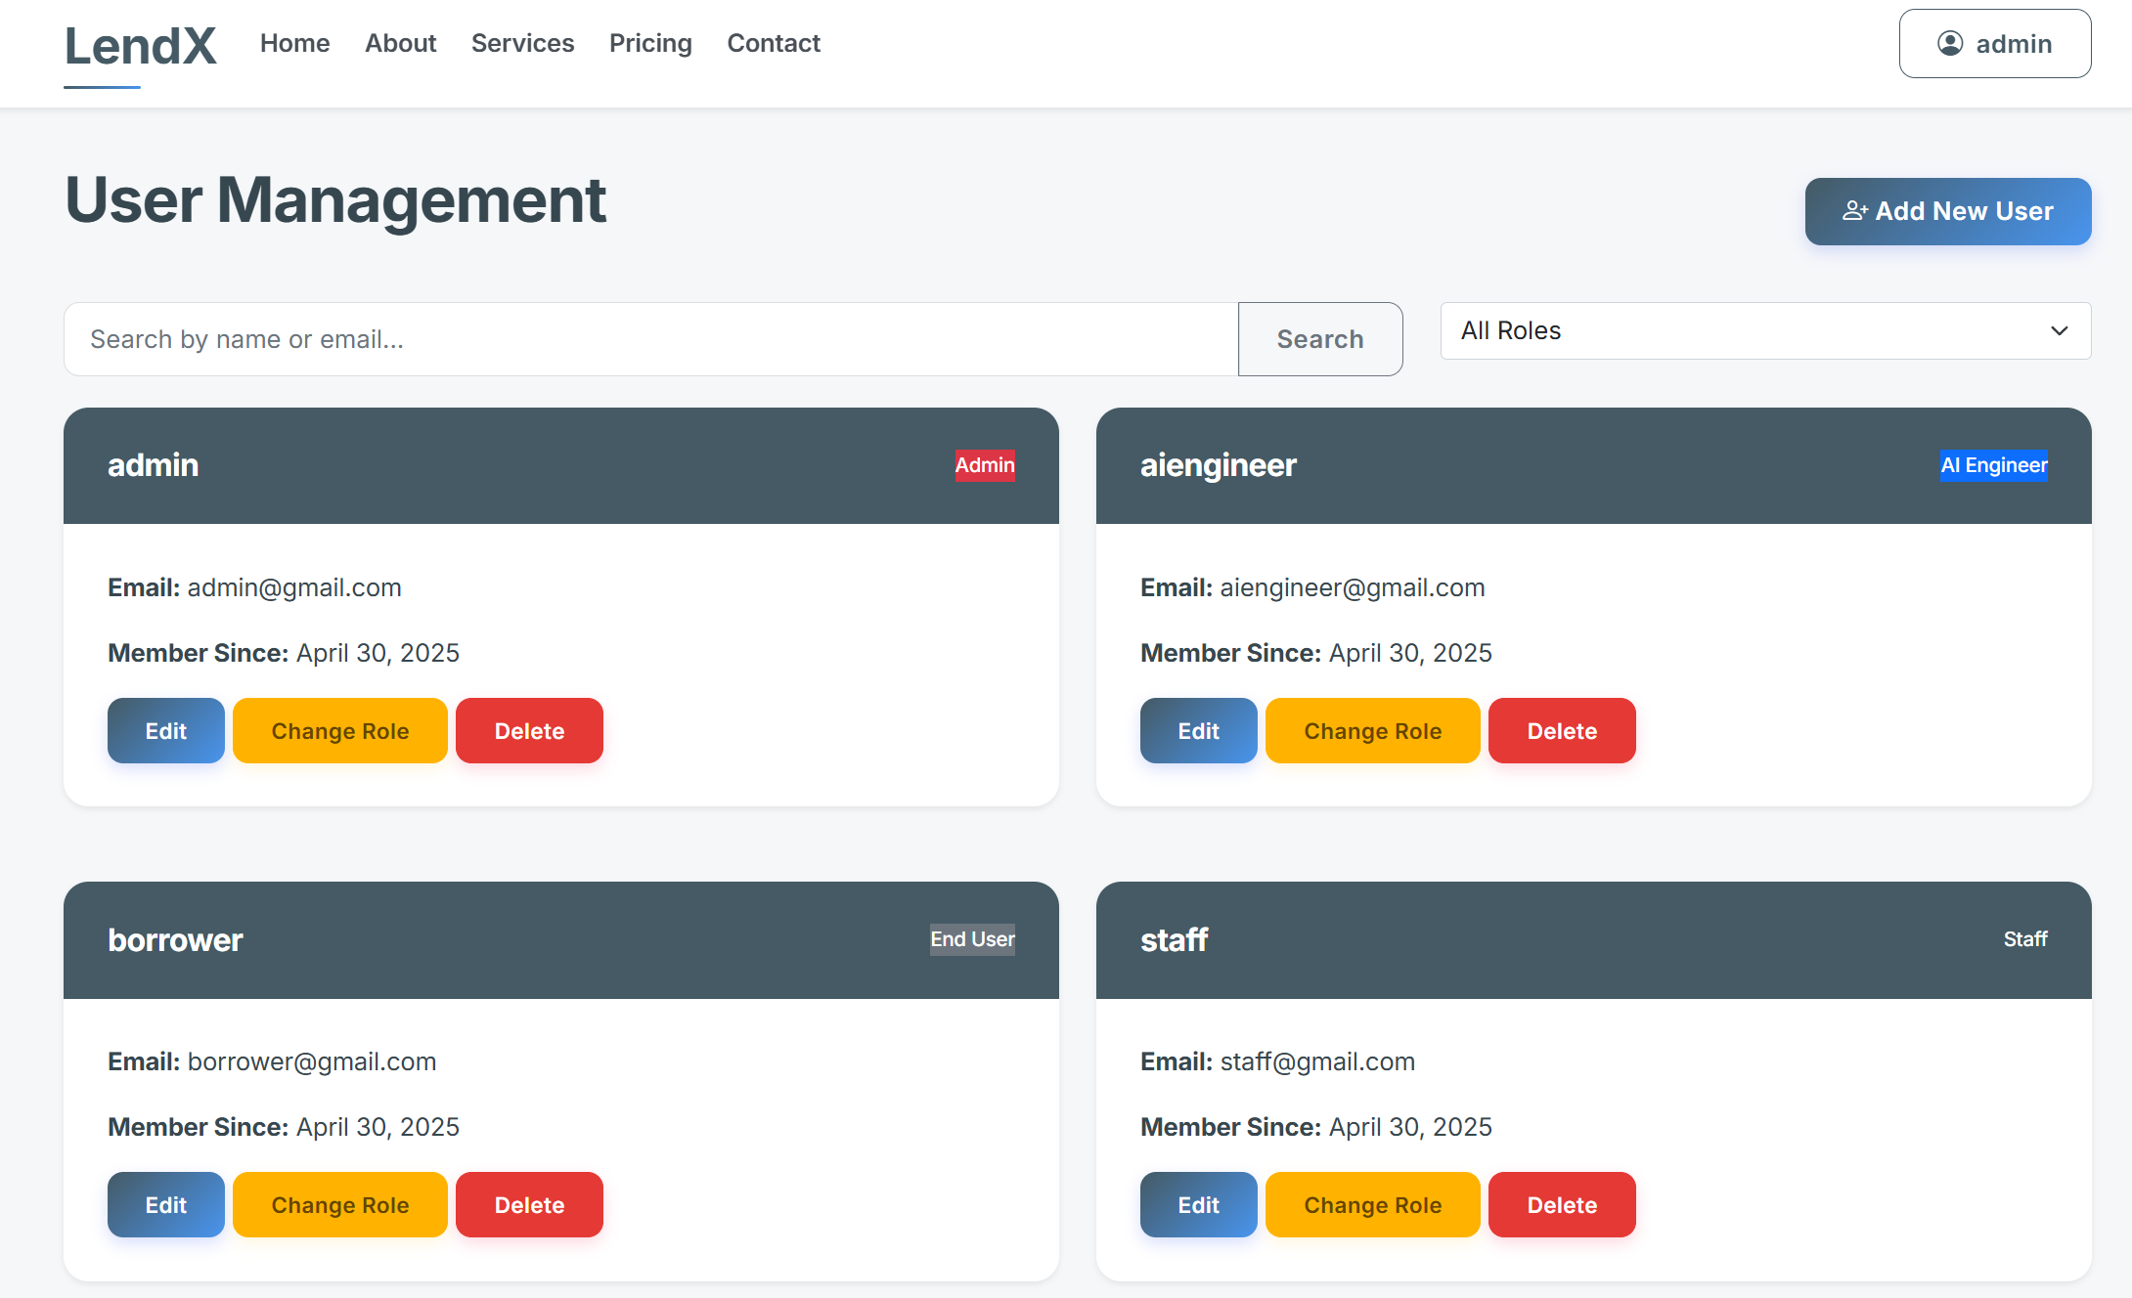

*Figure (): User Management UI page for administrator*

## SPRINT 3 – Borrowers and Loan Officers Functionalities

### ML Service Integration Challenges

In this part I faced some issues to integrate my developed ML and XAI service API into my Django project. I initially assumed FastAPI and Django could be directly integrated as Python libraries. This proved impossible due to fundamental architectural differences—Django uses WSGI while FastAPI uses ASGI. Both frameworks have incompatible application lifecycles and middleware systems, leading to runtime errors during my integration attempts. I ultimately had to redesign my integration approach entirely. I have implemented the approach below to overcome this.

In the main.py of FastAPI directory, CORS (Cross-Origin Resource Sharing) middleware is used to allow FastAPI applicaiton to communicate safely and accept requests from the Django app.

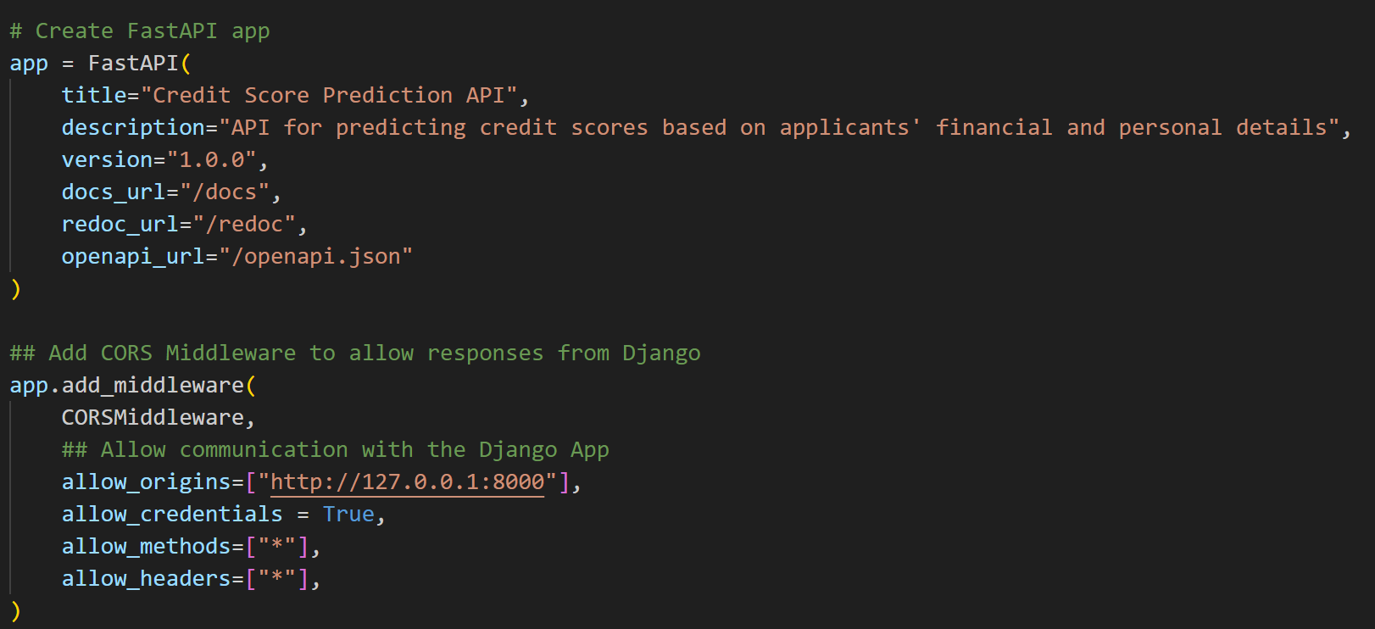

*Figure(): middleware configuration*

A dedicated client class MLApiClient is created in ml_api_client.py to handle all communication with FastAPI service. This client abstracts away the HTTP communication details, making it easy to call FastAPI from any part of the Django application.

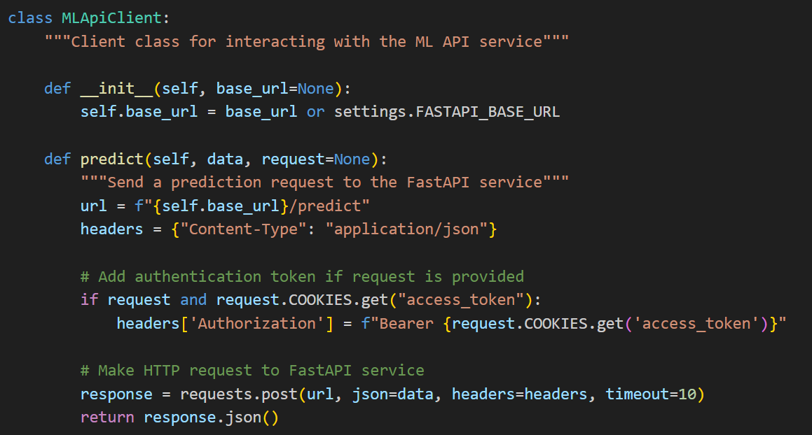

*Figure (): MLApiClient*

I implemented JWT authentication in both services Django views.py and FastAPi/auth to ensure tokens generated in Django were valid in FastAPI.

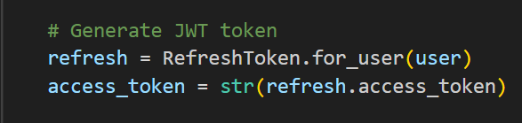

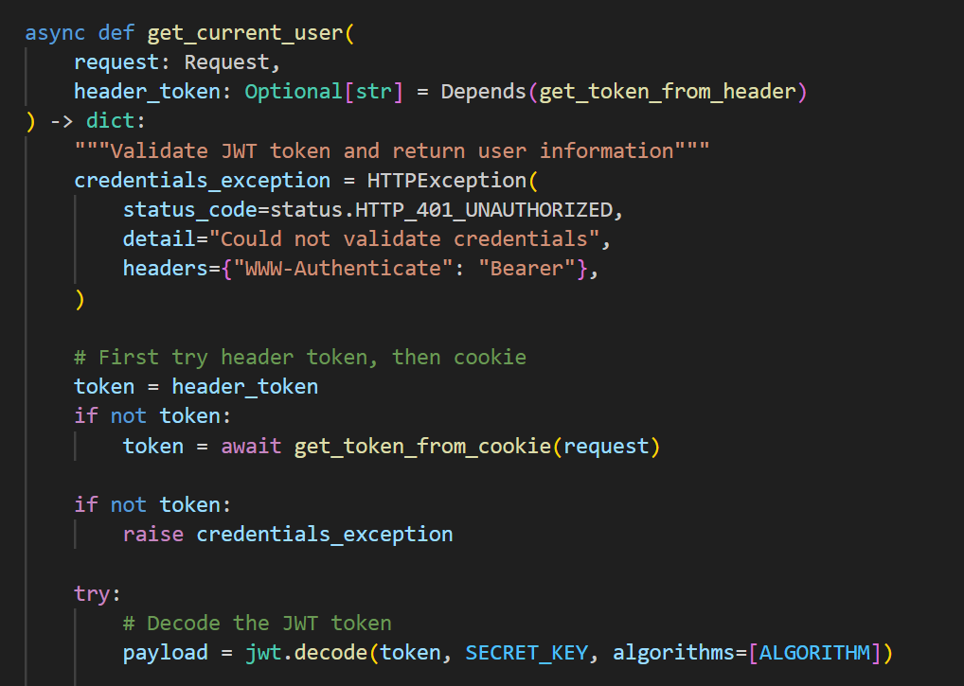

In settings.py, the configuration variable FAST_BASE_URL defines the FastAPI service location, which is to make the FastAPI endpoint configurable through environment variables, allowing different environments to use different endpoints.



These settings allow communication between Django and FastAPI.

### Borrower Functionalities Development

#### 6.3.2.1 Loan Application Form

The first part is to create a Loan Application Form with input validation such as required fields, input type validation, and range constraints. JavaScript Validation is also used for percentage field handling, rounding handling and form submission validation.

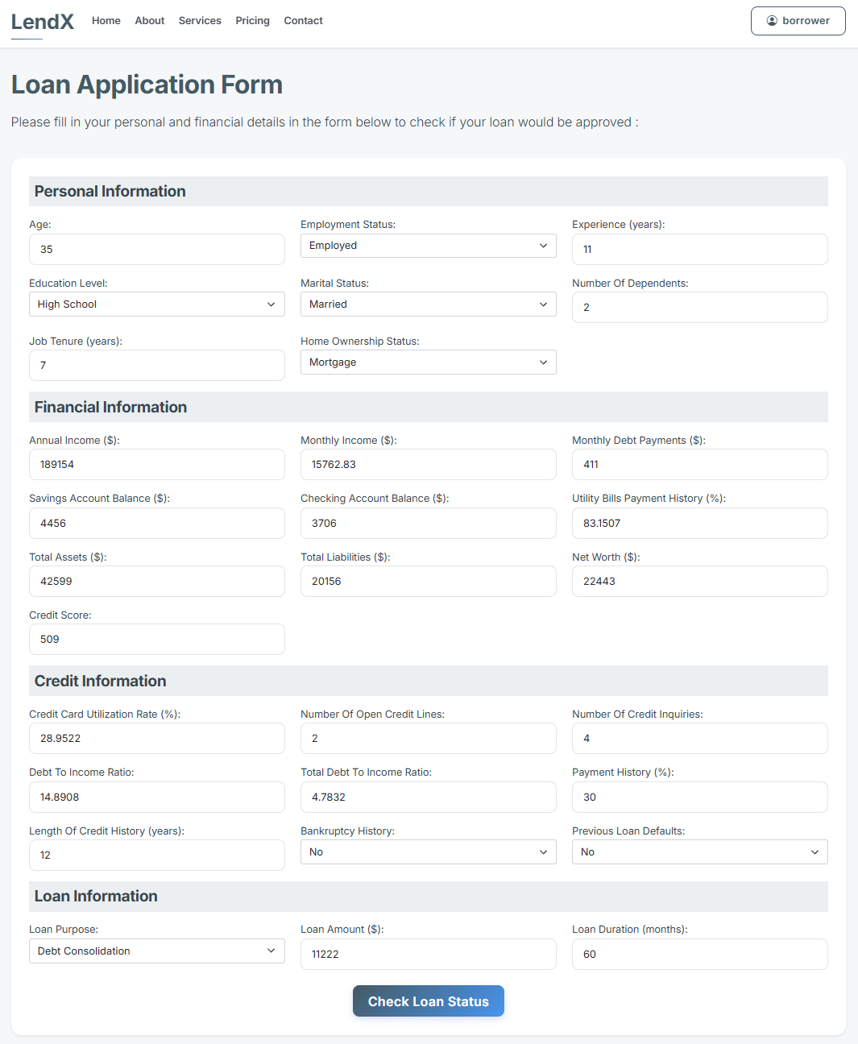 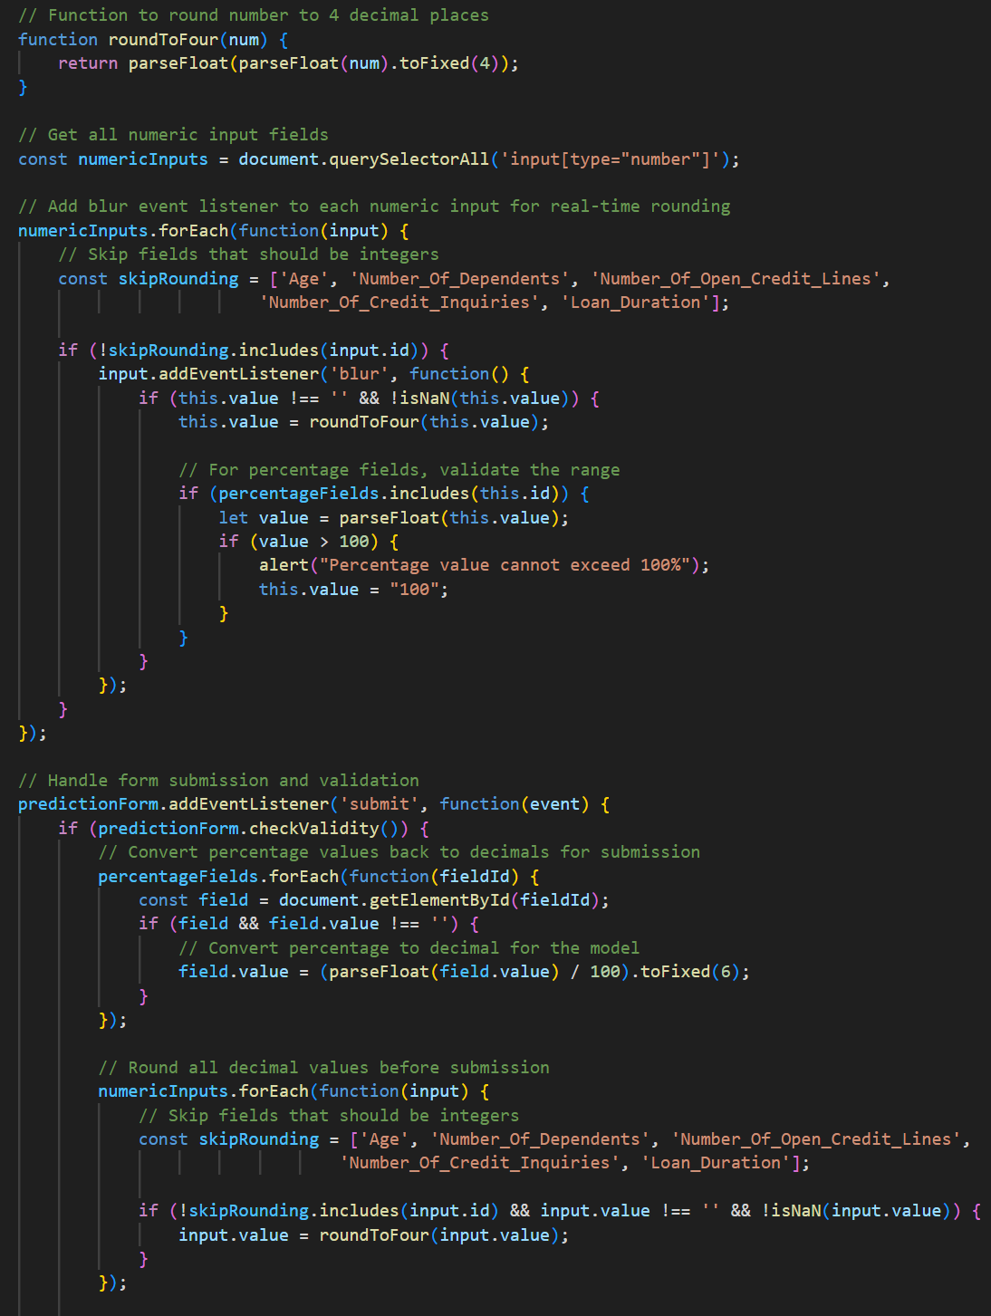

*Figure(): UI for Loan Application form*

The form collects user input with proper field names matching the API requirements. In main.py (ML Service API), the data arrives as a JSON payload and is converted to a Python dictionary.

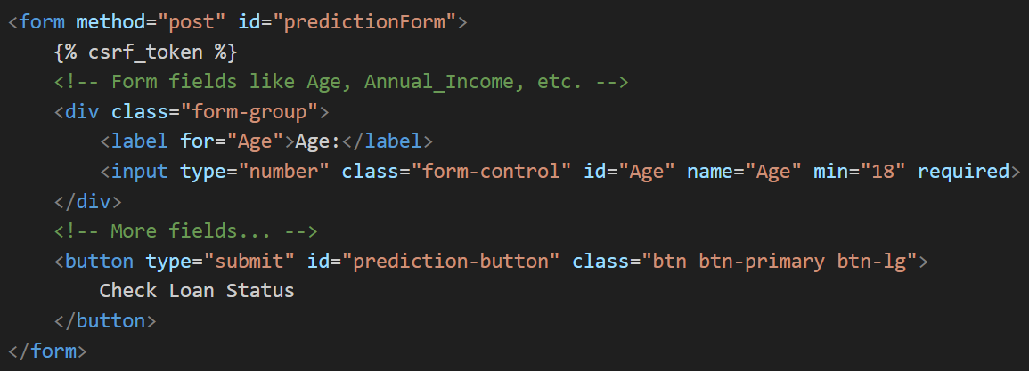

Figure(): Application Form Structure with HTML Form Control

#### 6.3.2.2 Loan Status Prediction

The complete loan application workflow is processed using prediction_form view function. When a form is submitted (POST request), the function extracts all form fields and performs data type conversion. The function communicates with the FastAPI service through the predict() function imported from utils.ml_api_client. Then the key information from the FastAPI response are extracted to ensure the explanation data is properly structured for the template.

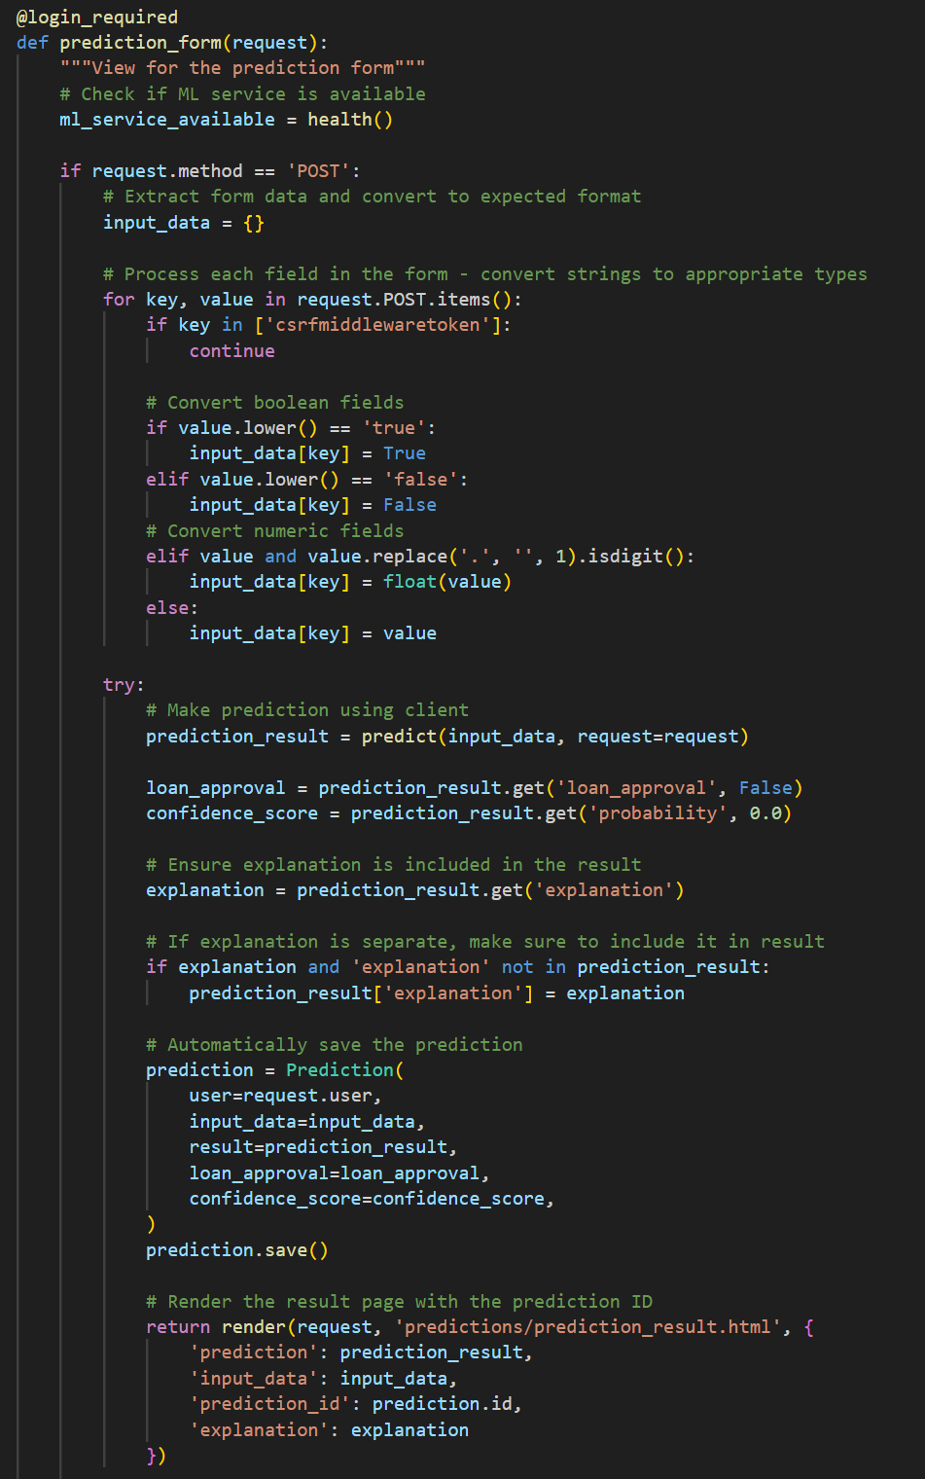

Handle Form Submission and Datatype conversion

Send request to FASTAPI to make predictions and get explanations

Save to database and render results in UI

*Figure(): prediction_form view function*

#### 6.3.2.3 Result Analysis and Explanation

In the prediction result and explanation page, first the loan applicant will see the loan decision with confidence score, which accessed from the FastAPI ML and XAI services. Next, applicants can check the submitted input summary in the dropdown session under the prediction result.



*Figure(): Loan Decision Summary Interface*

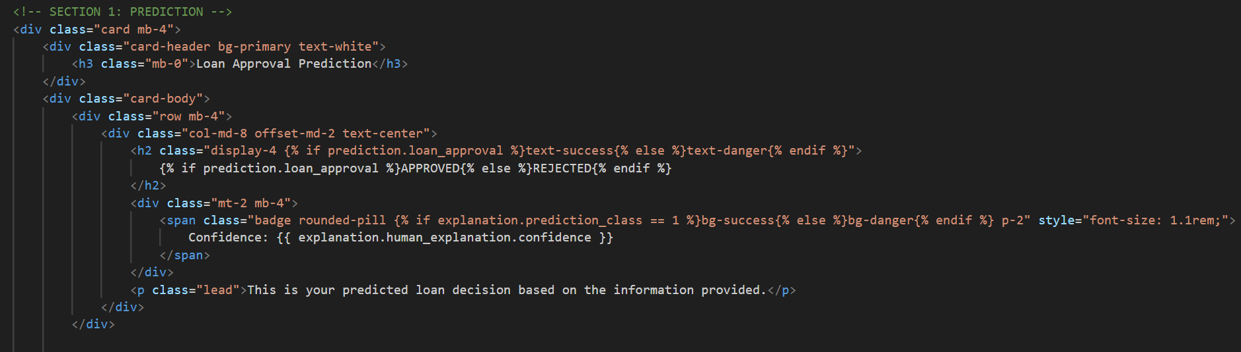

*Figure(): Front end for Loan Decision*

After the prediction result, the loan applicants can view the prediction explanations in the next section on the same page, which consist of 3 main parts: decision making process, feature contributions, and SHAP visualizations.

The first part of the explanation will be the decision process of the prediction. The first step is to calculate the log-odds space, which is the sum of the base value and total feature contributions.

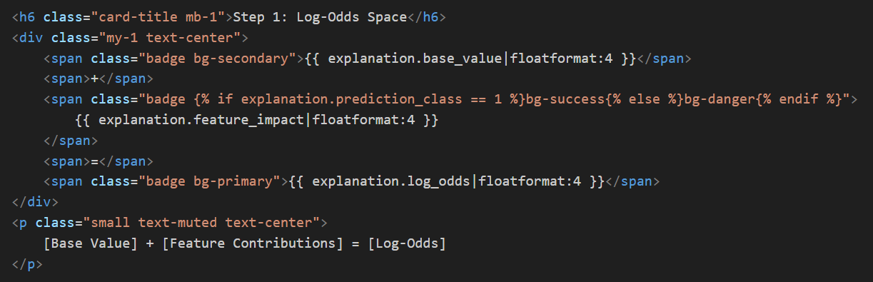

*Figure(): Template component for log-odd calculations step display*

The second step is to convert the log-odds to the probability (of approval) using the sigmoid function.

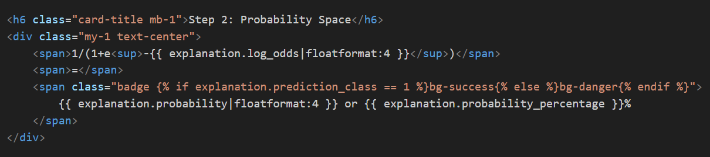

*Figure(): Template component for probability conversion step display*

The third step is to visualize the probability distribution using dynamic pie chart and explain the threshold-based decision. The probability must greater than the threshold (0.5) for the model to approve it.

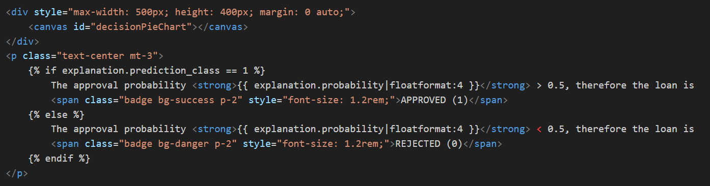

Figure(): Template component to visualize probability and threshold-based decision

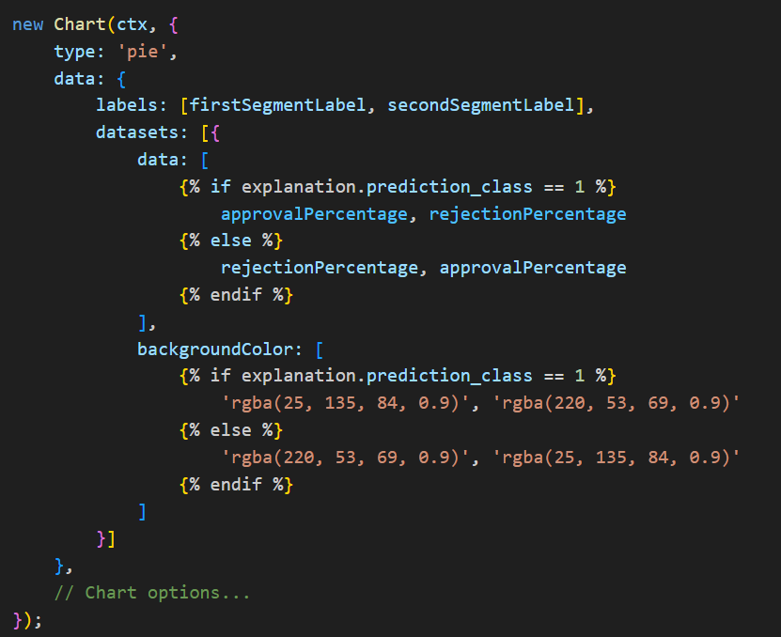

This is the interface displayed to the loan applicants.

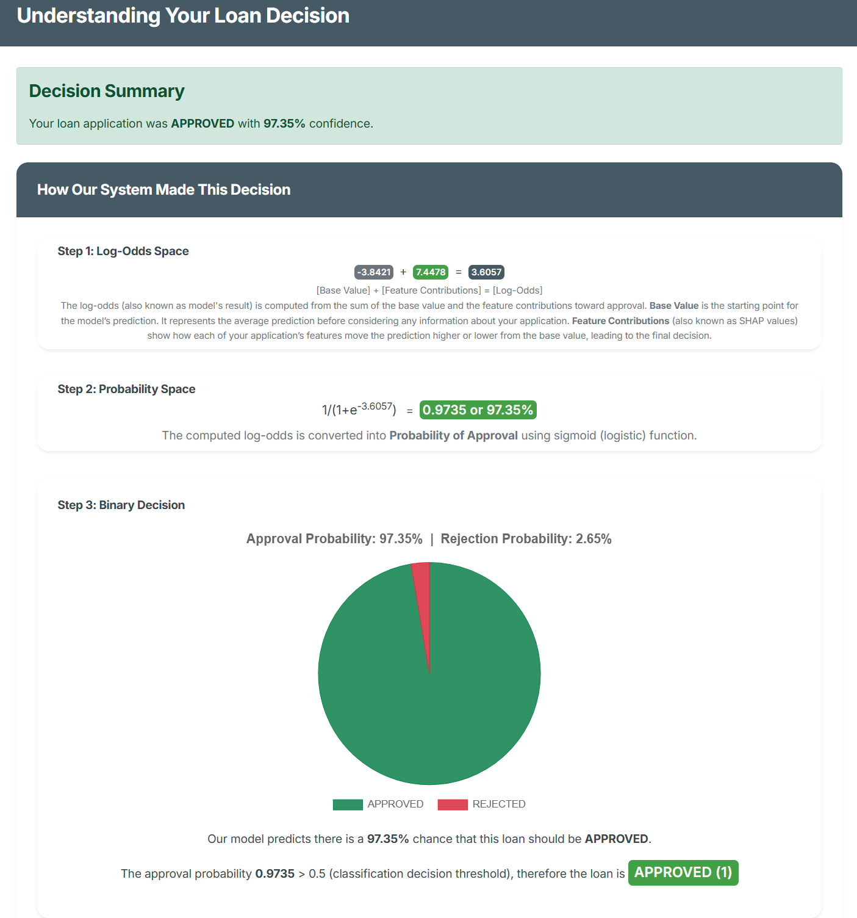

*Figure() : Explanation Part 1 – Three steps decision process visualization*

Next part of the explanation is the feature contribution. The dynamic dual card display is the cornerstone of the SHAP explanation system, designed to present complex machine learning insights in an immediately comprehensible format. Because of its context-awareness, the display automatically adapts all content based on the prediction outcome:

**For Approval Decisions (Class 1)**:

* Left card (green): "Factors that increase your APPROVAL likelihood"
* Right card (red): "Factors that increase your REJECTION likelihood"

**For Rejection Decisions (Class 0)**:

* Left card (red): "Factors that increase your REJECTION likelihood"
* Right card (green): "Factors that increase your APPROVAL likelihood"

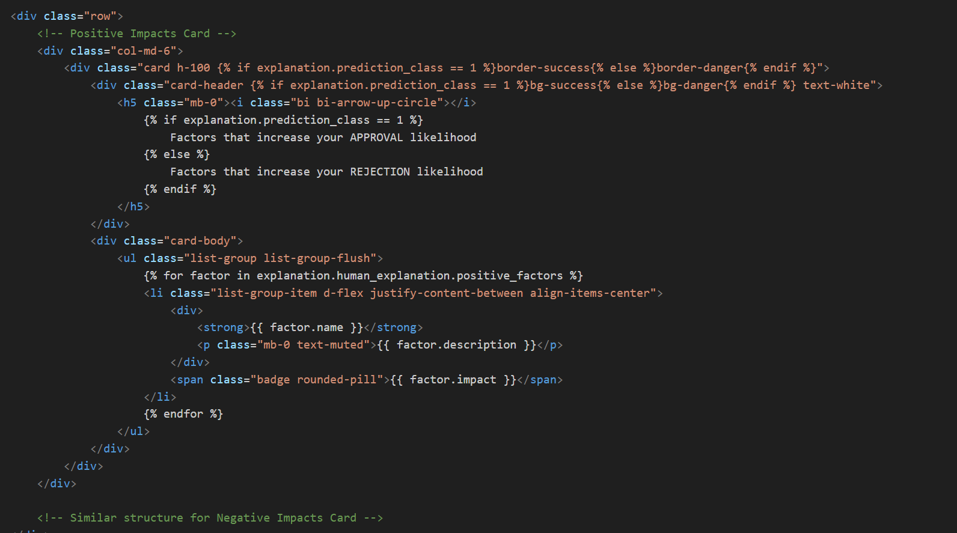

*Figure(): Template component for feature contributions display*

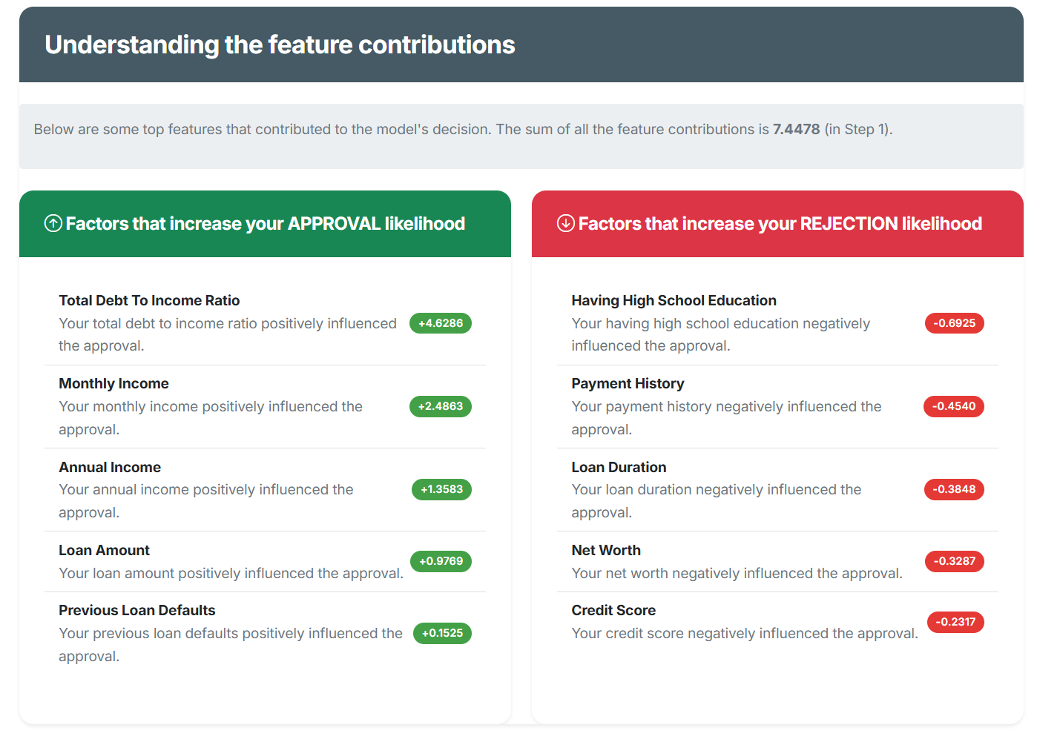

*Figure() : Explanation Part 2 – Feature Contribution*

For users seeking deeper insights, the system provides multiple technical visualizations such as force plot, waterfall plot and summary bar plot. For users seeking deeper insights, the system provides multiple technical visualizations. The base64-encoded PNG image generated from the FastAPI services are passed to the template, and same thing goes on the waterfall plot and summary plot.

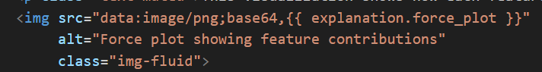

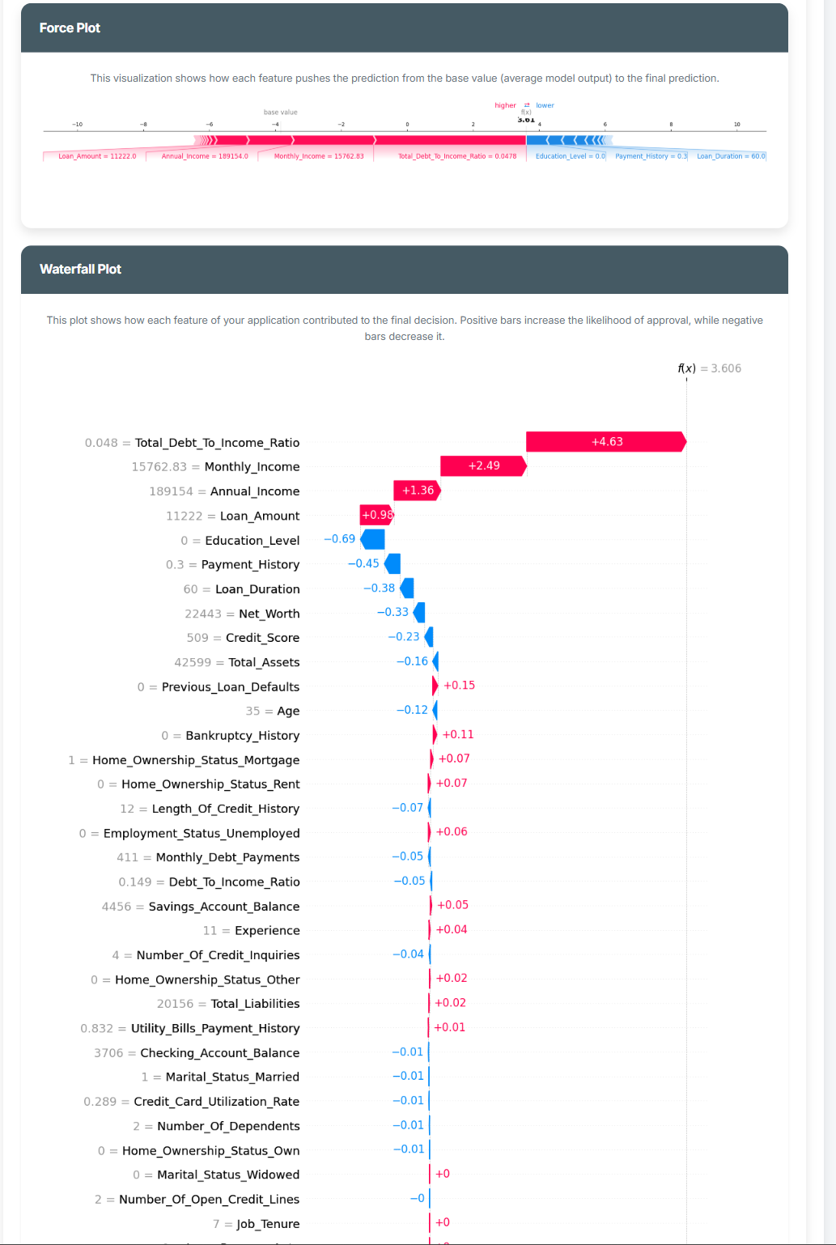

*Figure(): Explanation Part 3 – Force Plot in prediction explanation*



*Figure(): Explanation Part 3 – Waterfall Plot in prediction explanation*

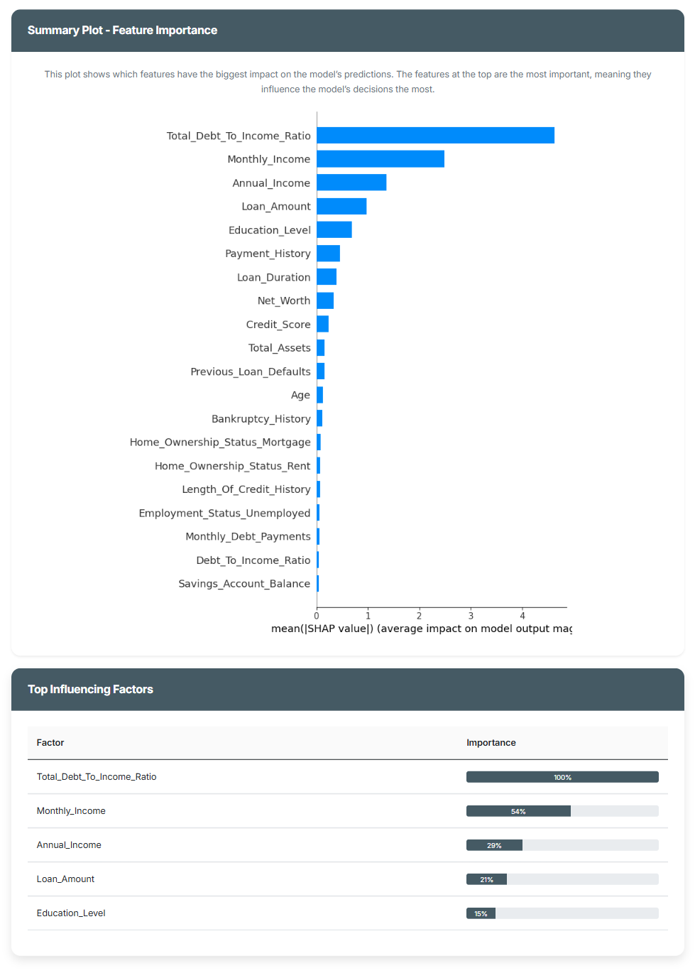

*Figure(): Explanation Part 3 – Summary Bar Plot in prediction explanation*

Another page ‘prediction history’ are created with the functionalities to let loan applicants to view the past application details or confirm the unconfirmed application. This view queries the database for all predictions associated with the current user and displays them in chronological order. The template renders each prediction with key information.

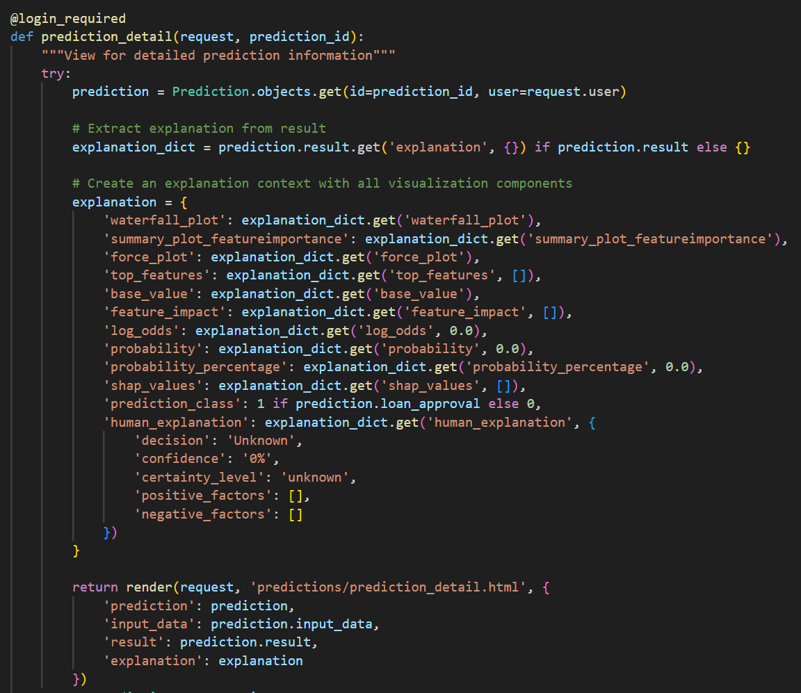

*Figure(): prediction_detail endpoint*

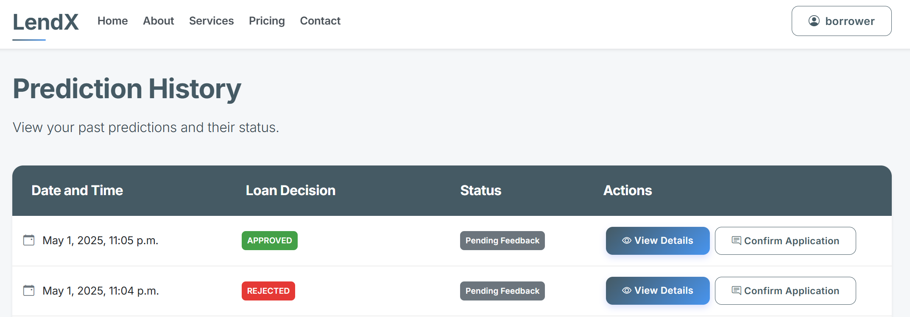

*Figure(): UI for borrower to view past application details*

### Loan Officers Functionalities Development

The staff_aiengineer_prediction_detail view has implemented staff functionality to review loan applications, manage application history, and override decisions.

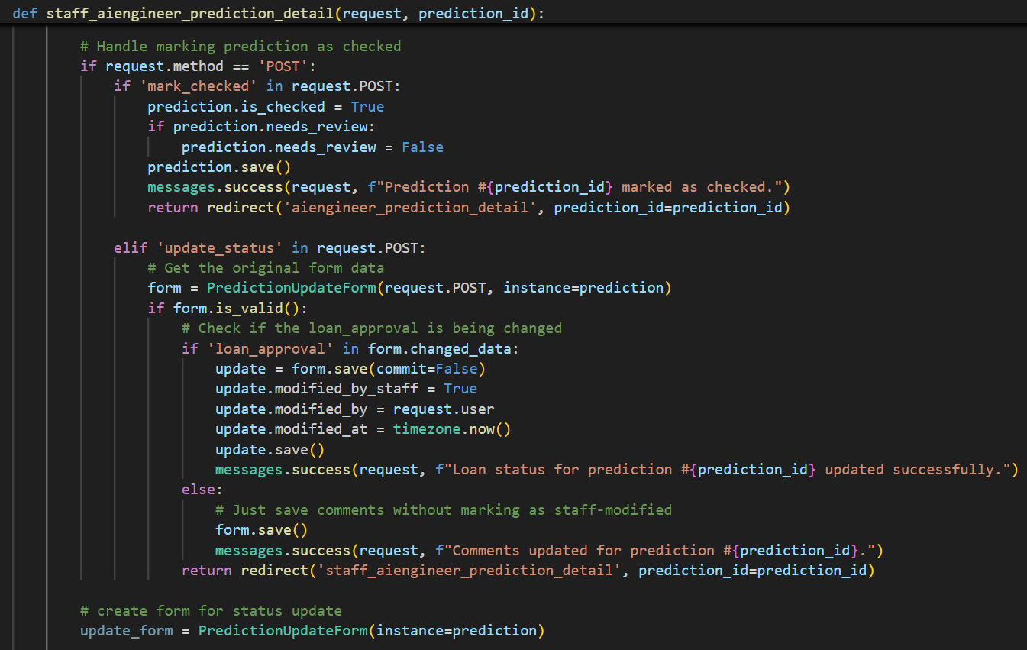

Mark loan application

record as

checked

Override predicted

loan decision

*Figure() : Views to mark as checked and override predicted loan decision*

On the ‘Manage Loan Applications’ page, loan officers can view application summaries data, filter the records, and mark applications as checked. This is achieved using if-else conditional statements, so that these specific functions are displayed only if the user’s role is staff.

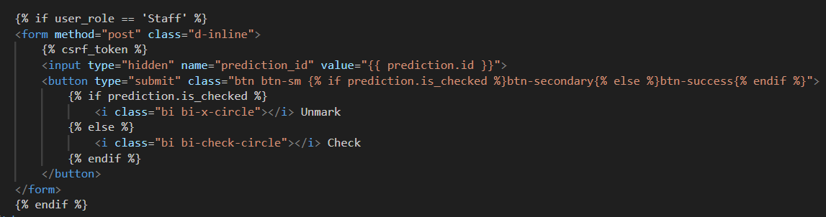

*Figure (): Conditions for only Staff to mark applications as checked*

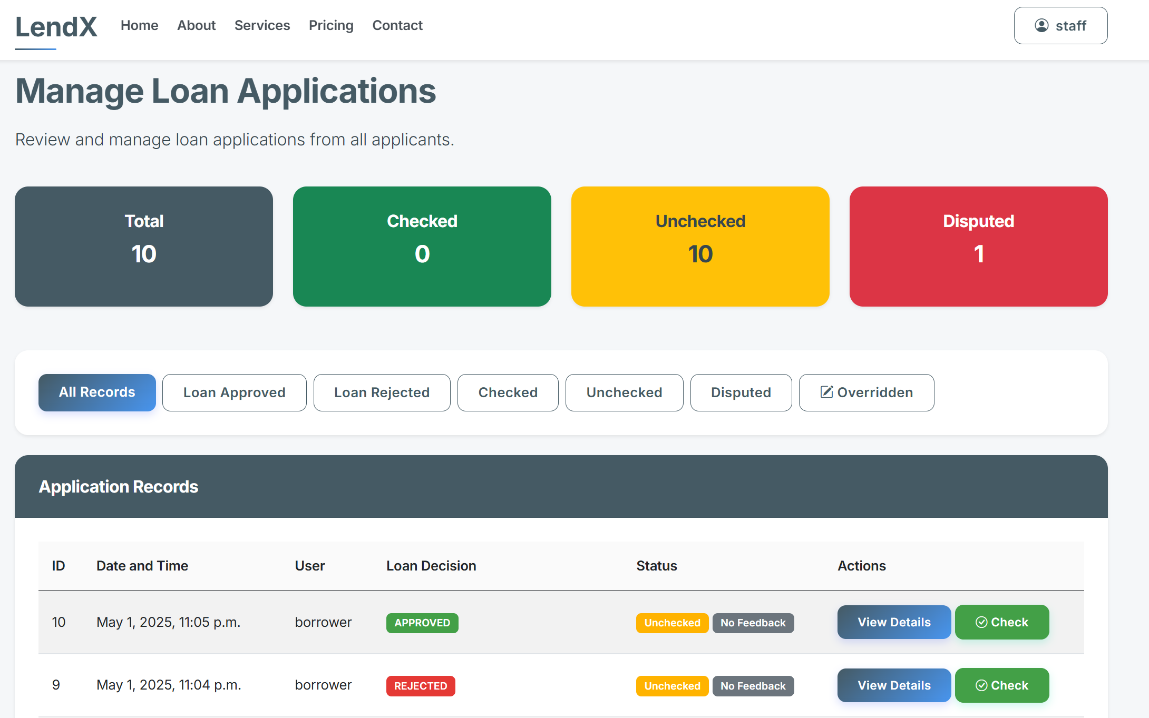

Filter Buttons

Mark as Checked or View Loan Details

Summary

*Figure() : UI for loan application management functionality*

The loan officers are provided with a form to override the predicted loan decisions when necessary and add comments explaining the override decision. If the loan officer updates the specific application, it will be updated across the system with a flagged badge ‘Overriden By Staff’

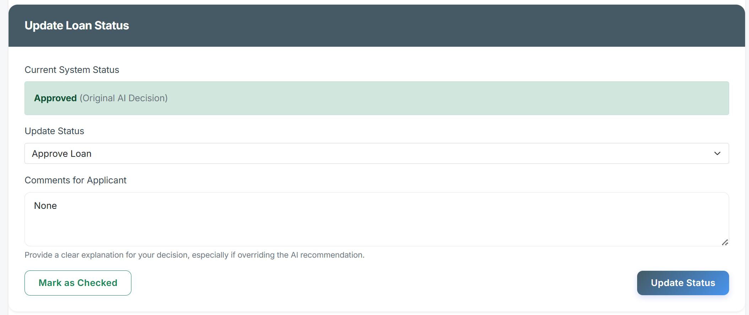

*Figure(): UI for update predicted loan status*

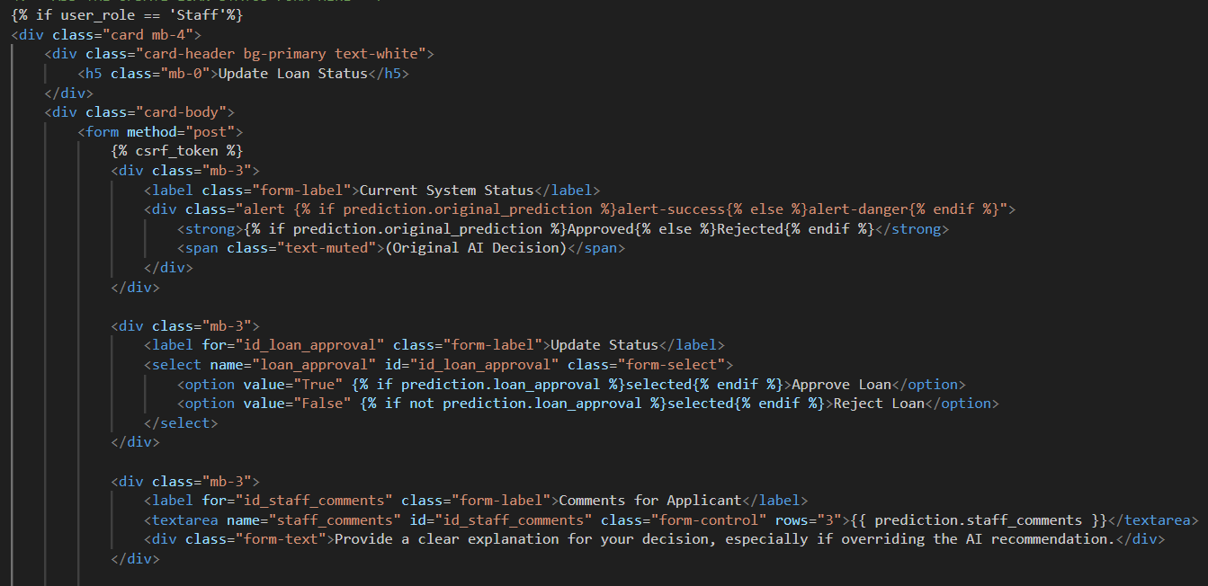

*Figure(): Condition for only staff can override the loan decision*

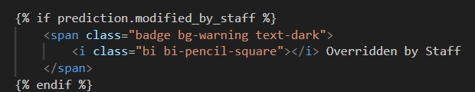

Figure(): Condition to add a flag for overridden loan decision

## SPRINT 4 – AI Engineer Functionalities

### ML Model Management

In this part, the functionalities for AI Engineers to perform CRUD on the ml models are developed.

The model_management endpoint processes form submissions for new model uploads, including validating file types and capturing metadata such as whether the model requires feature scaling.

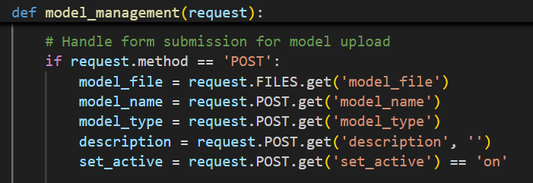

*Figure() : model_management endpoint*

The set_model_active endpoint handles the process of activating a model by copying it to a designated directory where the FastAPI service can access it. It also generates a metadata file containing the requires_scaling flag which determines preprocessing requirements, then notifies the FastAPI service to reload the model..

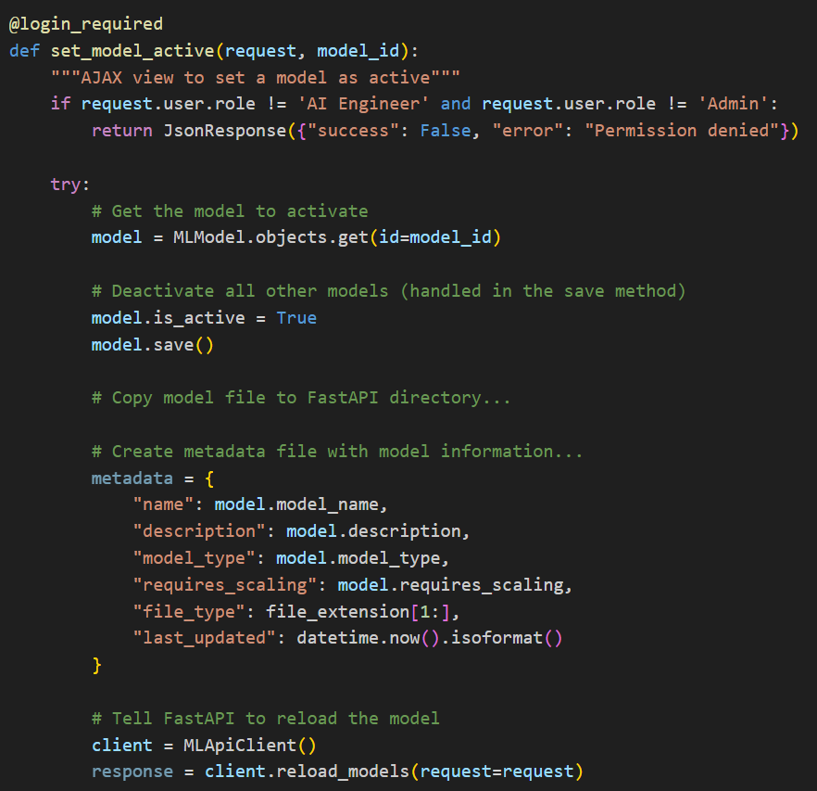

*Figure(): delete_model endpoint*

The delete_model endpoint handles the model deletion and also attempts to delete the actual file from the file system.

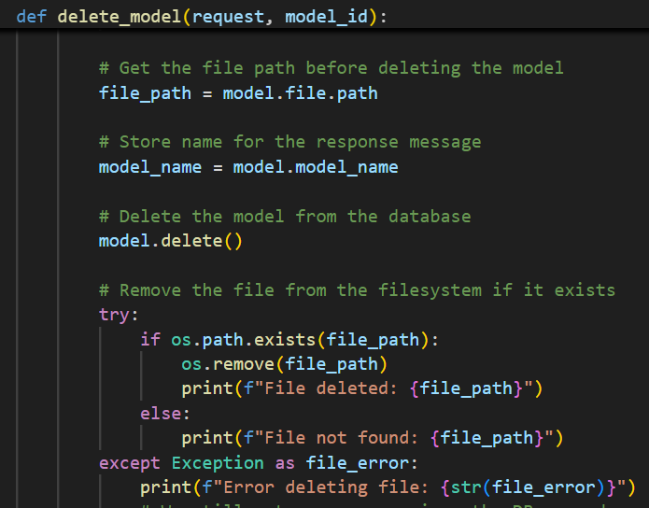

*Figure(): delete_model endpoint*

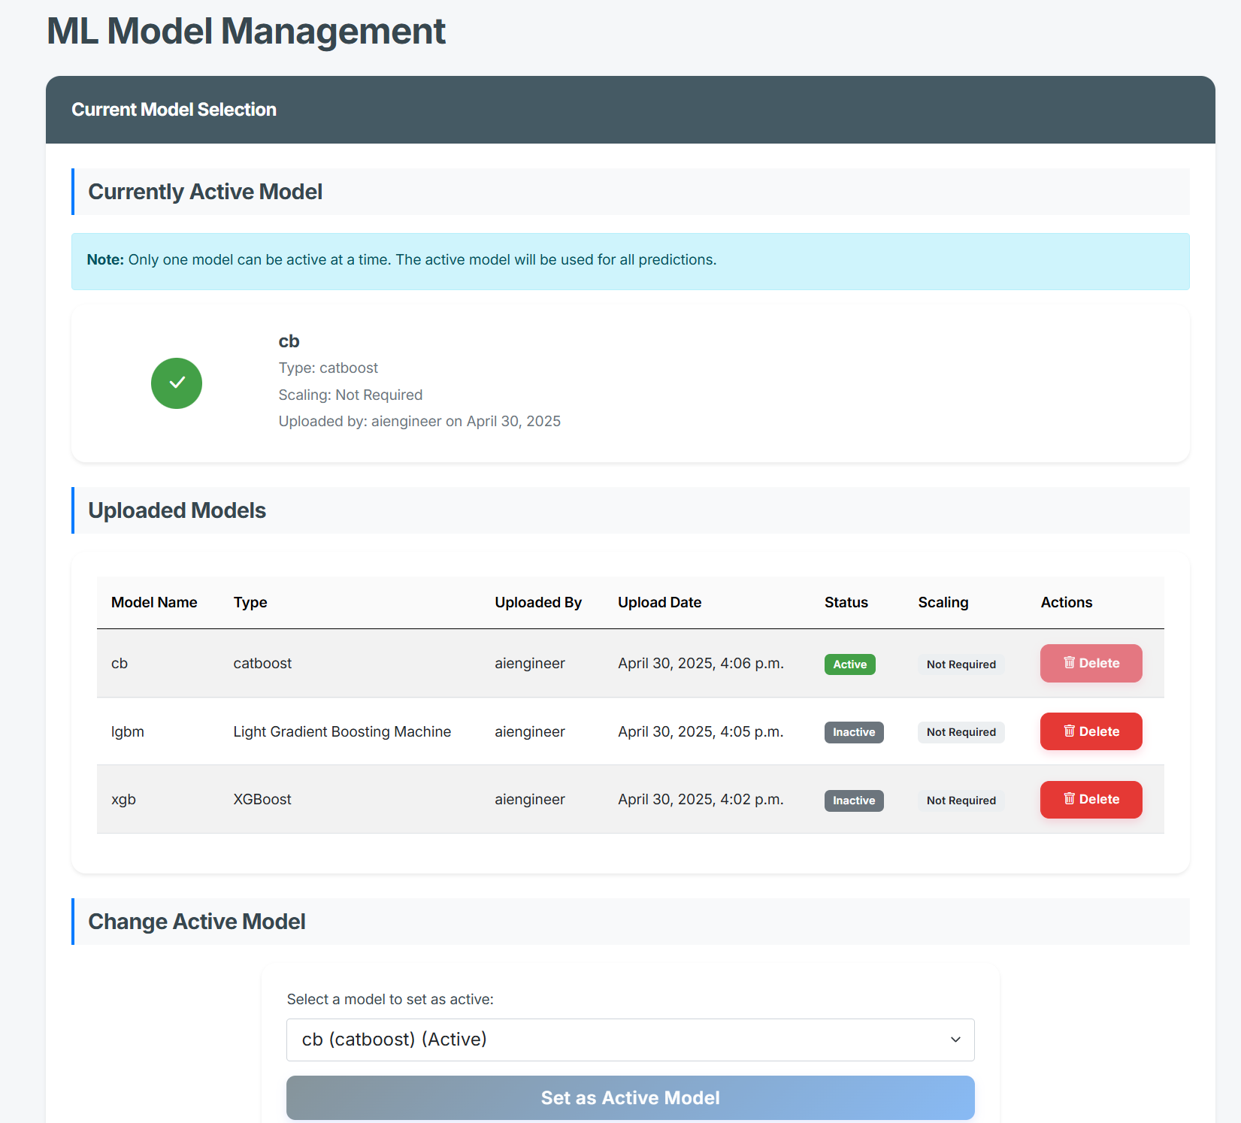

Display available model and provide button for deletion

Display Currently Active Model

Change active model

*Figure(): UI for ML Model Management*

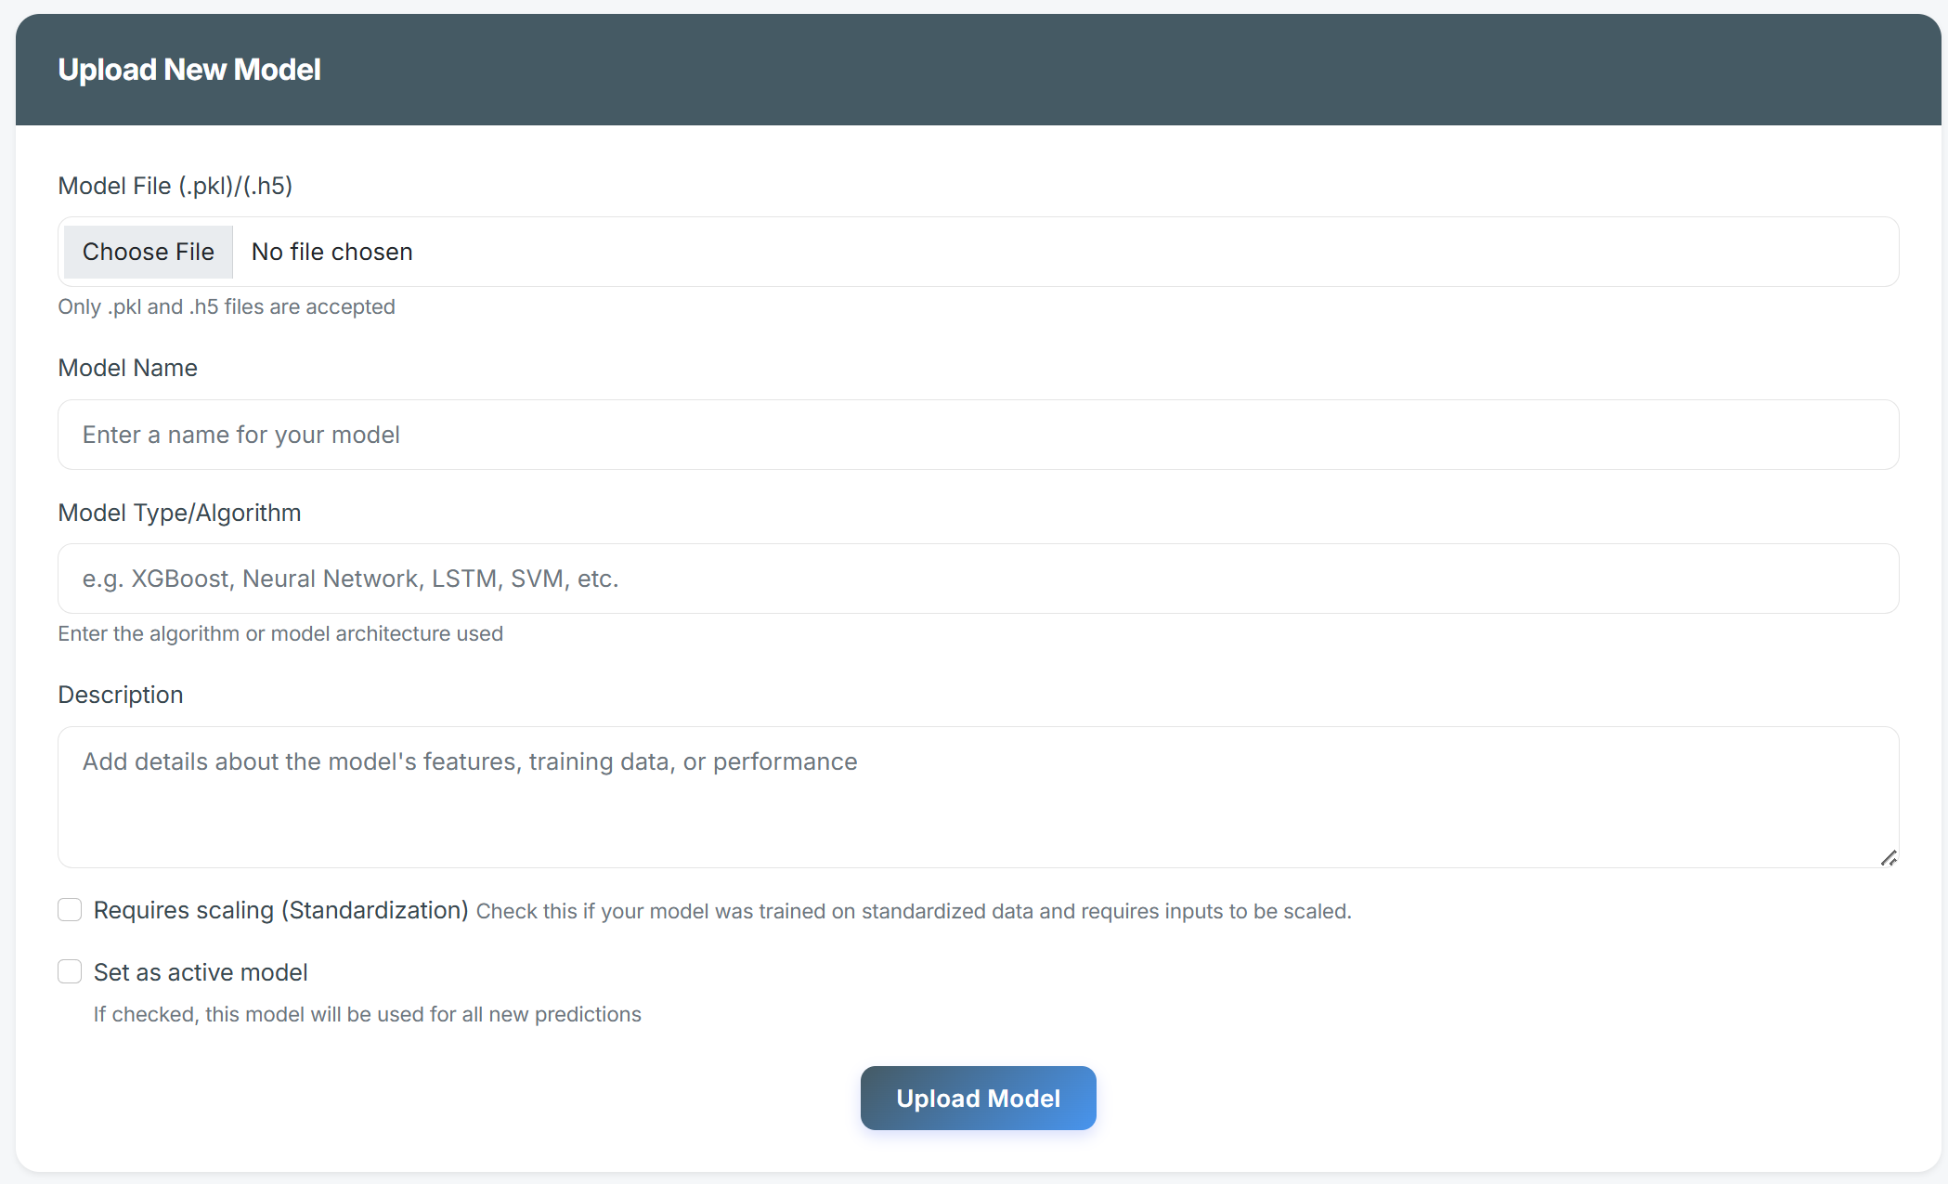

*Figure(): UI for uploading new model*

### Review Loan Application Records

In this part AI Engineers will be given access to view the same loan application records page as the staff, but they are not given access to check or override the AI loan decision.

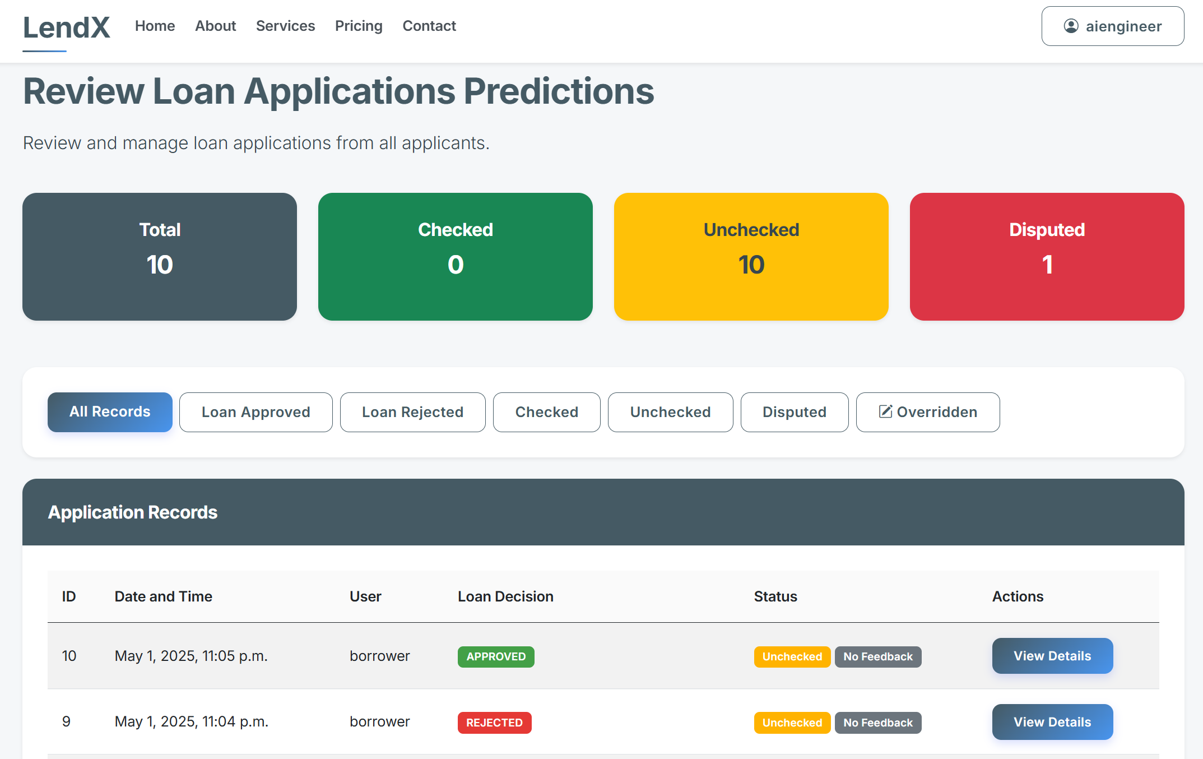

*Figure(): UI for reviewing loan application records*

# 7.0 Project Evaluation

Overall, this is a challenging project for me as I am new to this research topic, Explainable AI, and it is a new and rapidly evolving field with limited research and supporting materials available. Additionally, all the tools used for the implementation were unfamiliar to me, which added to the difficulty. However, through dedication and with the support of my supervisor, I was able to overcome these challenges.

## 7.1 Aims and Objectives

All the defined aims and objectives of this project have been fully accomplished. I successfully developed a functional and user-friendly loan credit assessment system that enables financial institutions to evaluate the creditworthiness of borrowers while delivering clear, actionable insights to support automated lending decisions. The ML models implemented for loan approval prediction achieved strong performance, and the integration of XAI techniques (SHAP) allowed the system to provide transparent and interpretable explanations for each prediction. This not only enhances user trust but also ensures compliance with regulatory requirements for explainability. Following the valuable advice of my project supervisor, Prof. Jun Hong, I was able to narrow the project scope and clearly specify the problem, which contributed significantly to the clarity and successful attainment of my aims and objectives.

## 7.2 Literature Review

In the literature review I did a in-depth analysis of the background of credit risk assessment including the concepts an context, application of AI in this field, and the challenges of existing ai adoption in this field and thorough xai research including historical development, concepts, its importance in credit risk assessment, approach and techniques, evaluation metrics, its adoption in my research field and also its limitations. Overall, the literature review equipped me with a solid theoretical foundation, helped me identify gaps and opportunities for innovation, and informed my methodological choices, ultimately resulting in a more robust, relevant, and responsible credit risk assessment solution.

## 7.3 Requirements

The requirements phase was a strength of the project, thanks to thorough research and clear prioritization. By studying existing literature, I identified critical needs like transparency and sorted requirements into priority categories like "must-have" and "could-have." This kept the project focused on essentials, such as SHAP explanations and loan decision overrides. I was pleasantly surprised to implement most of the "could-have" requirements, such as letting AI engineers update models through the interface, which made the system more robust than initially planned. The structured approach ensured the final system not only met core goals but also included user-friendly additions, like dispute resolution for borrowers, that enhanced its value. This experience showed how good planning, backed by research, can turn ambitious ideas into a functional, user-centered solution.

## 7.4 Methodology

In methodology, I followed the Agile software development methodology especially sprint planning that allows incremental delivery of project. The flexibility of this methodology allows me to refine priorities mid-sprint. The issues I faced here is uneven workload distribution, my Sprint 1 (ML/XAI development) was overloaded with excessive tasks while Sprint 4 (AI engineer features) had lighter workloads. This imbalance caused stress and delayed Sprint 1 by 1 week. For future projects, I will use story points for task estimation and distribute high-effort tasks across sprints.

## 7.5 Implementation

During the implementation phase, I encountered a significant challenge related to framework incompatibility, stemming from my limited experience with web frameworks. I initially underestimated the architectural differences between Django (WSGI-based) and FastAPI (ASGI-based), mistakenly assuming they could be integrated without issue. This knowledge gap led to substantial integration difficulties in Sprint 3, resulting in time-consuming rework to address protocol mismatches. I spent few days to find out the solutions. Upon identifying the root cause, I explored middleware solutions, such as Django’s JWTCookieMiddleware, which ultimately resolved the issue but at the cost of valuable development time. This experience highlighted the importance of thoroughly researching framework compatibility before attempting to integrate multiple technologies, and I will prioritize this in my future projects.

## 7.6 PIP Feedback

The feedback I received from my supervisor, Prof. Jun Hong during the “Project-In-Progress” day is extremely beneficial. He acknowledged my current efforts in the reports and initial development. He also confirmed my project development plans (which were planned after PIP) were on the right track, which enabled me to continue the project development with strong confidence. I managed to meet my second marker, Dr Elias Pimenidis to make sure that my project objectives are clear.

## 7.7 Project Limitation

|  |  |
| --- | --- |
| **Limitations** | **Improvement** |
| The use of a **single machine learning model** in the current system, such as basic XGBoost Classifier offers ease of explainability but inherently limits the system’s ability to capture complex, non-linear relationships within the loan applicant data. This can result in the model overlooking subtle patterns and interactions between variables, leading to less accurate or reliable loan predictions, especially as data complexity increases. | To overcome this limitation, more sophisticated modelling approaches—such as ensemble methods (such as Stacking or Voting) or deep learning techniques should be explored. These models are capable of learning intricate patterns and managing higher-dimensional data, which can significantly enhance predictive accuracy and robustness. Additionally, conducting careful hyperparameter tuning and cross-validation can further boost model performance and generalizability. |
| The current system relies on **synthetic datasets** for model development and evaluation, while useful for initial testing and experimentation, presents a major limitation because such data often lacks the complexity, variability, and real-world nuances found in actual loan applicant information. Synthetic data may fail to represent rare cases, edge scenarios, or true distribution of features, which can result in poor generalization of model in real-world applications. | To address this, future improvement should prioritize obtaining real-world datasets that reflect the genuine diversity and complexity of actual loan applications. By incorporating authentic data, the model can be trained and validated on information that includes complexity, variability, and rare cases present in real applicant populations. This not only allows the model to learn more effectively from real-world patterns but also enhances its ability to capture complex relationships and scenarios that synthetic data often fails to represent. |
| There are **limited explainability approaches** in the current system, primarily relying on SHAP values to interpret model predictions. While SHAP provides valuable insights into feature importance for each decision, this approach may not be sufficient for users who need deeper, more interactive, or more accessible explanations. This limitation can hinder user trust, especially for those unfamiliar with technical concepts or for borrowers from diverse backgrounds. | Future projects should expand beyond static SHAP visualizations by integrating interactive "what-if" scenario tools that leverage SHAP counterfactuals. These tools would empower users to actively explore how changes in their application data, such as increasing income or reducing existing debt could influence their credit assessment, thereby making model decisions more transparent and actionable. Furthermore, providing explanations in multiple languages would cater to a more diverse user base, ensuring that all users can clearly understand the reasoning behind credit decisions. Exploring additional explainability methods, such as LIME or counterfactual explanations, and designing easy-to-understand visualizations would further enhance transparency, user trust, and regulatory compliance. |

*Table(): Project Limitations and the Improvements*

# 8.0 Conclusion and Further Work

## 8.1 Conclusion

## 8.2 Future Work

# 9.0 Glossary and Table of Abbreviations

|  |  |
| --- | --- |
| **Abbreviations** | **Description** |
| ML | Machine Learning |
| XAI | Explainable Artificial Intelligence |
| SHAP | Shapley Additive Explanation |

# 10.0 References

1. Adel Abusitta, Li, M.Q. and Benjamin C.M. Fung (2024). Survey on Explainable AI: Techniques, challenges and open issues. Expert Systems with Applications, pp.124710–124710. doi:https://doi.org/10.1016/j.eswa.2024.124710.
2. Ariza-Garzon, M.J., Arroyo, J., Caparrini, A. and Segovia-Vargas, M.-J. (2020). Explainability of a Machine Learning Granting Scoring Model in Peer-to-Peer Lending. IEEE Access, 8, pp.64873–64890. doi:https://doi.org/10.1109/access.2020.2984412.
3. Azith, Y., Sushma, D. and Swathi, A. (2024). IPE Journal of Management, [online] 14(5). Available at: https://www.apgcu.edu.in/pdf/mba-publications/2024-18-2.pdf [Accessed 2 Jan. 2025].
4. Banton, C. (2024). How Underwriters Assess the Risk of Insurers. [online] Investopedia. Available at: https://www.investopedia.com/terms/u/underwriting.asp.
5. Bhatore, S., Mohan, L. and Reddy, Y.R. (2020). Machine Learning Techniques for Credit Risk evaluation: a Systematic Literature Review. Journal of Banking and Financial Technology, [online] 4(1), pp.111–138. doi:https://doi.org/10.1007/s42786-020-00020-3.
6. Bhattacharya, A. (2022). Understand the Workings of SHAP and Shapley Values Used in Explainable AI. [online] Medium. Available at: https://towardsdatascience.com/understand-the-working-of-shap-based-on-shapley-values-used-in-xai-in-the-most-simple-way-d61e4947aa4e [Accessed 8 Jan. 2025].
7. Biecek, P., Chlebus, M., Gajda, J., Gosiewska, A., Kozak, A., Ogonowski, D., Sztachelski, J. and Wojewnik, P. (2021). Enabling Machine Learning Algorithms for Credit Scoring -- Explainable Artificial Intelligence (XAI) methods for clear understanding complex predictive models. [online] arXiv.org. doi:https://doi.org/10.48550/arXiv.2104.06735.
8. Bogiatzis-Gibbons, D., Charles, L., Dewing, H., Gretschel, C., Jomy, M., Reid, A. and Slack, R. (2024). A Literature Review on Bias in Supervised Machine Learning. Available at: https://www.fca.org.uk/publication/research-notes/literature-review-bias-in-supervised-machine-learning.pdf [Accessed 4 Jan. 2025].
9. Bowden, J., Cummins, M., Dao, D. and Jain, K. (2024). Explainable AI for Financial Risk Management. [online] University of Strathclyde. Available at: <https://pureportal.strath.ac.uk/en/publications/explainable-ai-for-financial-risk-management>.
10. Brock, T. (2020). Credit Scoring. [online] Investopedia. Available at: https://www.investopedia.com/terms/c/credit_scoring.asp.
11. Brock, T. (2023). What is credit risk? [online] Investopedia. Available at: https://www.investopedia.com/terms/c/creditrisk.asp.
12. Bussmann, N., Giudici, P., Marinelli, D. and Papenbrock, J. (2020). Explainable AI in Fintech Risk Management. Frontiers in Artificial Intelligence, 3. doi:https://doi.org/10.3389/frai.2020.00026.
13. Chaitanya Krishna Kasaraneni (2021). Understanding XAI and EBM - Predmatic AI - Medium. [online] Medium. Available at: https://medium.com/predmatic/understanding-xai-and-ebm-112bcc7babc3 [Accessed 8 Jan. 2025].
14. Confalonieri, R., Coba, L., Wagner, B. and Besold, T.R. (2020). A historical perspective of explainable Artificial Intelligence. WIREs Data Mining and Knowledge Discovery, 11(1). doi:https://doi.org/10.1002/widm.1391.
15. Datrics (2024). AI Credit Scoring: The Future of Credit Risk Assessment. [online] www.datrics.ai. Available at: https://www.datrics.ai/articles/the-essentials-of-ai-based-credit-scoring.
16. Davis, R., Lo, A.W., Mishra, S., Nourian, A., Singh, M., Wu, N. and Zhang, R. (2022). Explainable Machine Learning Models of Consumer Credit Risk. SSRN Electronic Journal. doi:https://doi.org/10.2139/ssrn.4006840.
17. de Lange, P.E., Melsom, B., Vennerød, C.B. and Westgaard, S. (2022). Explainable AI for Credit Assessment in Banks. Journal of Risk and Financial Management, 15(12), p.556. doi:https://doi.org/10.3390/jrfm15120556.
18. Ding, W., Abdel-Basset, M., Hawash, H. and Ali, A.M. (2022). Explainability of Artificial Intelligence Methods, Applications and Challenges: A Comprehensive Survey. Information Sciences. doi:https://doi.org/10.1016/j.ins.2022.10.013.
19. Dwivedi, R., Dave, D., Naik, H., Singhal, S., Rana, O., Patel, P., Qian, B., Wen, Z., Shah, T., Morgan, G. and Ranjan, R. (2022). Explainable AI (XAI): Core Ideas, Techniques and Solutions. ACM Computing Surveys, 55(9). doi:https://doi.org/10.1145/3561048.
20. European Commission (2024). Regulatory framework on AI | Shaping Europe’s digital future. [online] European Commission. Available at: <https://digital-strategy.ec.europa.eu/en/policies/regulatory-framework-ai>.
21. Fathima, S. (2024). LIME vs SHAP: A Comparative Analysis of Interpretability Tools. [online] Available at: <https://www.markovml.com/blog/lime-vs-shap#lime-vs-shap>.
22. Financial Stability Board (2017). Artificial intelligence and machine learning in financial services. [online] Fsb.org. Available at: https://www.fsb.org/2017/11/artificial-intelligence-and-machine-learning-in-financial-service/.
23. Goel, A. (2023). Model Explainability using SHAP (SHapley Additive exPlanations) and LIME (Local Interpretable…. [online] Medium. Available at: <https://medium.com/@anshulgoel991/model-exploitability-using-shap-shapley-additive-explanations-and-lime-local-interpretable-cb4f5594fc1a>.
24. Hashemi-Pour, C., Gillis, A.S. and Wigmore, I. (2024) What is explainable AI? - Definition from WhatIs.com. Available at: <https://www.techtarget.com/whatis/definition/explainable-AI-XAI>.
25. Heaven, W.D. (2021). Bias isn’t the only problem with credit scores—and no, AI can’t help. [online] MIT Technology Review. Available at: <https://www.technologyreview.com/2021/06/17/1026519/racial-bias-noisy-data-credit-scores-mortgage-loans-fairness-machine-learning/>.
26. ico.org.uk. (2023). Explaining decisions made with AI. [online] Available at: <https://ico.org.uk/for-organisations/uk-gdpr-guidance-and-resources/artificial-intelligence/explaining-decisions-made-with-artificial-intelligence/>.
27. Kenton, W. (2020). Black Box Model. [online] Investopedia. Available at: <https://www.investopedia.com/terms/b/blackbox.asp>.
28. Kwashie, A.A., Baidoo, S.T. and Ayesu, E.K. (2022). Investigating the impact of credit risk on financial performance of commercial banks in Ghana. Cogent Economics & Finance, 10(1). doi:https://doi.org/10.1080/23322039.2022.2109281.
29. Leslie, D. (2020). Explaining Decisions Made with AI. SSRN Electronic Journal. doi:https://doi.org/10.2139/ssrn.4033308.
30. Lip, G. (n.d.). Credit Risk Analysis. [online] Corporate Finance Institute. Available at: https://corporatefinanceinstitute.com/resources/commercial-lending/credit-risk-analysis/.
31. Loredana Coroama and Groza, A. (2022). Evaluation Metrics in Explainable Artificial Intelligence (XAI). Communications in computer and information science, pp.401–413. doi:https://doi.org/10.1007/978-3-031-20319-0_30.
32. Lundberg, S. and Lee, S.-I. (2017). A Unified Approach to Interpreting Model Predictions. [online] arXiv.org. doi:https://doi.org/10.48550/arXiv.1705.07874.
33. ‌Md. Mahmudul Hasan (2024). Understanding Model Predictions: A Comparative Analysis of SHAP and LIME on Various ML Algorithms. Journal of Scientific and Technological Research, 5(1), pp.17–26. doi:https://doi.org/10.59738/jstr.v5i1.23(17-26).eaqr5800.
34. Misheva, B.H., Osterrieder, J., Hirsa, A., Kulkarni, O. and Lin, S.F. (2021). Explainable AI in Credit Risk Management. arxiv.org. [online] doi:https://doi.org/10.48550/arXiv.2103.00949.
35. Nallakaruppan, M.K., Balusamy, B., Shri, M.L., Malathi, V. and Bhattacharyya, S. (2024). An Explainable AI framework for credit evaluation and analysis. Applied Soft Computing, [online] 153, p.111307. doi:https://doi.org/10.1016/j.asoc.2024.111307.
36. Nallakaruppan, M.K., Chaturvedi, H., Grover, V., Balamurugan Balusamy, Praveen Jaraut, Bahadur, J., Meena, V.P. and Hameed, I.A. (2024). Credit Risk Assessment and Financial Decision Support Using Explainable Artificial Intelligence. Risks, 12(10), pp.164–164. doi:https://doi.org/10.3390/risks12100164.
37. Ndungula, S. (2022). Model Accuracy and Interpretability. [online] Medium. Available at: <https://samuelndungula.medium.com/model-accuracy-and-interpretability-3d875439942c>.
38. Nilesh Patil, Sridhar Iyer, Chaitya Lakhani, Param Shah, Ansh Bhatt, Harsh Patel, Dev Patel (2024) “XAI - Credit Risk Analysis”, International Journal of Communication Networks and Information Security (IJCNIS), 16(4), pp. 428–439. Available at: https://ijcnis.org/index.php/ijcnis/article/view/7080 (Accessed: 7January2025).
39. Nwafor, C.N., Nwafor, O. and Sanjukta Brahma (2024). Enhancing transparency and fairness in automated credit decisions: an explainable novel hybrid machine learning approach. Scientific Reports, 14(1). doi:https://doi.org/10.1038/s41598-024-75026-8.
40. OECD (2021), Artificial Intelligence, Machine Learning and Big Data in Finance: Opportunities, Challenges, and Implications for Policy Makers, <https://www.oecd.org/finance/artificial-intelligence-machine-learningbig-data-in-finance.htm>.
41. Sachan, S., Yang, J.-B., Xu, D.-L., Benavides, D.E. and Li, Y. (2020). An explainable AI decision-support-system to automate loan underwriting. *Expert Systems with Applications*, 144, p.113100. doi:https://doi.org/10.1016/j.eswa.2019.113100.
42. Salih, A.M., Zahra Raisi‐Estabragh, Ilaria Boscolo Galazzo, Petia Radeva, Petersen, S.E., Karim Lekadir and Menegaz, G. (2024). A Perspective on Explainable Artificial Intelligence Methods: SHAP and LIME. Advanced Intelligent Systems. doi:https://doi.org/10.1002/aisy.202400304.
43. Segal, T. (2022). Nonperforming Loan – NPL. [online] Investopedia. Available at: https://www.investopedia.com/terms/n/nonperformingloan.asp.
44. Stein, F., Preece, A., & Boicu, M. (2018). Artificial intelligence in government and public sector proceedings. In Proceedings of the AAAI FSS-18 Arlington, Virginia, USA arXiv: 1810.06018 .
45. Supanhan Lavanathan (2024). An Introduction to Explainable AI and SHAP - Supanhan Lavanathan - Medium. [online] Medium. Available at: https://medium.com/@supankanofficial/an-introduction-to-explainable-ai-and-shap-df18cd98a672 [Accessed 6 Jan. 2025].
46. Uddin, N., Uddin Ahamed, Md.K., Uddin, M.A., Islam, Md.M., Talukder, Md.A. and Aryal, S. (2023). An ensemble machine learning based bank loan approval predictions system with a smart application. International Journal of Cognitive Computing in Engineering, [online] 4, pp.327–339. doi:https://doi.org/10.1016/j.ijcce.2023.09.001.
47. UK Government (2023). A pro-innovation Approach to AI Regulation. [online] GOV.UK. Available at: <https://www.gov.uk/government/publications/ai-regulation-a-pro-innovation-approach/white-paper>.
48. Visani, G. (2021). LIME: explain Machine Learning predictions. [online] Medium. Available at: <https://towardsdatascience.com/lime-explain-machine-learning-predictions-af8f18189bfe>.
49. Xu, F., Uszkoreit, H., Du, Y., Fan, W., Zhao, D. and Zhu, J. (2019). Explainable AI: A Brief Survey on History, Research Areas, Approaches and Challenges. Natural Language Processing and Chinese Computing, 11839, pp.563–574. doi:https://doi.org/10.1007/978-3-030-32236-6_51.
50. Yang, W., Wei, Y., Wei, H., Chen, Y., Huang, G., Li, X., Li, R., Yao, N., Wang, X., Gu, X., Muhammad Bilal Amin and Byeong Ho Kang (2023). Survey on Explainable AI: From Approaches, Limitations and Applications Aspects. Human-centric intelligent systems, 3(3), pp.161–188. doi:https://doi.org/10.1007/s44230-023-00038-y.
51. Ahmad, K.S., Ahmad, N., Tahir, H. and Khan, S. (2017). Fuzzy_MoSCoW: A fuzzy based MoSCoW method for the prioritization of software requirements. 2017 International Conference on Intelligent Computing, Instrumentation and Control Technologies (ICICICT). doi:https://doi.org/10.1109/icicict1.2017.8342602.
52. Brush, K. (2023). What Is the MoSCoW Method? [online] TechTarget. Available at: <https://www.techtarget.com/searchsoftwarequality/definition/MoSCoW-method>.
53. Siau, K. and L, L. (2001). Role of Use Case Diagram in Requirement Analysis. 2001 Americas Conference on Information Systems (AMCIS 2001). [online] Available at: <https://www.researchgate.net/publication/265381246_Role_of_Use_Case_Diagram_in_Requirement_Analysis>.
54. Sommerville, I. (2016) Software Engineering. 10th Edition, Pearson Education Limited, Boston.
55. Naidu, N. (2024). Software engineering | Agile Software Development. [online] GeeksforGeeks. Available at: <https://www.geeksforgeeks.org/software-engineering-agile-software-development/>.
56. Abrahamsson, P., Salo, O., Ronkainen, J. and Warsta, J. (2002). Agile Software Development Methods: Review and Analysis. [online] arXiv.org. doi:https://doi.org/10.48550/arXiv.1709.08439.
57. GeeksforGeeks. (2023). *What is Scrum?* [online] Available at: <https://www.geeksforgeeks.org/what-is-scrum/>.

**6.0 Implementation**

1. Patil, P. (2023). Decoding the Machine Learning Development Lifecycle (MLDLC). [online] Medium. Available at: <https://medium.com/@pp1222001/decoding-the-machine-learning-development-lifecycle-mldlc-4133e05ab8c7>.
2. Prati, R.C., Batista, G.E.A.P.A. & Silva, D.F. Class imbalance revisited: a new experimental setup to assess the performance of treatment methods. Knowl Inf Syst 45, 247–270 (2015). <https://doi.org/10.1007/s10115-014-0794-3>
3. JPMorgan (2021) ‘Generating synthetic data in finance: opportunities, challenges and pitfalls’. Available at: <https://www.jpmorgan.com/content/dam/jpm/cib/complex/content/technology/ai-research-publications/pdf-8.pdf>
4. Financial Conduct Authority (FCA) (2023) ‘Using Synthetic Data in Financial Services’. Available at: <https://www.fca.org.uk/publication/corporate/report-using-synthetic-data-in-financial-services.pdf>
5. Journal of Artificial Intelligence Research (JAIR) (2023) ‘Privacy-Preserving Synthetic Data Generation in Financial Services’. Available at: <https://thesciencebrigade.com/JAIR/article/view/373>.
6. Chen, Y.Z., Calabrese, R. and Belén Martín-Barragán (2024). Interpretable machine learning for imbalanced credit scoring datasets. European Journal of Operational Research, 312(1), pp.357–372. doi:https://doi.org/10.1016/j.ejor.2023.06.036.

# 11.0 Appendix A: First Appendix

## 11.1 Project Repository

The GitHub Repository Link is provided as below:

[**https://github.com/KF52/Benjamin-23001158-DSP.git**](https://github.com/KF52/Benjamin-23001158-DSP.git)

## 11.2 Full Test Case

**SPRINT 1 –**

|  |  |  |  |  |  |  |
| --- | --- | --- | --- | --- | --- | --- |
| Identifier | Description | Input | System State | Expected Result | Actual Result | Pass / Fail |
|  |  |  |  |  |  |  |

## 11.3 Machine Learning (6.0 Implementation continued)

## 11.4 Explainable AI